AIW FAQ
How to bring up EWM-341 4G feature with RSB-3720
Category | AIW | Date | 2026/1/9
Keyword | EWM-341(4G),RSB-3720(Yocto 5.2 LTS) with linux kernel 6.6.23)
Catergory:
1. Check Device 2
2. Build Environment on Host 2
3. Getting Linux Code and Setting Environment 2
4. Build Kernel Image and build Tool-Chain 4
5. Flash Image 7
Appendix: 8

Check Device
Before driver installed, you will see the device as below by “lsusb”.

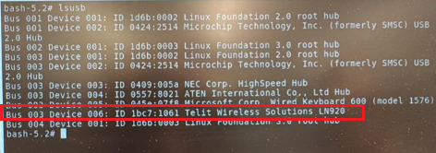

Build Environment on Host
[RSB-3720]
https://ess-wiki.advantech.com.tw/view/IoTGateway/BSP/Linux/iMX8/Yocto_LBVF_User_Guide
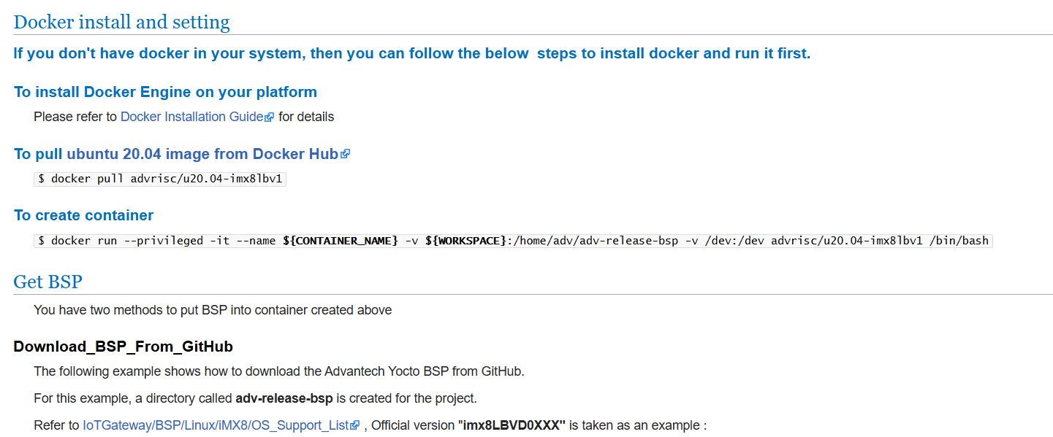

Getting Linux Code and Setting Environment
[RSB-3720]
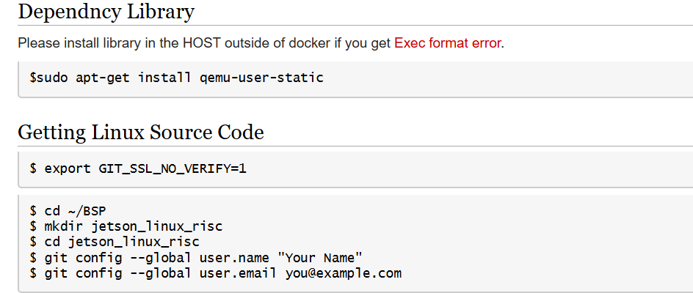
$ repo init -u git://github.com/ADVANTECH-Corp/adv-arm-yocto-bsp.git -b imx-linux-kirkstone -m imx8LBVF0071.xml
$ repo sync
$ MACHINE=imx8mprsb3720a2 UBOOT_CONFIG=6G DISTRO=fsl-imx-xwayland source imx-setup-release.sh -b build_x11
$ bitbake virtual/kernel

For build hostapd and wpa_supplicant you will need add below tool in the local config
$ cd /home/adv/adv-release-bsp/build_x11/conf
$ vi local.conf
Add below content at the end of “local.conf”
# Enable 4G tool
RDEPENDS:packagegroup-core-tools-testapps:remove = "connman-client connman-tools"
IMAGE_INSTALL:remove = "packagegroup-core-tools-testapps connman connman-client connman-gnome connman-conf"
PACKAGE_EXCLUDE = "connman connman-client connman-tools connman-conf connman-gnome"
IMAGE_INSTALL:append = " networkmanager modemmanager libqmi libmbim usbutils pciutils"
DISTRO_FEATURES:remove = "connman"
DISTRO_FEATURES:append = " networkmanager"

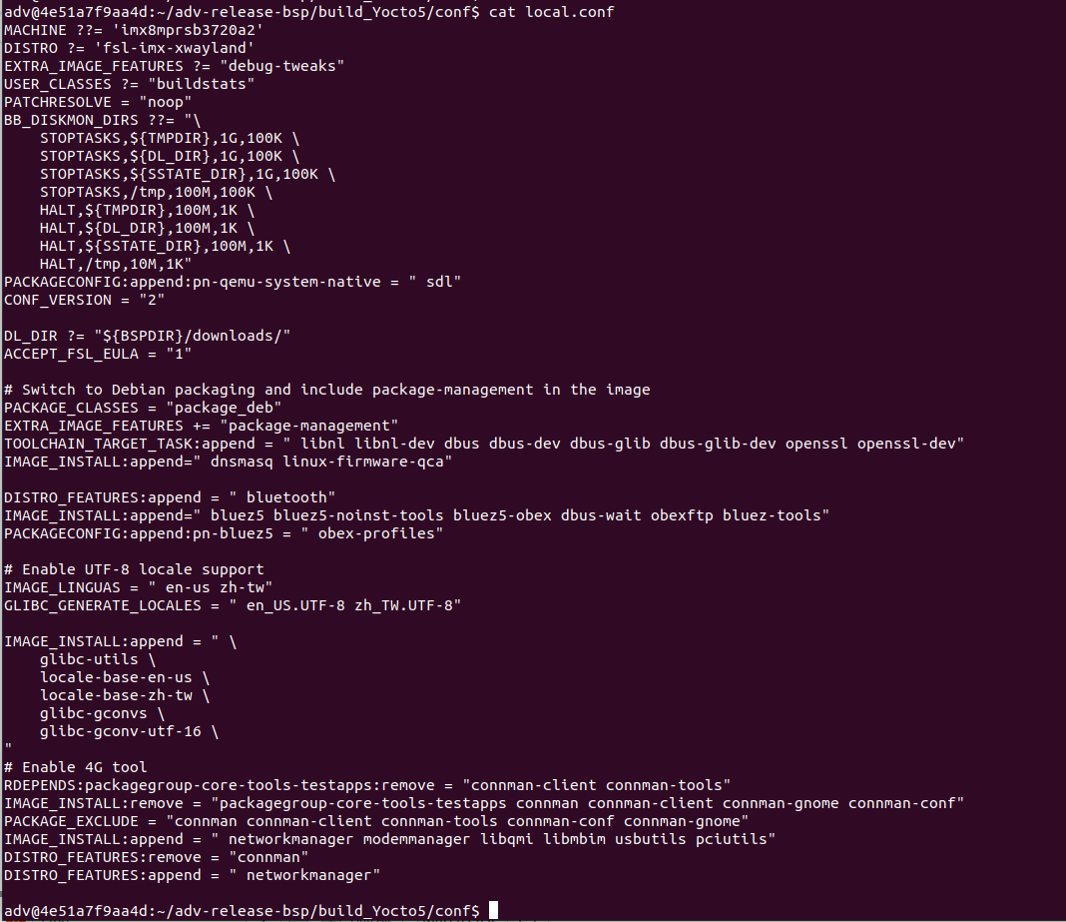

Build Kernel Image and build Tool-Chain
[RSB-3720]

$ vi /home/adv/adv-release-bsp/sources/meta-imx/meta-imx-ml/recipes-nnstreamer/nnshark/nnshark_2023.11.imx.bb
Modify
NNSHARK_SRC ?= "gitsm://github.com/nxp-imx/nnshark.git;protocol=https"
to
NNSHARK_SRC ?= "git://github.com/nxp-imx/nnshark.git;protocol=https"

add below content in the nnshardk_2023.11.imx.bb
do_configure[network]="1"
do_configure:prepend() {
cd ${S}
echo ">>> Fixing GStreamer common submodule URL"
if grep -q "anongit.freedesktop.org" .gitmodules; then
sed -i 's#git://anongit.freedesktop.org/gstreamer/common#https://gitlab.freedesktop.org/gstreamer/common.git#g' .gitmodules || true
fi
git submodule sync --recursive || true
git submodule update --init --recursive || true
echo ">>> Submodule fix done."
}
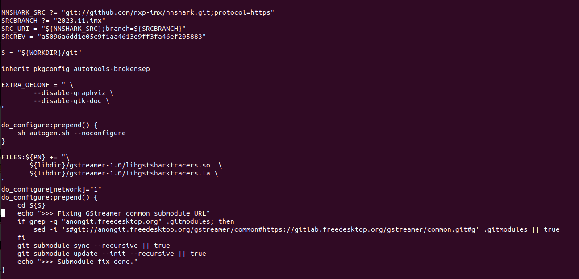

$ vi ~/adv-release-bsp/sources/meta-imx/meta-imx-ml/recipes-libraries/onnxruntime/onnxruntime_1.17.1.bb
Add below function as below
DEPENDS = "libpng zlibi libeigen"

EXTRA_OECMAKE += "\
-DFETCHCONTENT_FULLY_DISCONNECTED=OFF \
-DCMAKE_BUILD_TYPE=RelWithDebInfo \
-Donnxruntime_BUILD_UNIT_TESTS=ON \
-Donnxruntime_USE_PREINSTALLED_EIGEN=ON\
-Deigen_SOURCE_PATH=${STAGING_INCDIR}/eigen3\

"

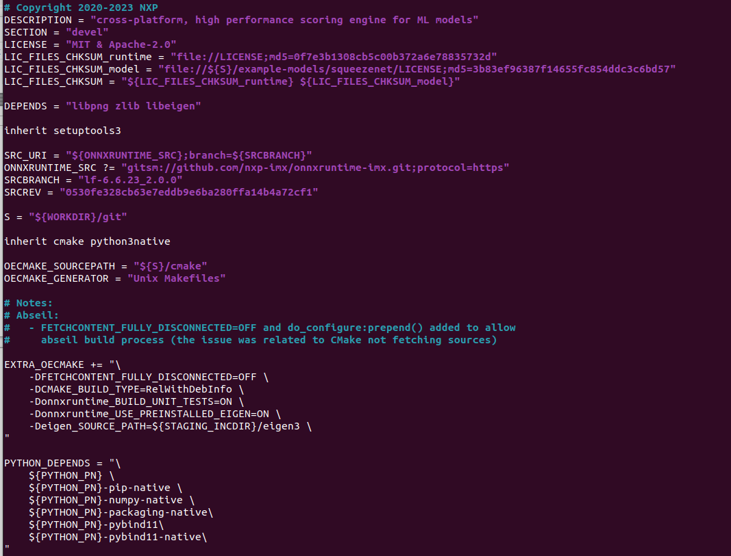
$ cd ~/adv-release-bsp/build_x11
$ bitbake imx-image-full
$ bitbake meta-toolchain
The below installer will be located in the directory "./tmp/deploy/sdk".
fsl-imx-wayland-glibc-x86_64-meta-toolchain-armv8a-imx8mp-lpddr4-evk-toolchain-${KERNEL}-scarthgap.sh
You need install the tool chain and source the environment
The full image will in the “./tmp/deploy/img”

Flash Image
[RSB-3720]
Flash image to SD card
OS image path “/home/adv/adv-release-bsp/build_x11/tmp/deploy/images/imx8mprsb3720a2”
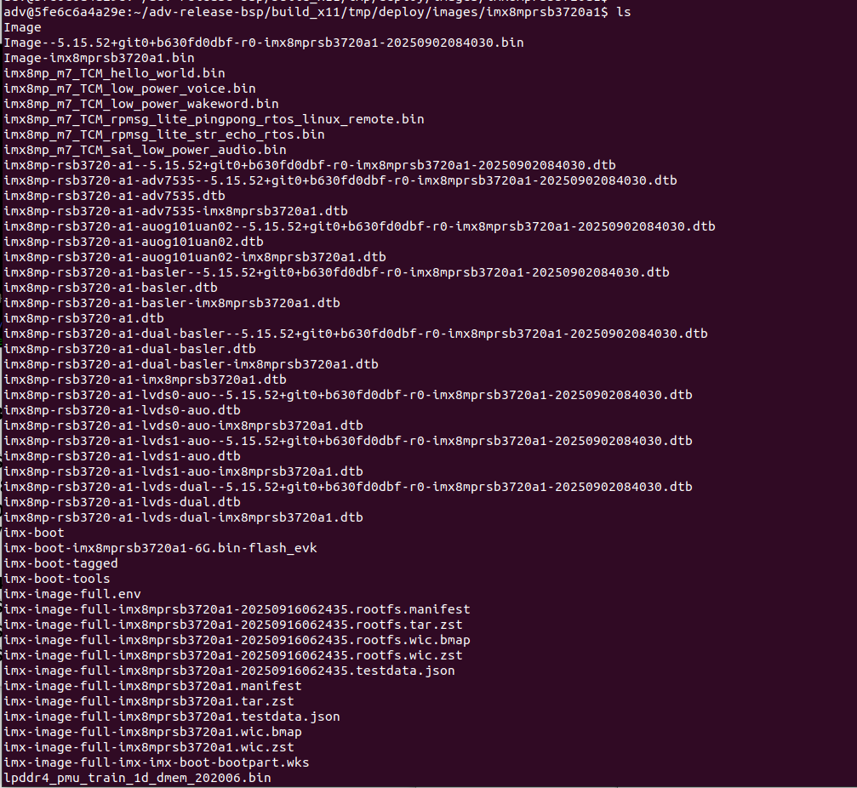

.wic.zst if full OS image
You need copy it to your system.
$ maker p ~/adv-release-bsp/Temp/SD_img
$ cp imx-image-full-imx8mprsb3720a2-20251209023921.rootfs.wic.zst ~/adv-release-bsp/Temp/SD_img

Change to your real system(Not in the docker)
- $ cd ~/Downloads/adv-release-bsp/Temp/SD_img
- $ zstd -d imx-image-full-imx8mprsb3720a1-xxxx.rootfs.wic.zst (Example: imx-image-full-imx8mprsb3720a2-20251209023921.rootfs.wic.zst)
- $ sudo dd if=imx-image-full-imx8mprsb3720a1-xxxx.rootfs.wic of=/dev/sdb bs=4M status=progress conv=fsync

Appendix:
Wireless network establishment:
RMnet mode(at#usbcfg=1) :
-With ModemManager
Disable NetworkManager
Check the modem interface. For example, the modem interface is 1.
$ mmcli -L
You need check the modem interface. For example, the interface is 1.
$ mmcli -m 1 –enable
$ mmcli -m 1 –simple-connect=”apn=internet”
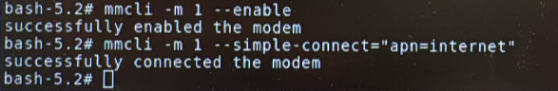
$ udhcpc -i wwan0 -q -n
The connection will establish.

-Without ModemManager
Disable NetworkManager
$ systemctl stop ModemManager
$ systemctl status ModemManager
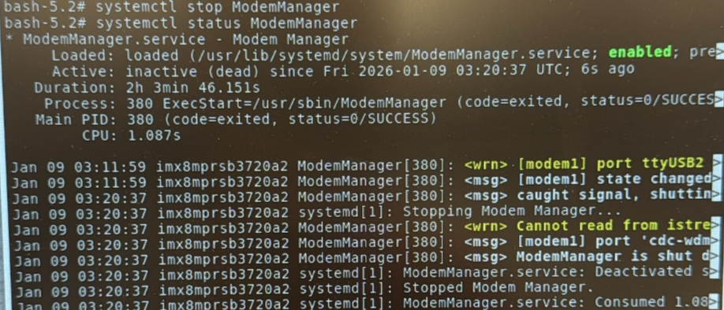
$ systemctl stop NetworkManager
$ systemctl status NetworkManager
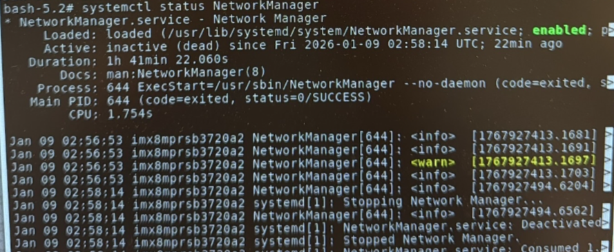
$ ip link set wwan0 down
$ echo Y> /sys/class/net/wwan0/qmi/raw_ip
$ cat /sys/class/net/wwan0/qmi/raw_ip
$ ip link set wwan0 up
$ qmicli -d /dev/cdc-wdm0 --dms-get-operating-mode
$ qmicli -d /dev/cdc-wdm0 --nas-get-home-network
$ qmicli -d /dev/cdc-wdm0 --nas-get-signal-strength
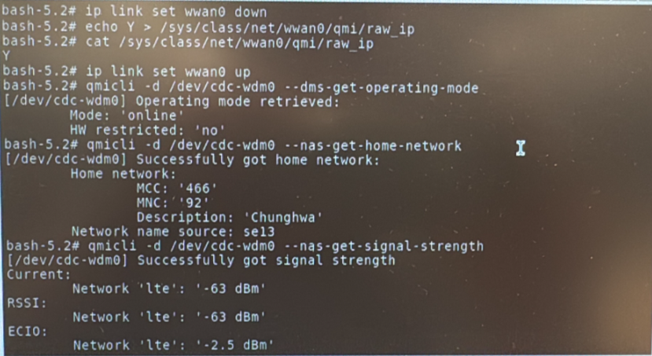
$ qmicli -d /dev/cdc-wdm0 --wds-start-network=”apn=’internet’,ip-type=4” --client-no-release-cid
$ udhcpc -i wwan0 -q -n
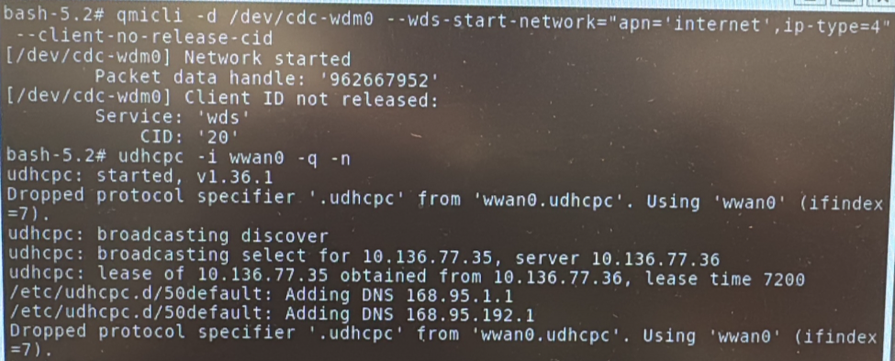

MBIM mode(at#usbcfg=2) :
-With ModemManager.service
Check ModemManager service is on
The NetworkManager service can on or off. If the NetworkManager service is on, when you dial out to the station your net work interface will auto attach wwan0.
$ systemctl sart NetworkManager
$ systemctl start ModemManager
Then check the service
$ systemctl status NetworkManager
$ systemctl status ModemManager
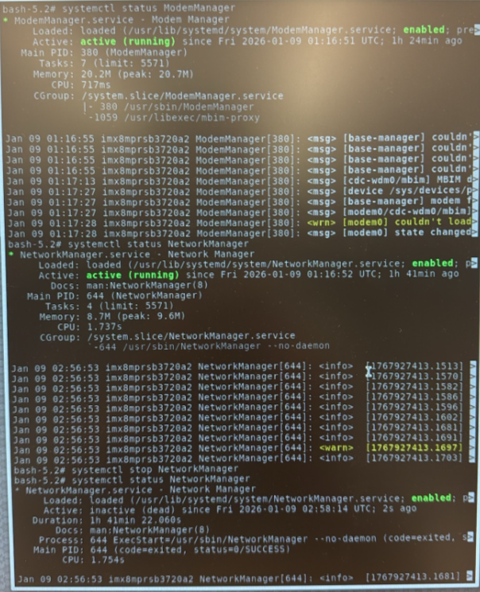

$ mmcli -m 0 --enable
$ mmcli -m 0 --simple-connect=”apn=internet”
$ mmcli -m 0
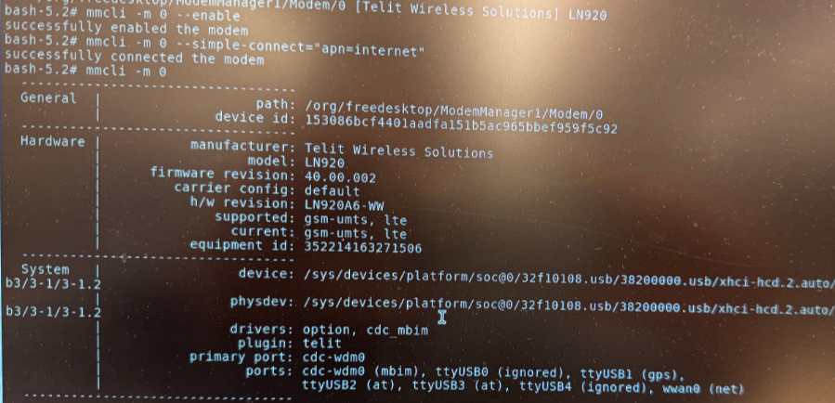
If your NetwrokManger service is on, you can skip below command “ip link set wwan0 up”.
$ ip link set wwan0 up
$ udhcpc -i wwan0 -q -n
The connection will establish

The other one method is using mbim-network
Make a mbim-network.conf in the /etc folder
$ echo “APN=internet”> /etc/mbim-network.conf
$ echo “PROXY=yes” >> /etc/mbim-network.conf
$ cat /etc/mbim-network.conf
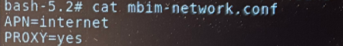
$ mbim-network /dev/cdc-wdm0 start
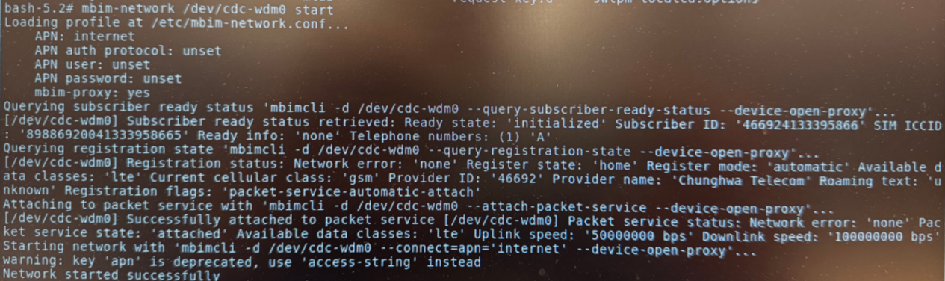
$ udhcpc -i wwan0 -q -n

