AIW FAQ
How to bring up AIW-356 4G feature with RSB-3720 or FRDM-IMX95
Category | AIW | Date | 2026/5/25
Keyword | AIW-356,RSB-3720(Yocto 5.0) with linux kernel 6.6.23), FRDM-IMX95 (Yocto 5.2 with Linux kernel 6.12.49)
Catergory:
1. Check Device 2
2. Build Environment on Host 2
3. Getting Linux Code and Setting Environment 2
4. Build Kernel Image and build Tool-Chain 4
5. Flash Image 7
Appendix: 8

Check Device
Before driver installed, you will see the device as below by “lsusb”.

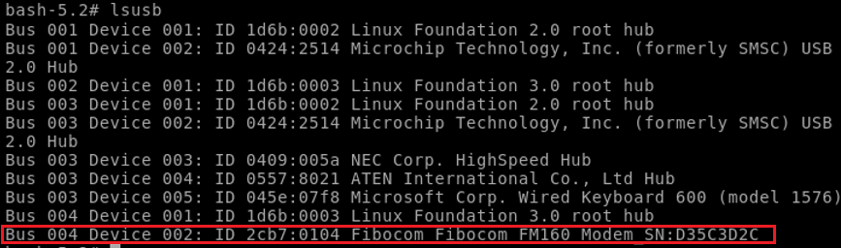

[FRDM-IMX95]

For the FRDM-IMX95 board, the following steps are required for showing the USB devices. Otherwise, you will see nothing by using “lsusb” command.

1. Disable the “FSL_DMA” driver from the kernel menu config. It’s in the “Device Drivers ➔ DMA Engine support ➔ Freescale eDMA engine support”
2. Add the following content at the end of “imx95-15x15-frdm.dts” file.
&edma1 { status = "disabled"; };
&edma2 { status = "disabled"; };
&edma3 { status = "disabled"; };

&{/soc/bus@42000000/i2c@42530000} {
/delete-property/ dmas;
/delete-property/ dma-names;
};

&{/soc/bus@42000000/i2c@42540000} {
/delete-property/ dmas;
/delete-property/ dma-names;
};

&{/soc/bus@44000000/i2c@44350000} {
/delete-property/ dmas;
/delete-property/ dma-names;
};

&{/soc/bus@42000000/spi@42550000} {
/delete-property/ dmas;
/delete-property/ dma-names;
};

Compile the kernel again, you will see the AIW-356 USB device by using “lsusb”.

Build Environment on Host
[RSB-3720]
https://ess-wiki.advantech.com.tw/view/IoTGateway/BSP/Linux/iMX8/Yocto_LBVF_User_Guide
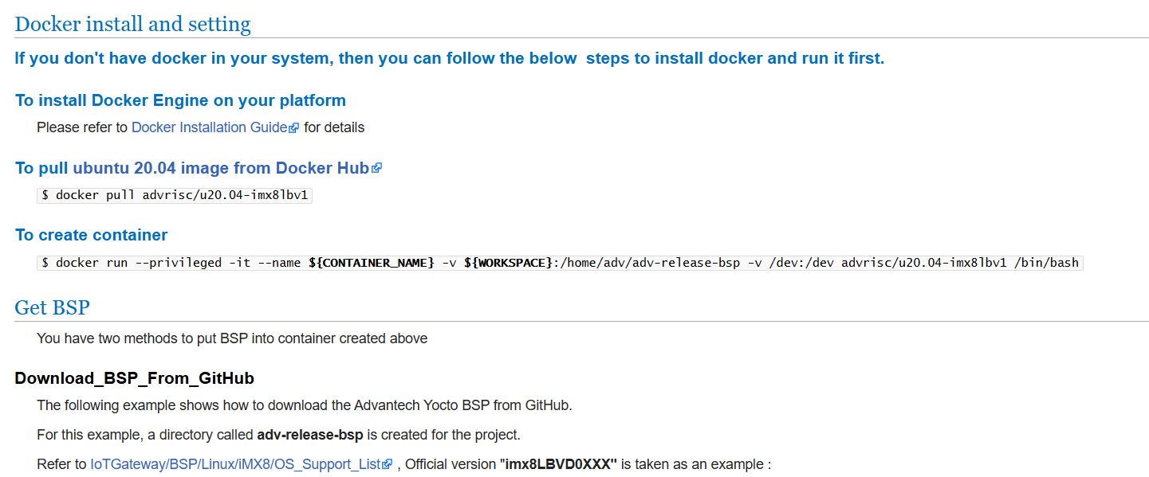

[FRDM-IMX95]

You can get the i.MX Yocto Project user’s guide from the NXP website below:
https://www.nxp.com/docs/en/user-guide/UG10164.pdf

Getting Linux Code and Setting Environment
[RSB-3720]
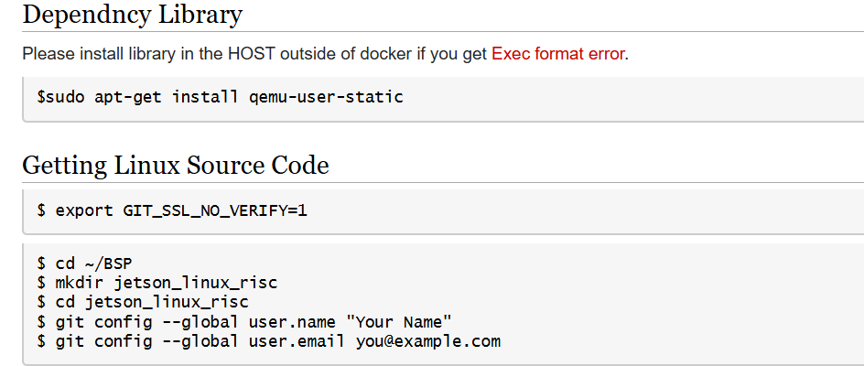
$ repo init -u git://github.com/ADVANTECH-Corp/adv-arm-yocto-bsp.git -b imx-linux-kirkstone -m imx8LBVF0071.xml
$ repo sync
$ MACHINE=imx8mprsb3720a2 UBOOT_CONFIG=6G DISTRO=fsl-imx-xwayland source imx-setup-release.sh -b build_x11
$ bitbake virtual/kernel

[FRDM-IMX95]
# docker pull advrisc/u20.04-imx8lbv1
# docker run --privileged -it --name imx95_frdm -v /home/eiotae/aiw/kevin/BSP/imx95_frdm:/home/adv/imx-yocto-bsp -v /dev:/dev advrisc/u20.04-imx8lbv1 /bin/bash
# cd imx-yocto-bsp
# repo init -u https://github.com/nxp-imx/imx-manifest -b imx-linux-walnascar -m imx-6.12.49-2.2.0.xml
# repo sync
# DISTRO=fsl-imx-wayland MACHINE=imx95-15x15-lpddr4x-frdm source imx-setup-release.sh -b build_dir
# sudo mkdir -p /tmp
# sudo chmod 1777 /tmp
# bitbake imx-image-full
If you need to use “bitbake linux-imx -c menuconfig” to configure kernel config, please make sure the tmux screen, Python 3.10, GCC-10 and g++-10 are installed.

tmux installation:
# sudo apt-get update
# sudo apt-get install tmux screen -y
# echo 'OE_TERMINAL = "tmux"' >> conf/local.conf

# bitbake linux-imx -c menuconfig
# bitbake linux-imx -c savedefconfig
# bitbake linux-imx

(It needs to enable MBIM and RMNET driver in the kernel menuconfig for FRDM-IMX95, the both of default value are “disabled”)

kernel default config:
~/imx-yocto-bsp/build_dir/tmp/work/imx95_15x15_lpddr4x_frdm-poky-linux/linux-imx/6.12.49+git/build/defconfig

kernel DTS file:
~/imx-yocto-bsp/build_dir/tmp/work-shared/imx95-15x15-lpddr4x-frdm/kernel-source/arch/arm64/boot/dts/freescale/imx95-15x15-frdm.dts

[RSB-3720] [FRDM-IMX95]

For build hostapd and wpa_supplicant you will need add below tool in the local config
$ cd /home/adv/adv-release-bsp/build_x11/conf (For the “FRDM-IMX95”, the path is :“~/imx-yocto-bsp/build_dir/conf”)
$ vi local.conf

Add below content at the end of “local.conf”
# Enable 4G tool
RDEPENDS:packagegroup-core-tools-testapps:remove = "connman-client connman-tools"
IMAGE_INSTALL:remove = "packagegroup-core-tools-testapps connman connman-client connman-gnome connman-conf"
PACKAGE_EXCLUDE = "connman connman-client connman-tools connman-conf connman-gnome"
IMAGE_INSTALL:append = " networkmanager modemmanager libqmi libmbim usbutils pciutils"
DISTRO_FEATURES:remove = "connman"
DISTRO_FEATURES:append = " networkmanager"

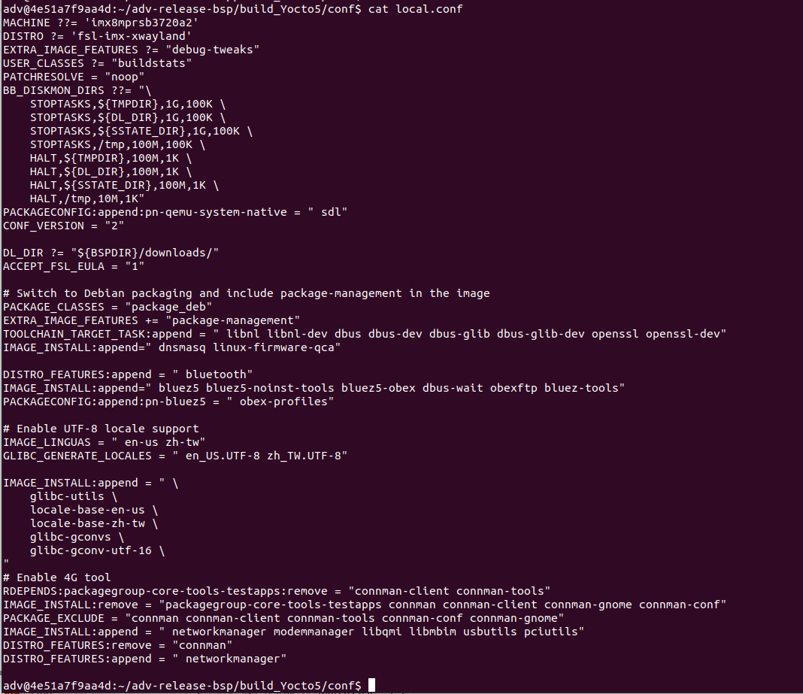

Build Kernel Image and build Tool-Chain
[RSB-3720]

$ vi /home/adv/adv-release-bsp/sources/meta-imx/meta-imx-ml/recipes-nnstreamer/nnshark/nnshark_2023.11.imx.bb
Modify
NNSHARK_SRC ?= "gitsm://github.com/nxp-imx/nnshark.git;protocol=https"
to
NNSHARK_SRC ?= "git://github.com/nxp-imx/nnshark.git;protocol=https"

add below content in the nnshardk_2023.11.imx.bb
do_configure[network]="1"
do_configure:prepend() {
cd ${S}
echo ">>> Fixing GStreamer common submodule URL"
if grep -q "anongit.freedesktop.org" .gitmodules; then
sed -i 's#git://anongit.freedesktop.org/gstreamer/common#https://gitlab.freedesktop.org/gstreamer/common.git#g' .gitmodules || true
fi
git submodule sync --recursive || true
git submodule update --init --recursive || true
echo ">>> Submodule fix done."
}
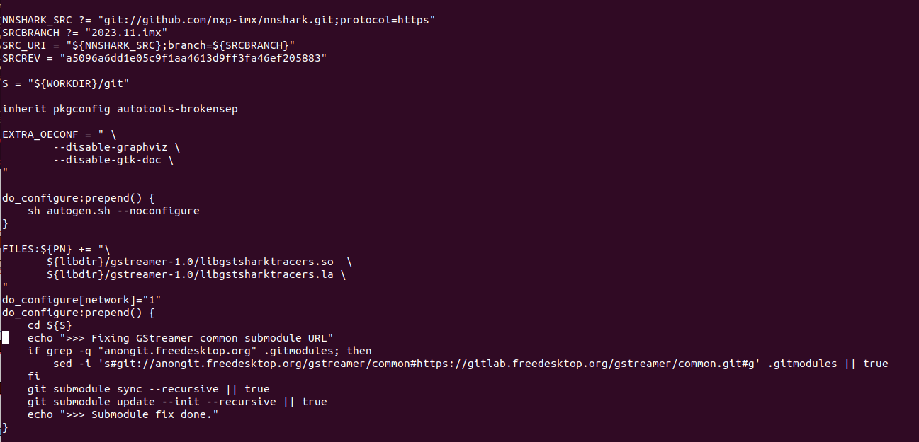

$ vi ~/adv-release-bsp/sources/meta-imx/meta-imx-ml/recipes-libraries/onnxruntime/onnxruntime_1.17.1.bb
Add below function as below
DEPENDS = "libpng zlibi libeigen"

EXTRA_OECMAKE += "\
-DFETCHCONTENT_FULLY_DISCONNECTED=OFF \
-DCMAKE_BUILD_TYPE=RelWithDebInfo \
-Donnxruntime_BUILD_UNIT_TESTS=ON \
-Donnxruntime_USE_PREINSTALLED_EIGEN=ON\
-Deigen_SOURCE_PATH=${STAGING_INCDIR}/eigen3\

"

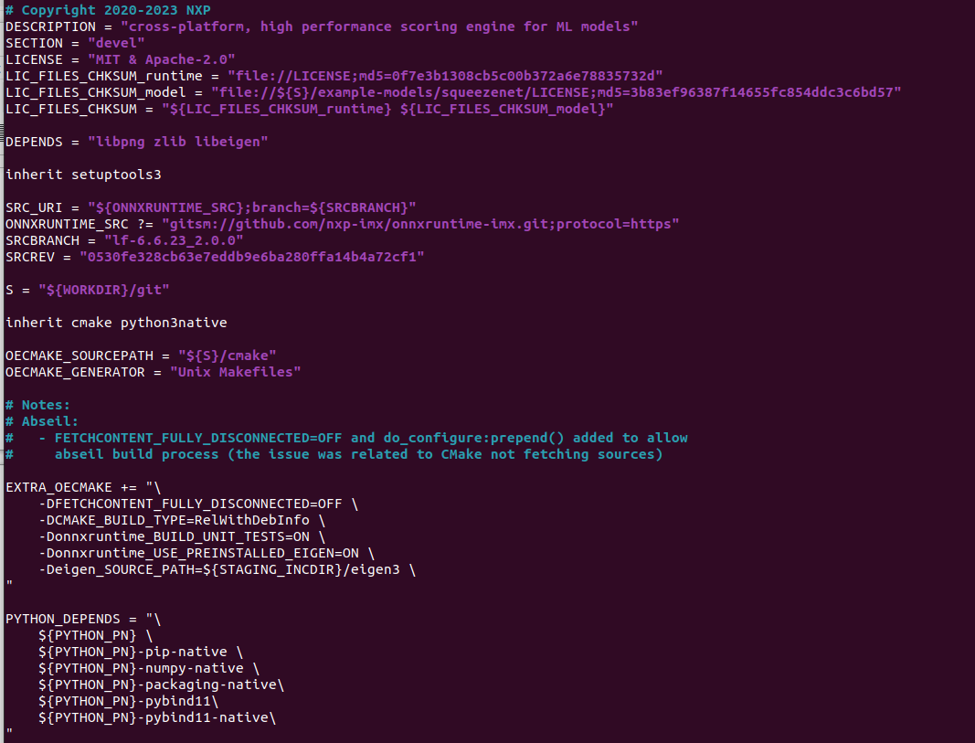
$ cd ~/adv-release-bsp/build_x11
$ bitbake imx-image-full
$ bitbake meta-toolchain
The below installer will be located in the directory "./tmp/deploy/sdk".
fsl-imx-wayland-glibc-x86_64-meta-toolchain-armv8a-imx8mp-lpddr4-evk-toolchain-${KERNEL}-scarthgap.sh
You need install the tool chain and source the environment
The full image will in the “./tmp/deploy/img”

Flash Image
[RSB-3720]
Flash image to SD card
OS image path “/home/adv/adv-release-bsp/build_x11/tmp/deploy/images/imx8mprsb3720a2”
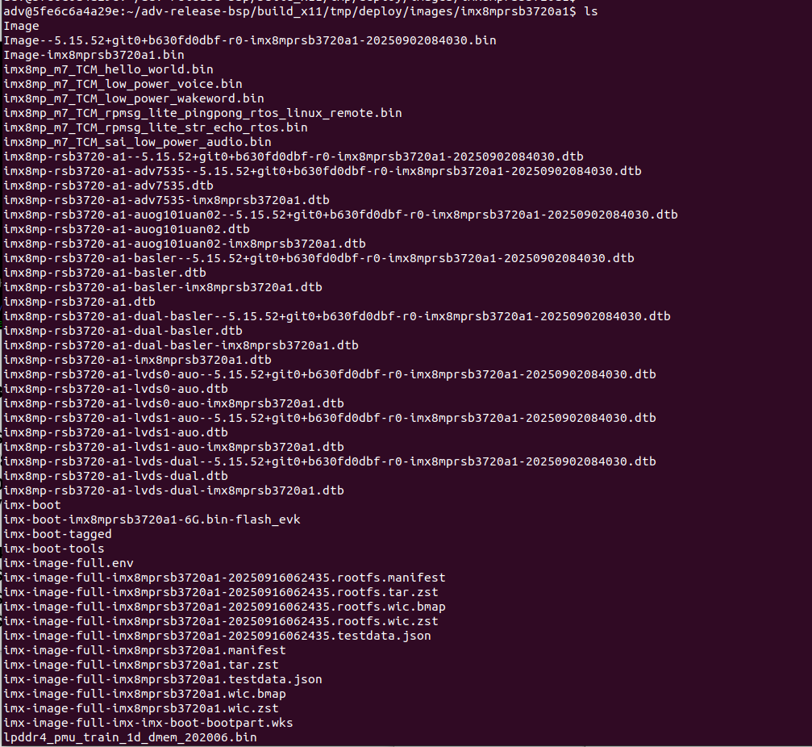

.wic.zst if full OS image
You need copy it to your system.
$ maker p ~/adv-release-bsp/Temp/SD_img
$ cp imx-image-full-imx8mprsb3720a2-20251209023921.rootfs.wic.zst ~/adv-release-bsp/Temp/SD_img

Change to your real system(Not in the docker)
- $ cd ~/Downloads/adv-release-bsp/Temp/SD_img
- $ zstd -d imx-image-full-imx8mprsb3720a1-xxxx.rootfs.wic.zst (Example: imx-image-full-imx8mprsb3720a2-20251209023921.rootfs.wic.zst)
- $ sudo dd if=imx-image-full-imx8mprsb3720a1-xxxx.rootfs.wic of=/dev/sdb bs=4M status=progress conv=fsync

[FRDM-IMX95]
It needs to use “uuu” tool to flash the image to a SD card for FRDM-IMX95 board. It’s recommended to use it under the Ubuntu environment.

- Download “uuu” source code from https://github.com/nxp-imx/mfgtools/releases
- mkdir “build” in the source code
- go to “build”, run “cmake ..”
- then “make -j8”, it will generate a “uuu” command in the “uuu” directory

Use the “uuu” command you compiled instead of use the one from website or github. Do not use it on windows directly.

sudo ./uuu -b sd_all imx-boot-imx95-15x15-lpddr4x-frdm-sd.bin-flash_all imx-image-full-imx95evk.wic

sd_all : Flash the image to SD card
imx-boot-imx95-15x15-lpddr4x-frdm-sd.bin-flash_all: this is important to use FRDM-i.MX95 (the board is 15x15 package, the RAM is DDR 4)

Appendix:
Wireless network establishment:
RMnet mode(at+gtusbmode=32) :
-With ModemManager
Disable NetworkManager
Check the modem interface. For example, the modem interface is 1.
$ mmcli -L
You need check the modem interface. For example, the interface is 1.
$ mmcli -m 1 –enable
$ mmcli -m 1 –simple-connect=”apn=internet”
$ ifconfig -a
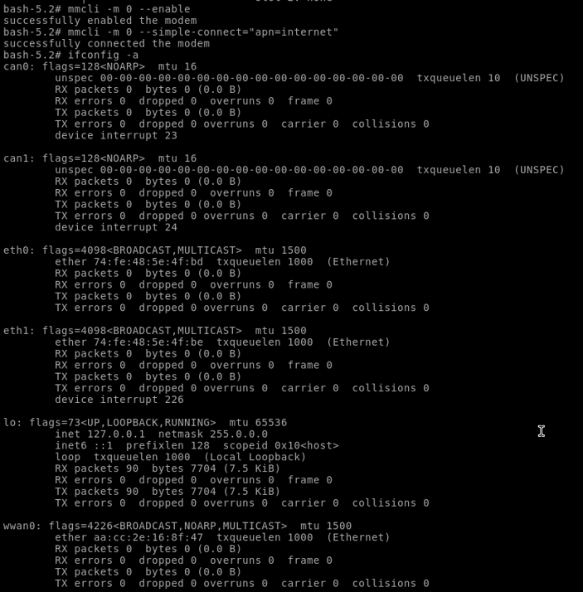
$ udhcpc -i wwan0
The connection will establish.
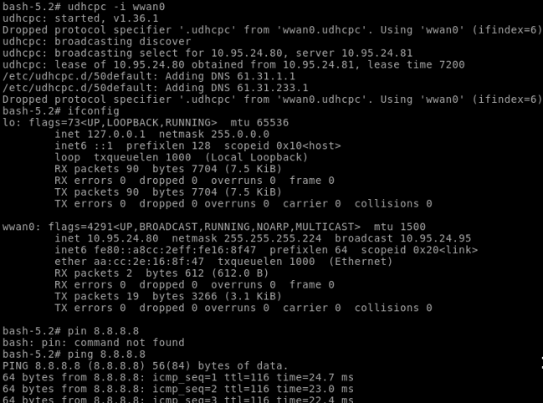

-Without ModemManager
Disable NetworkManager
$ systemctl stop ModemManager
$ systemctl status ModemManager
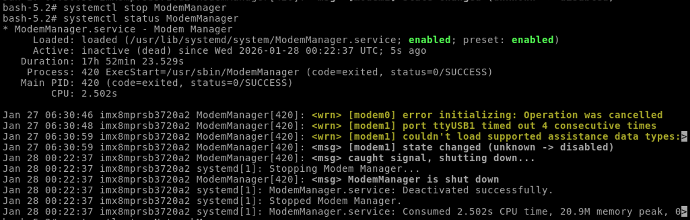
$ systemctl stop NetworkManager
$ systemctl status NetworkManager
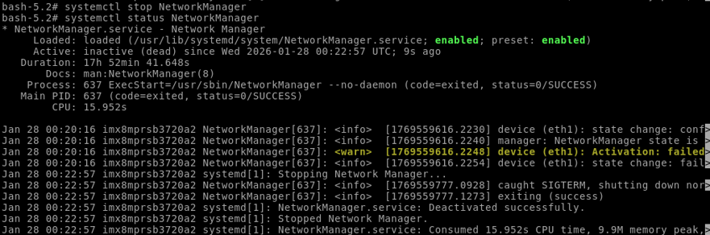
$ ip link set wwan0 down
$ echo Y> /sys/class/net/wwan0/qmi/raw_ip
$ cat /sys/class/net/wwan0/qmi/raw_ip
$ ip link set wwan0 up
$ qmicli -d /dev/cdc-wdm0 --dms-get-operating-mode
$ qmicli -d /dev/cdc-wdm0 --nas-get-home-network
$ qmicli -d /dev/cdc-wdm0 --nas-get-signal-strength
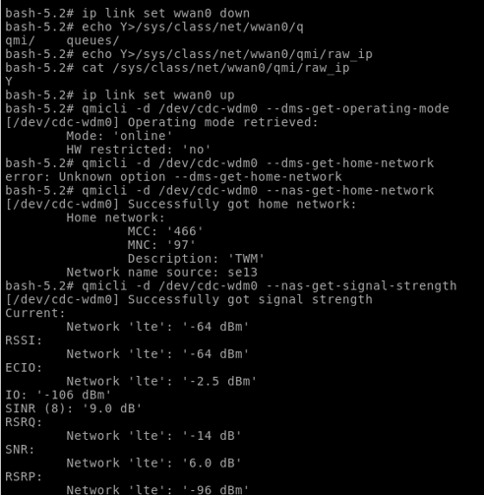
$ qmicli -d /dev/cdc-wdm0 --wds-start-network=”apn=internet” --client-no-release-cid
After connect to the internet you need get the current setting and set the static IP address and route.
$ qmicli -d /dev/cdc-wdm0 –wds-get-current-settings
$ ip addr add 10.176.10.7 dev wwan0
$ ip route add default dev wwan0 via 10.176.10.8 dev wwan0 onlink
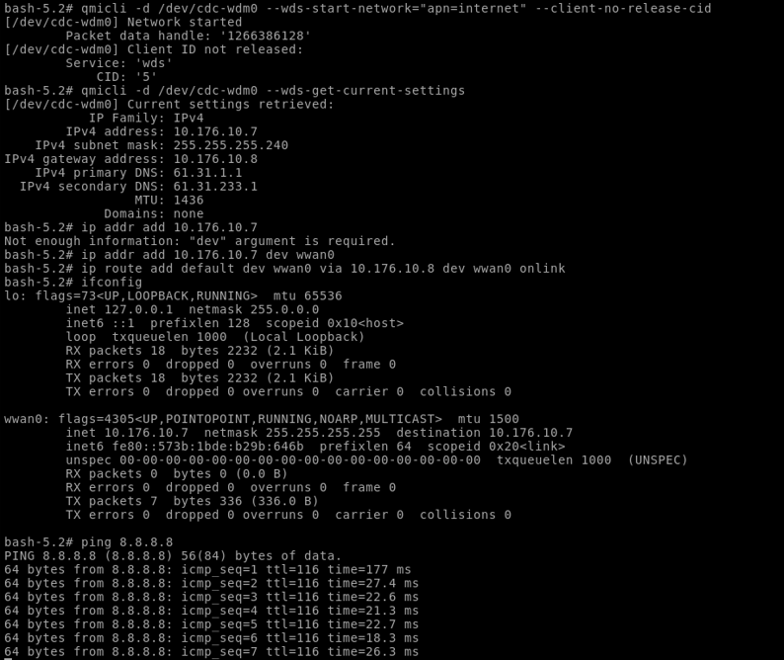

MBIM mode(at+gtusbmode=30) :
-With ModemManager.service
Check ModemManager service is on
The NetworkManager service can on or off. If the NetworkManager service is on, when you dial out to the station your net work interface will auto attach wwan0.
$ systemctl sart NetworkManager
$ systemctl start ModemManager
Then check the service
$ systemctl status NetworkManager
$ systemctl status ModemManager
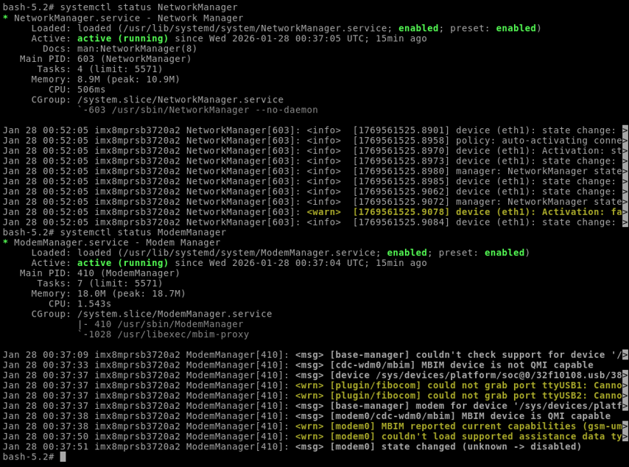

$ mmcli -m 0 –enable
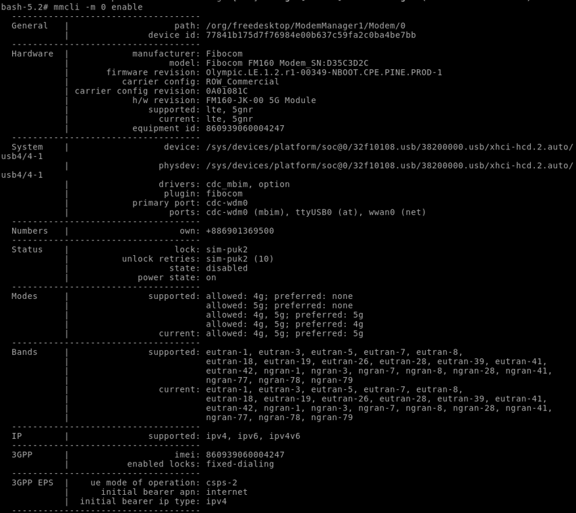
$ mmcli -m 0 --simple-connect=”apn=internet”
$ mmcli -m 0
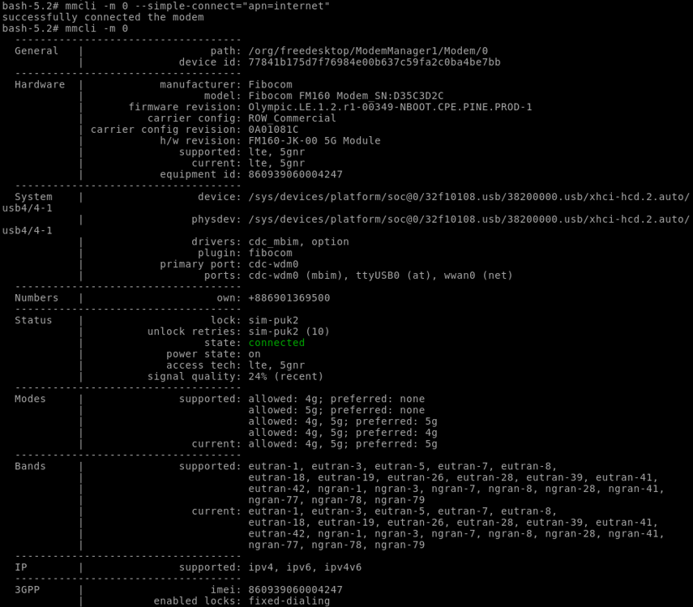
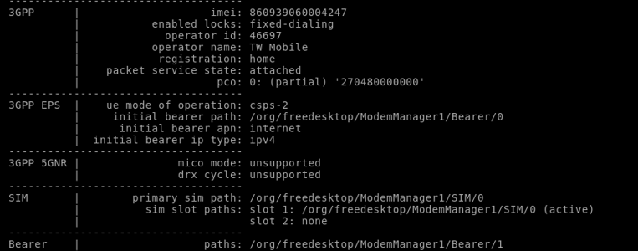
If your NetwrokManger service is on, you can skip below command “ip link set wwan0 up”.
$ ip link set wwan0 up
$ udhcpc -i wwan0
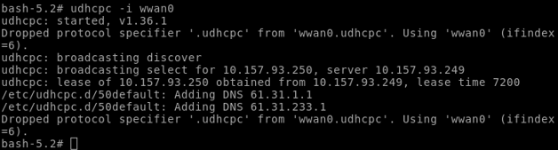
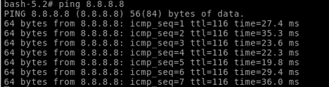
The connection will establish

