AIW FAQ
How to bring up AIW-173 Wifi feature with RSB-3720
Category | AIW | Date | 2025/11/27
Keyword | AIW-173(WiFi 7),RSB-3720(Yocto 4.0 LTS) with linux kernel 5.15.52
Catergory:
1. Check Device 2
2. Build Environment on Host 2
3. Getting Linux Code and Setting Environment 2
4. Build Kernel Image and build Tool-Chain 5
5. Build WLAN Driver and network tool(hostapd and wpa_supplicant) 5
6. Flash Image 10
7. Install Driver 11
8. Check Device After installed driver 11
Appendix: 12

Check Device
Before driver installed, you will see the device as below by “lspci”.

$ lspci
01:00.0 Network controller: Qualcomm Technologies, Inc WCN785x Wi-Fi 7(802.11be) 320MHz 2x2 [FastConnect 7800] (rev 01)

Build Environment on Host
[RSB-3720]
https://ess-wiki.advantech.com.tw/view/IoTGateway/BSP/Linux/iMX8/Yocto_LBVD_User_Guide
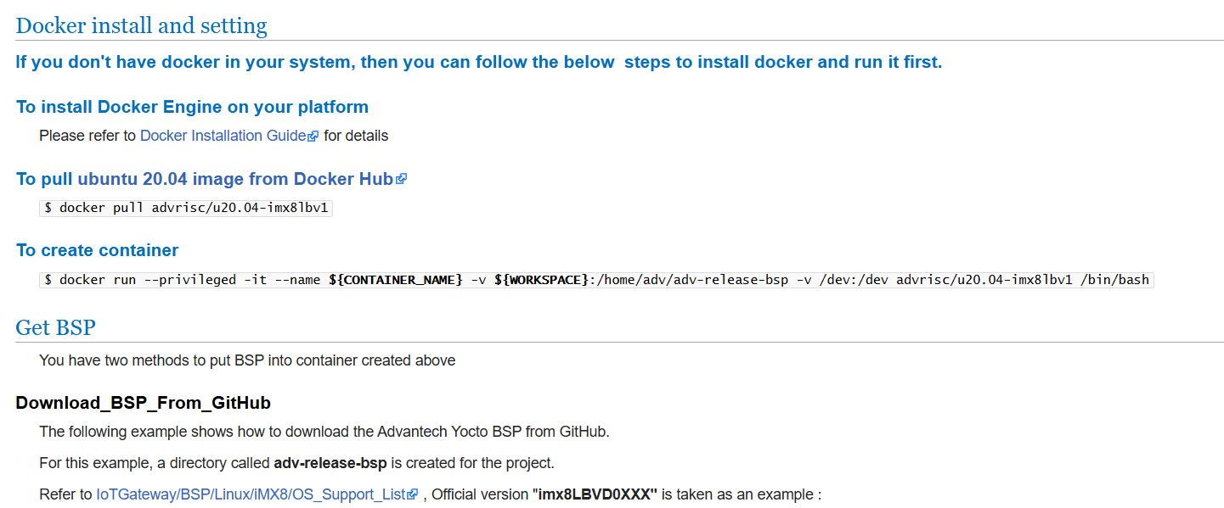

Getting Linux Code and Setting Environment
[RSB-3720]
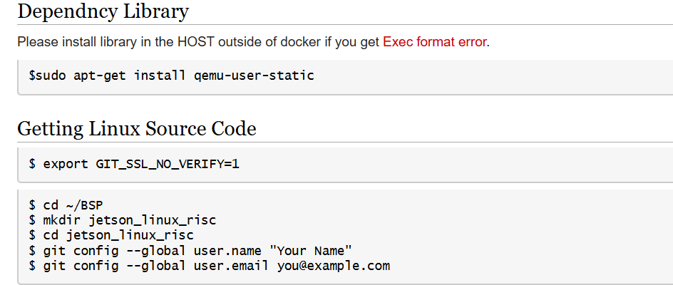
$ repo init -u git://github.com/ADVANTECH-Corp/adv-arm-yocto-bsp.git -b imx-linux-kirkstone -m imx8LBVC0047.xml
$ repo sync
$ MACHINE=imx8mprsb3720a1 UBOOT_CONFIG=6G DISTRO=fsl-imx-xwayland source imx-setup-release.sh -b build_x11
$ bitbake virtual/kernel

$ mkdir -p ~/adv-release-bsp/sources/meta-advantech/meta-fsl-imx/recipes-kernel/linux/linux-imx/
Move below file in the “~/adv-release-bsp/sources/meta-advantech/meta-fsl-imx/recipes-kernel/linux/linux-imx/”
$ mv fragment.cfg ~/adv-release-bsp/sources/meta-advantech/meta-fsl-imx/recipes-kernel/linux/linux-imx/

$ nano ~/adv-release-bsp/sources/meta-advantech/meta-fsl-imx/recipes-kernel/linux/linux-imx_5.15.bbappend
Add content below at the end of this file.

SRC_URI+= "file://fragment.cfg"
do_configure:append () {
cat ${WORKDIR}/*.cfg >> ${B}/.config
}

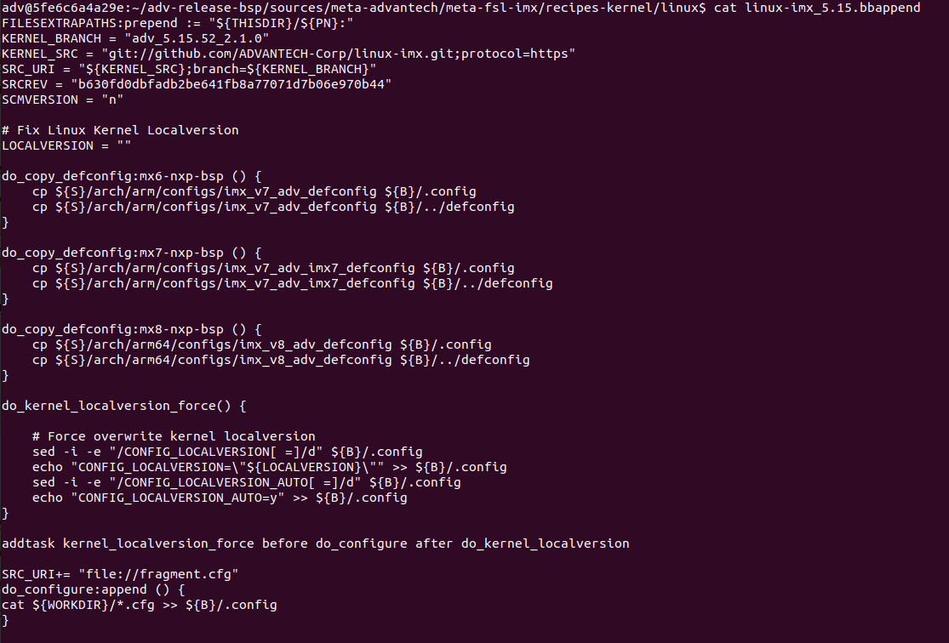

For build hostapd and wpa_supplicant you will need add below tool in the local config
$ cd /home/adv/adv-release-bsp/build_x11/conf
$ vi local.conf
Add below content at the end of “local.conf”
TOOLCHAIN_TARGET_TASK:append = " libnl libnl-dev libnl-router dbus dbus-dev dbus-glib dbus-glib-dev openssl openssl-dev"

Rebuild kernel
$ bitbake -c cleansstate virtual/kernel
$ bitbake virtual/kernel
Check the .config file
$ cat /home/adv/adv-release-bsp/build_x11/tmp/work/imx8mprsb3720a1-poky-linux/linux-imx/5.15.52+gitAUTOINC+b630fd0dbf-r0/build/.config
Make the kernel folder can build driver
Copy the .config file to work-share folder
$ cp
/home/adv/adv-release-bsp/build_x11/tmp/work/imx8mprsb3720a1-poky-linux/linux-imx/5.15.52+gitAUTOINC+b630fd0dbf-r0/build/.config /home/adv/adv-release-bsp/build_x11/tmp/work-shared/imx8mprsb3720a1/kernel-source
$ cd /home/adv/adv-release-bsp/build_x11/tmp/work-shared/imx8mprsb3720a1/kernel-source
Note. You need have sdk to do below command. You can reference next chapter.
$ source /opt/fsl-imx-xwayland/5.15-kirkstone/environment-setup-armv8a-poky-linux
$ make ARCH=arm64 CROSS_COMPILE=aarch64-poky-linux- oldconfig
$ make ARCH=arm64 CROSS_COMPILE=aarch64-poky-linux- prepare
$ make ARCH=arm64 CROSS_COMPILE=aarch64-poky-linux- modules_prepare

Build Kernel Image and build Tool-Chain
[RSB-3720]

$ cd ~/adv-release-bsp/build_x11/tmp/work/armv8a-poky-linux/nnshark/2021.10.imx-r0/git
$ git config submodule.common.url https://github.com/GStreamer/common.git
$ git submodule update
$ cd ~/adv-release-bsp/build_x11
$ bitbake imx-image-full
$ bitbake meta-toolchain
The below installer will be located in the directory "./tmp/deploy/sdk".
fsl-imx-wayland-glibc-x86_64-meta-toolchain-armv8a-imx8mp-lpddr4-evk-toolchain-${KERNEL}-scarthgap.sh
You need install the tool chain and source the environment
The full image will in the “./tmp/deploy/img”

Build WLAN Driver and network tool(hostapd and wpa_supplicant)
5.1 Build WLAN Driver
- Download the driver source code from git server
[RSB-3720]
AIW_173_driver.tar.gz
$ cd /
$ git clone ssh://adv_ae@172.22.24.155:/volume1/git-server/AIW_173_driver
NOTE: the password for adv_ae is “123456”
- Copy header files to kernel
RSB-3720’s folder name is “AIW_173_driver”

$ cd /AIW_173_driver_XXX /AIO/build
$ sudo cp -r ../drivers/core_tech_modules/include/linux/mhi.h <kernel_path>/include/linux/
$ sudo cp -r ../drivers/core_tech_modules/include/trace/events/qrtr.h <kernel_path>/include/trace/events/
$ sudo cp -r ../drivers/core_tech_modules/inc/cnss2.h <kernel_path>/include/net/
$ sudo cp -r ../drivers/core_tech_modules/inc/cnss_nl.h <kernel_path>/include/net/
$ sudo cp -r ../drivers/core_tech_modules/inc/cnss_utils.h <kernel_path>/include/net/
$ sudo cp -r ../drivers/core_tech_modules/inc/cnss_prealloc.h <kernel_path>/include/net/
- Patch the driver
- $ cd /AIW_173_driver
- $ git add AIO
- $ git commit -m "Add AIO drivers baseline"
- $ git apply --3way 0001-add-some-modified-files.patch
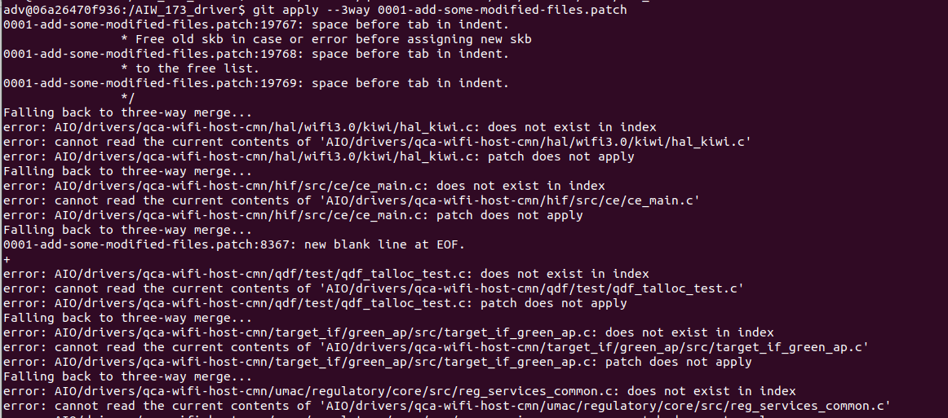
You will see a lot of conflict as below
You can use below command to check which file you should modified
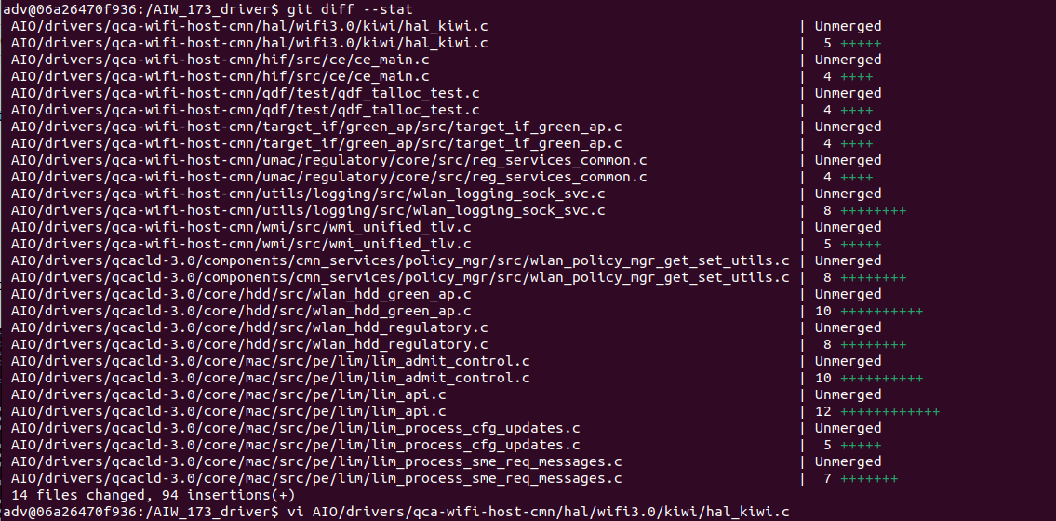
$ git diff --stat
You need manual modify all conflict and use git add the modified file to remove the git diff –stat
For example, when you modify the conflict file and you use git diff -stat, you will see the below information.
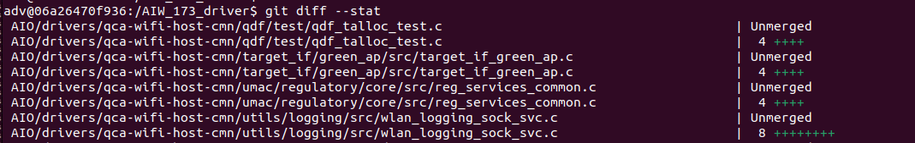
$ git add AIO/drivers/qca-wifi-host-cmn/hal/wifi3.0/kiwi/hal_kiwi.c
You will see the hal_kiwi.c is disappear
You will need modify all conflict file and use git diff –stat to check all file is modified.

- Build driver
$ sudo apt-get install build-essential libncurses5-dev flex bison libnl-3-dev
$ sudo apt-get -y install kernel-package openssl
$ sudo apt-get install libssl-dev
$ sudo apt-get install libelf-dev
$ sudo apt-get install -y libnl-genl-3-dev
$ sudo apt-get install libdbus-1-dev
$ sudo apt-get install git
$ sudo apt install xterm tmux screen -y
$ vim /AIW_173_driver/AIO/build/scripts/tr-f10/config.tr-f10
Modify below information in the config.tr-f10
export KERNELPATH=/home/adv/adv-release-bsp/build_x11/tmp/work-shared/imx8mprsb3720a1/kernel-source
export KERNELARCH=arm64
export TOOLPREFIX=/opt/fsl-imx-xwayland/5.15-kirkstone/sysroots/x86_64-pokysdk-linux/usr/bin/aarch64-poky-linux/aarch64-poky-linux-
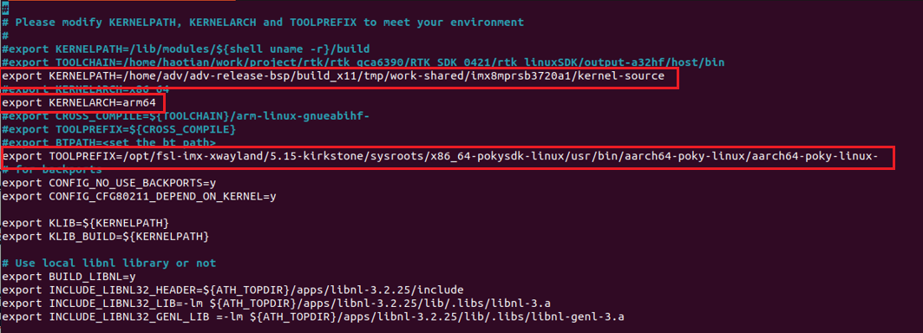
$ cp /home/adv/adv-release-bsp/build_x11/tmp/work/imx8mprsb3720a1-poky-linux/linux-imx/5.15.52+gitAUTOINC+b630fd0dbf-r0/build/.config /home/adv/adv-release-bsp/build_x11/tmp/work-shared/imx8mprsb3720a1/kernel-source
- $ cd /home/adv/adv-release-bsp/build_x11/tmp/work-shared/imx8mprsb3720a1/kernel-source
- $ source /opt/fsl-imx-xwayland/5.15-kirkstone/environment-setup-armv8a-poky-linux
- $ make ARCH=arm64 CROSS_COMPILE=aarch64-poky-linux- oldconfig
- $ make ARCH=arm64 CROSS_COMPILE=aarch64-poky-linux- prepare
- $ make ARCH=arm64 CROSS_COMPILE=aarch64-poky-linux- modules_prepare
- $ cd /AIW_173_driver_XXX /AIO/build
- $ sudo make CONFIG_FULL_CORE_BUILD=y CONFIG_PERF_BUILD=y drivers

- Get wlan_cnss_core_pcie.ko, wlan.ko from specific folder ( /AIW_173_driver_XXX /AIO/rootfs-tr-f10.build /lib/modules)
- The FW will in the specific folder
(/AIW_173_driver/AIO/rootfs-tr-f10.build/lib/firmware/WLAN-firmware)

  - Build hostapd and wpa_supplicant
- For build hostapd and wpa_supplicant you will need add below tool in the local config :
$ cd /home/adv/adv-release-bsp/build_x11/conf
$ vi local.conf
Add below content at the end of “local.conf”
- TOOLCHAIN_TARGET_TASK:append = " libnl libnl-dev dbus dbus-dev dbus-glib dbus-glib-dev openssl openssl-dev"
- IMAGE_INSTALL:append="dnsmasq linux-firmware-qca"
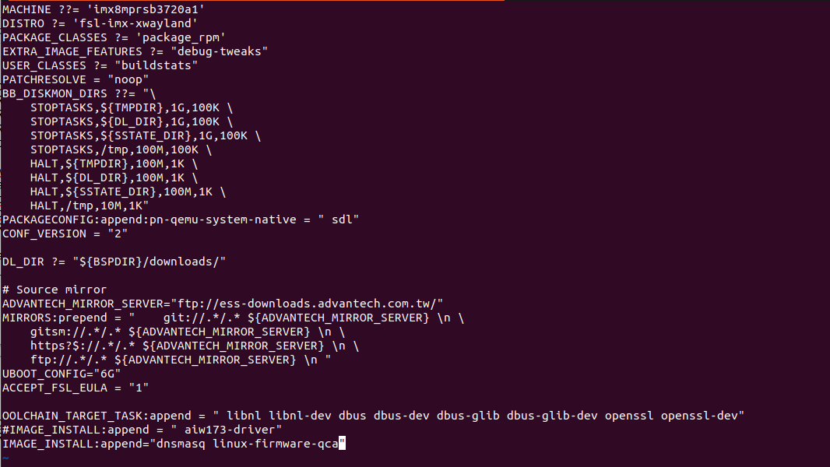
- Build hostapd
$ cd /AIW_173_driver /AIO/apps/hostap/hostapd
$ sudo make clean
$ make CROSS_COMPILE="aarch64-poky-linux-" CONFIG_FULL_CORE_BUILD=y CONFIG_PERF_BUILD=y

- Build wpa_supplicant
$ cd /AIW_173_driver/AIO/apps/hostap/wpa_supplicant
$ sudo make clean
$ make CROSS_COMPILE="aarch64-poky-linux-"CONFIG_FULL_CORE_BUILD=y CONFIG_PERF_BUILD=y

After built hostapd and wpa_supplicant, you need copy it to the SD card and boot up the RSB-3720. You need confirm “wpa_supplicant” version if is 2.11 version
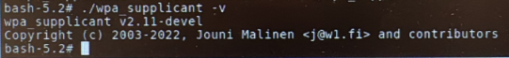

Flash Image
[RSB-3720]
Flash image to SD card
OS image path “/home/adv/adv-release-bsp/build_x11/tmp/deploy/images/imx8mprsb3720a1”
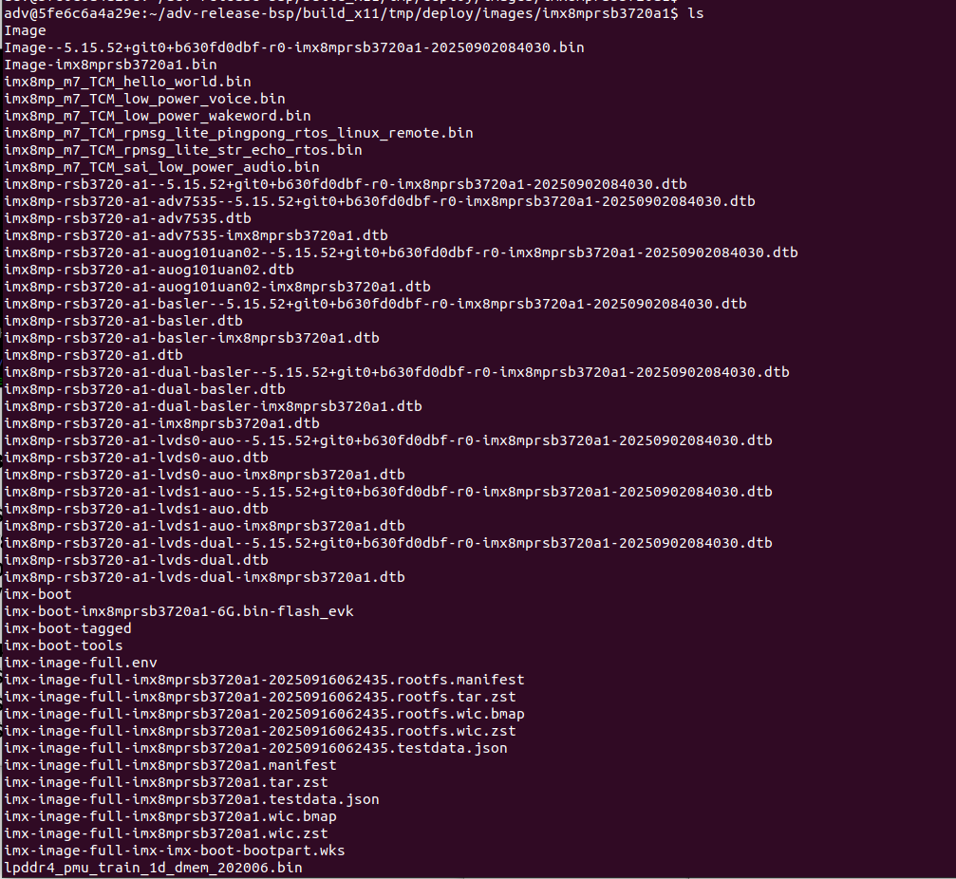

.wic.zst if full OS image
You need copy it to your system.
$ maker p ~/adv-release-bsp/Temp/SD_img
$ cp imx-image-full-imx8mprsb3720a1-20250916062435.rootfs.wic.zst ~/adv-release-bsp/Temp/SD_img

Change to your real system(Not in the docker)
- $ cd ~/Downloads/adv-release-bsp/Temp/SD_img
- $ zstd -d imx-image-full-imx8mprsb3720a1-xxxx.rootfs.wic.zst (Example: imx-image-full-imx8mprsb3720a1-20250916062435.rootfs.wic.zst)
- $ sudo dd if=imx-image-full-imx8mprsb3720a1-xxxx.rootfs.wic of=/dev/sdb bs=4M status=progress conv=fsync

Install Driver
Copy firmware files to device:
$sudo cp -rf /AIW-173_driver /AIO/rootfs-tr-f10.build/lib/firmware/WLAN-firmware/* /lib/firmware/
$sudo cp -f /AIW-173_driver /AIO/ rootfs-tr-f10.build/lib /firmware/BT_firmware/usb/* /lib/firmware/qca
Insmod driver:
$ sudo modprobe cfg80211
$ sudo insmod <path to .ko>/wlan_cnss_core_pcie.ko
$ sudo insmod <path to .ko>/wlan.ko country_code=US

Check Device After installed driver
# ifconfig -a
# ifconfig wlan0 up
The result should like below:
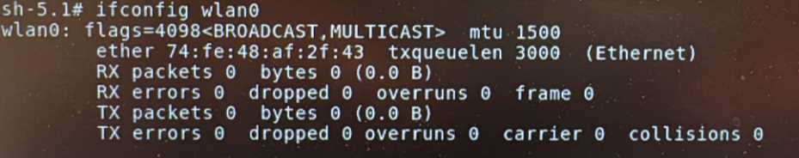
# iw wlan0 scan
You will get scan result in the screen.

Appendix:
wpa_supplicant test
2G wpa_supplicant config sample
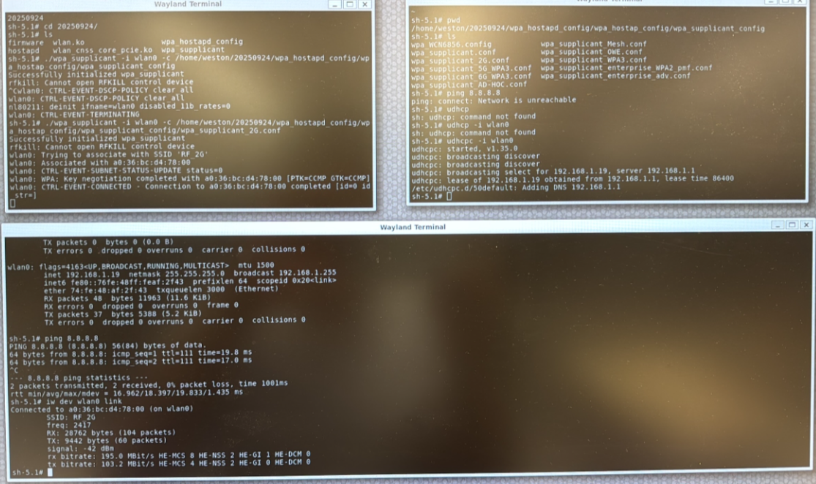
5G wpa_supplicant config sample
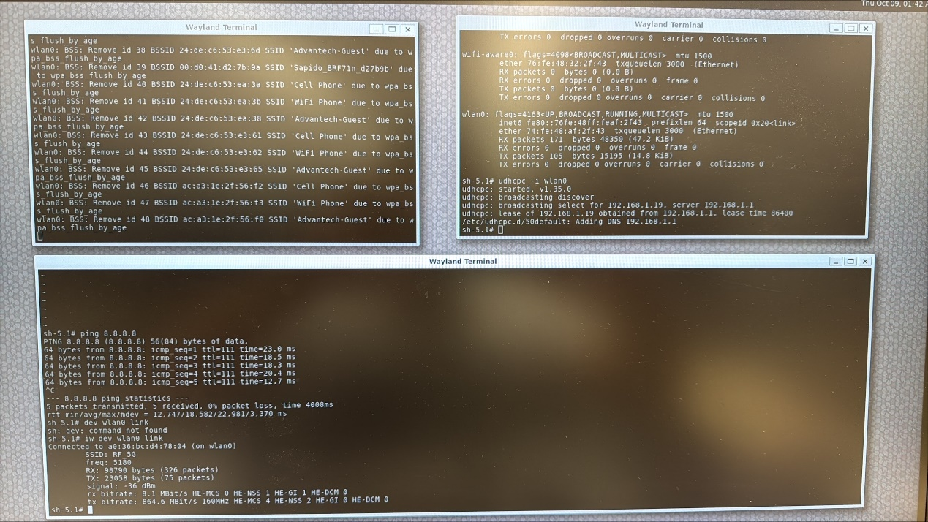
6G wpa_supplicant config sample
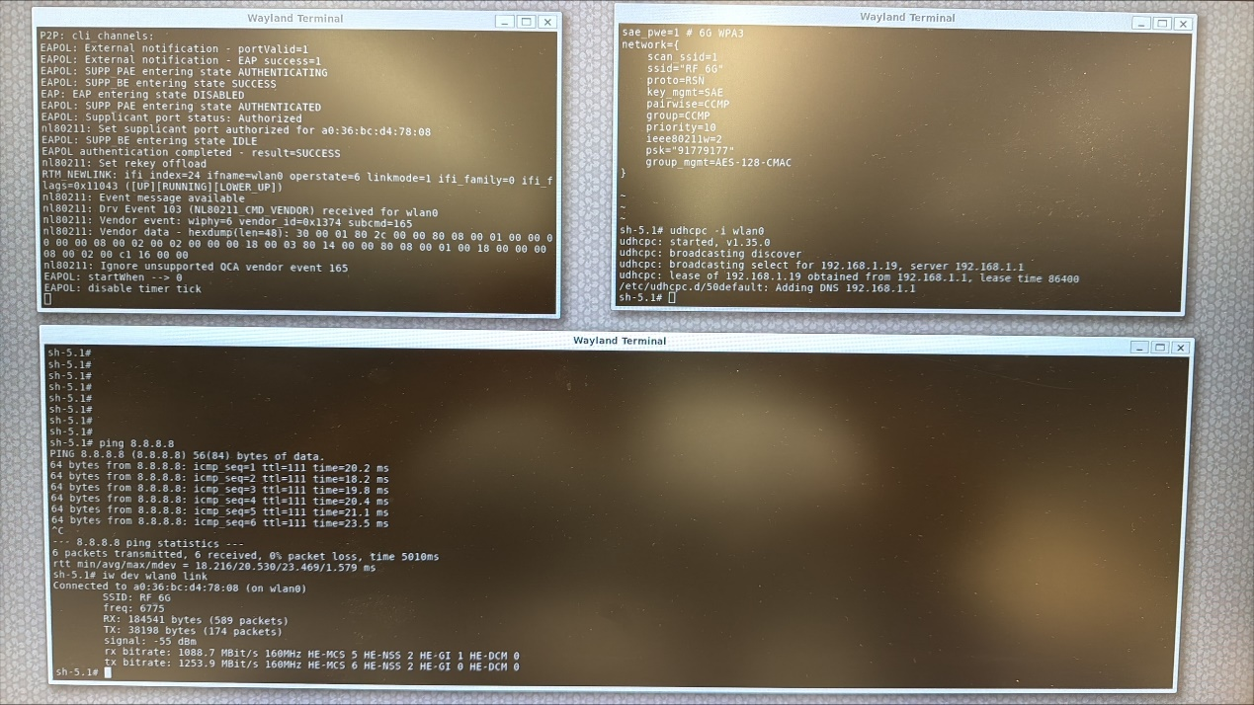
Hostapd and iperf test
2G config
2G hostapd uplink
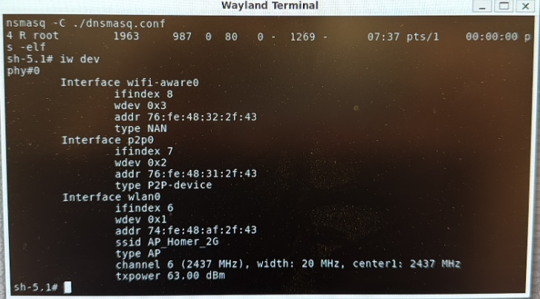
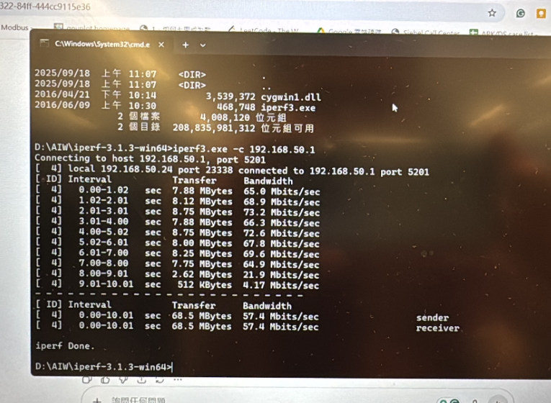
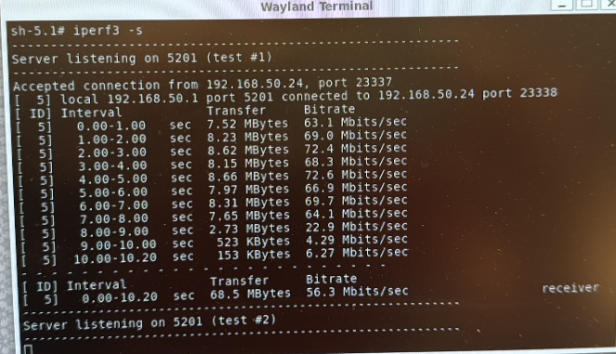
2G hostapd downlink
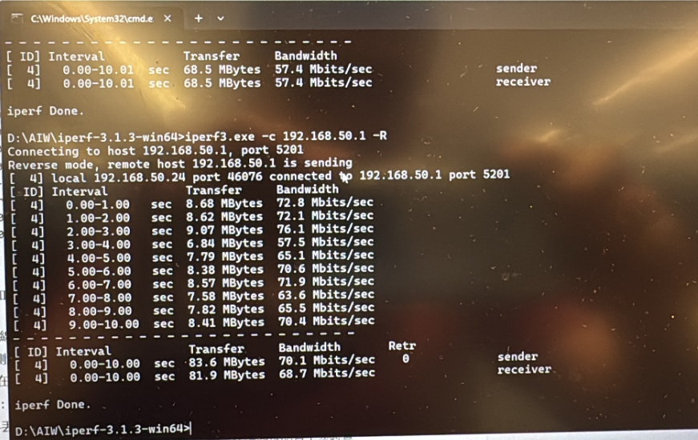
5G
5G config
5G hostapd uplink
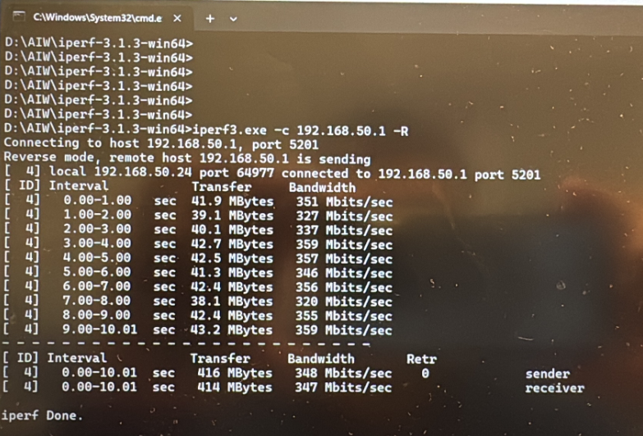
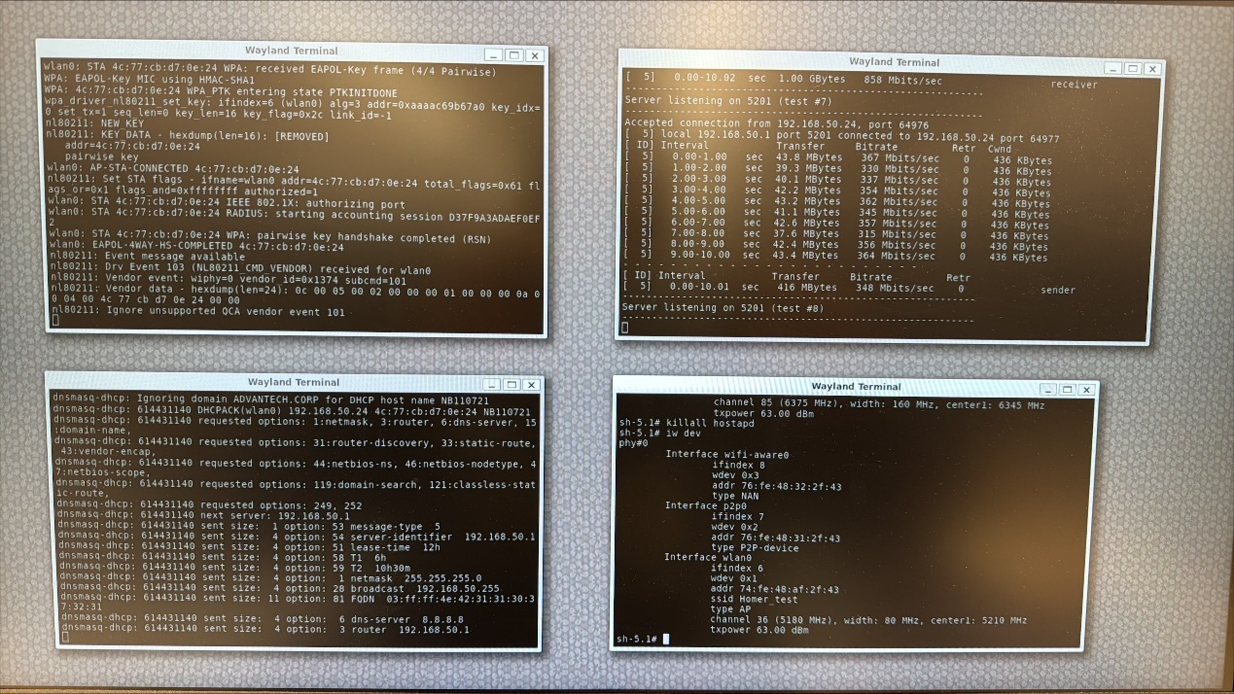
5G hostapd downlink
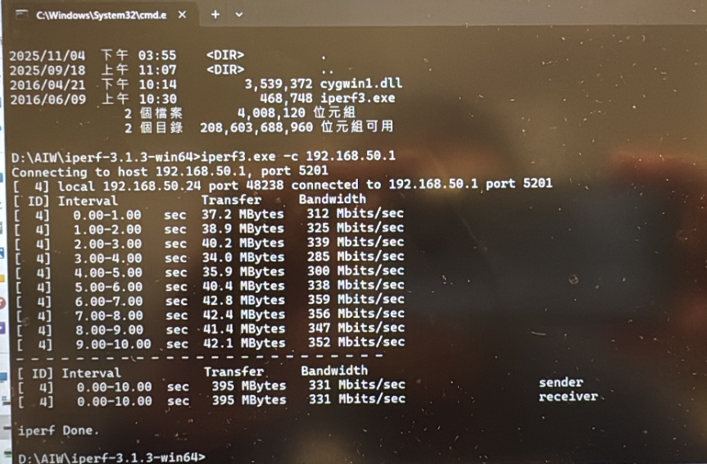
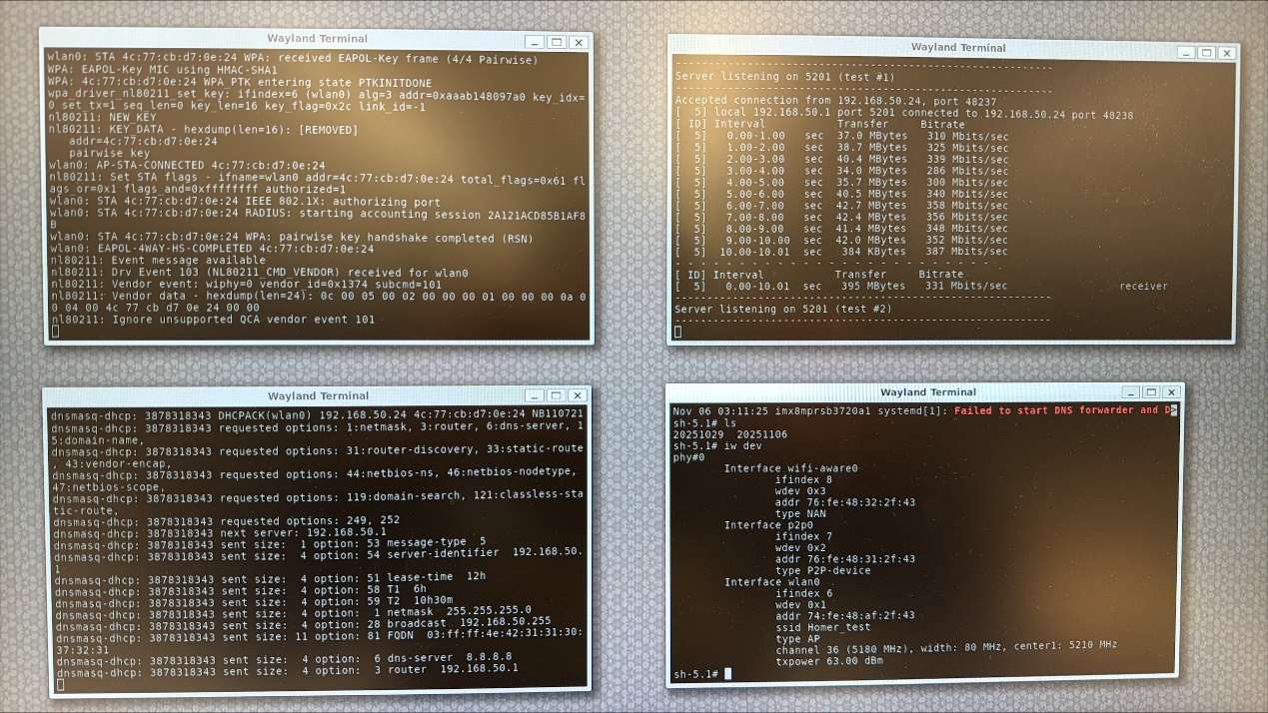
6G
6G hostapd uplink
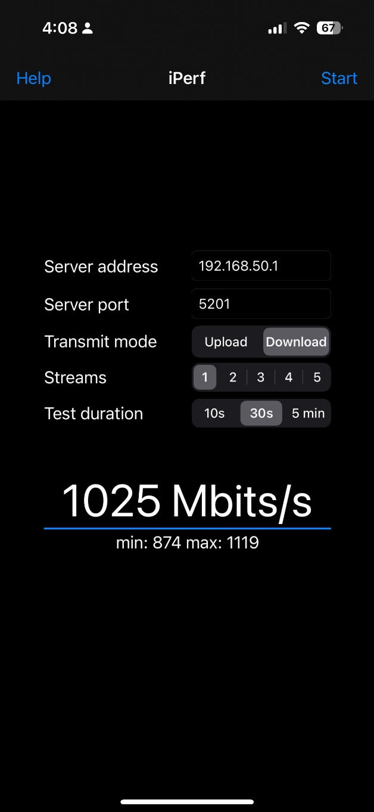
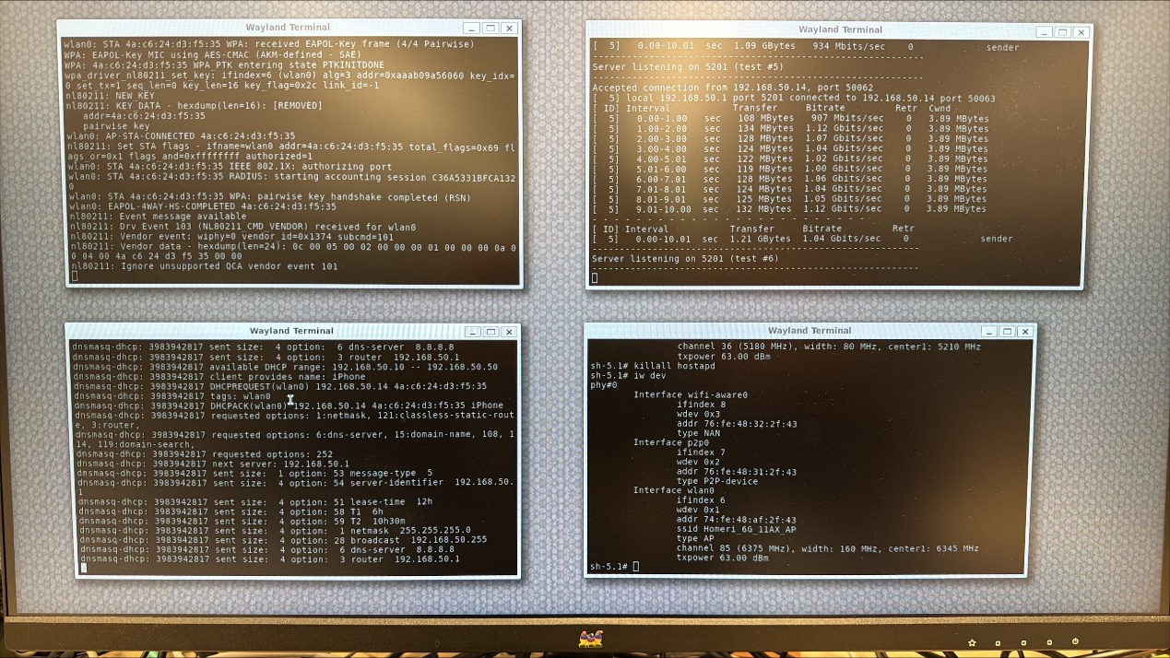
6G Downlink
