AIW FAQ
How to bring up AIW-173 Wifi feature with AFE-R750/AIR-030
Category | AIW | Date | 2025/11/11
Keyword | AIW-173(WiFi 7),AIR-030(Nvidia Jetson Orin+JetPack 6.0 R36.3(Ubuntu OS 22.04.4 LTS) with linux kernel 5.15.136-tegra),AFE-R750(NvidiaJetson Orin+JetPack 6.1 R36.4(Ubuntu 22.04) with linux kernel 5.15.148)
Catergory:
1. Check Device 2
2. Build Environment on Host 2
3. Getting Linux Code and Setting Environment 3
4. Build Kernel Image 4
5. Build WLAN Driver 5
6. Flash Image 6
7. Build hostapd and wpa_supplicant 8
8. Install Driver 9
9. Check Device After installed driver 10

Check Device
Before driver installed, you will see the device as below by “lspci”.

$ lspci
01:00.0 Network controller: Qualcomm Technologies, Inc WCN785x Wi-Fi 7(802.11be) 320MHz 2x2 [FastConnect 7800] (rev 01)

Build Environment on Host
[AIR-030]
https://ess-wiki.advantech.com.tw/view/AIR-030
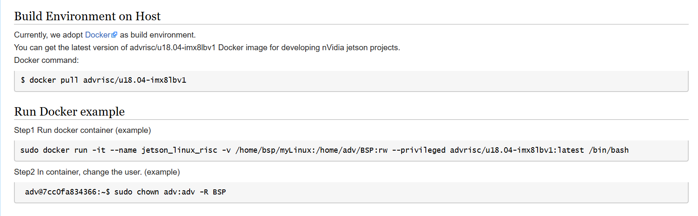
[AFE-R750]
Currently, we adopt Docker as build environment.
You can get the latest version of advrisc/u20.04-nvlbv2:20240515 Docker image for developing nVidia jetson projects.
Docker command:
$ sudo docker pull advrisc/u20.04-nvlbv2:20240515

Run Docker example
Step1 Run docker container (example)
$ sudo docker run -it --name jetson_linux_risc -v /home/bsp/myLinux:/home/adv/BSP:rw --privileged advrisc/u20.04-nvlbv2:20240515 /bin/bash

Step2 In container, change the user. (example)
$ sudo chown adv:adv -R BSP

Getting Linux Code and Setting Environment
[AIR-030]
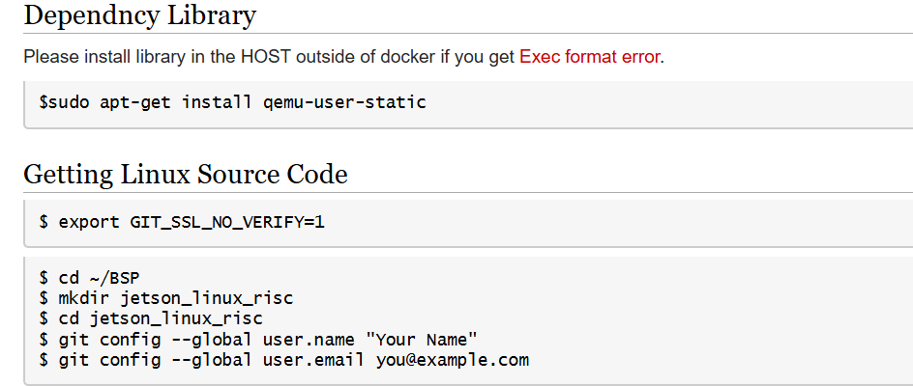
$ repo init -u https://AIM-Linux@dev.azure.com/AIM-Linux/risc_nvidia_jetson_36.3/_git/manifest -m air030.xml
$ repo sync
$ cd /home/adv/BSP/jetson_linux_risc/kernel
- Add AIW-173’s kernel patch to original kernel source
**Note**
this specific patch file was detached from AFE-R750’s kernel source by using following command (git format-patch -100)
- Input “sudo patch -p1 --dry-run < /path/to/your/patchfile.patch” to cross check if all of code modification can be applied successfully
<Example>:
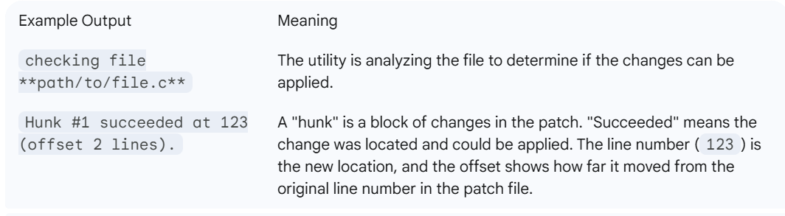
- It might encounter some failed during file patching, please fix it one by one and ensure each modification is success
<Example>:
checking file kernel/kernel-jammy-src/net/wireless/sme.c
checking file kernel/kernel-jammy-src/net/wireless/trace.h
checking file kernel/kernel-jammy-src/net/wireless/util.c
checking file kernel/kernel-jammy-src/net/wireless/wext-compat.c
checking file kernel/kernel-jammy-src/net/wireless/wext-sme.c
checking file nvidia-oot/drivers/net/wireless/realtek/rtl8822ce/os_dep/linux/ioctl_cfg80211.c
Hunk #9 FAILED at 5634.
Hunk #10 FAILED at 7015.
Hunk #11 succeeded at 11124 (offset -3 lines).
2 out of 11 hunks FAILED
- After correcting some failed items during patch process, please input “sudo patch -p1 -b < /path/to/your/patchfile.patch” to apply whole files
[AFE-R750]
$ sudo apt-get install qemu-user-static
$ cd ~/BSP
$ mkdir jetson_linux_risc
$ cd jetson_linux_risc
$ git config --global user.name "Your Name"
$ git config --global user.email "Your@example.com"

$ repo init -u https://AIM-Linux@dev.azure.com/AIM-Linux/risc_nvidia_jetson_36.4/_git/manifests -m afer750.xml
$ repo sync

$ /home/adv/BSP/jetson_linux_risc/kernel
$ git checkout origin/afer750-aiw173

Build Kernel Image
Prebuild Image including wpa_supplicant & hostapd tool:
AIR-030_Jetpack_6.0_AIW-173customized_20251106.tar.gz

[AIR-030]
$ cd /home/adv/BSP/jetson_linux_risc
$ sudo ./scripts/build_release.sh -v <VERSION>
[AFE-R750]
$ cd /home/adv/BSP/jetson_linux_risc
$ sudo ./scripts/build_release.sh

Build WLAN Driver
- Download the driver source code from git server
[AIR-030]
AIW_173_driver.tar.gz
$ cd /
$ sudo git clone -b nvidia_jp_6_1 ssh://adv_ae@172.22.24.155:/volume1/git-server/AIW_173_driver
NOTE: the password for adv_ae is “123456”
[AFE-R750]
AIW_173_driver_AFE-R750.tar.gz
$ cd /
$ sudo git clone ssh://adv_ae@172.22.24.155:/volume1/git-server/AIW_173_driver_AFE-R750
NOTE: the password for adv_ae is “123456”

- Copy header files to kernel
AIR-030’s folder name is “AIW_173_driver”
AFE-R750’s folder name is “AIW_173_driver_AFE-R750”
$ cd /AIW_173_driver_XXX /AIO/build
$ sudo cp -r ../drivers/core_tech_modules/include/linux/mhi.h <kernel_path>/include/linux/
$ sudo cp -r ../drivers/core_tech_modules/include/trace/events/qrtr.h <kernel_path>/include/trace/events/
$ sudo cp -r ../drivers/core_tech_modules/inc/cnss2.h <kernel_path>/include/net/
$ sudo cp -r ../drivers/core_tech_modules/inc/cnss_nl.h <kernel_path>/include/net/
$ sudo cp -r ../drivers/core_tech_modules/inc/cnss_utils.h <kernel_path>/include/net/
$ sudo cp -r ../drivers/core_tech_modules/inc/cnss_prealloc.h <kernel_path>/include/net/
For example, <kernel-path>: /home/adv/BSP/jetson_linux_risc/kernel/kernel_out/kernel/kernel-jammy-src

- Build driver
$ cd /AIW_173_driver_XXX /AIO/build
$ sudo make KERNELARCH=arm64 ARCH=arm64 KERNELPATH=/home/adv/BSP/jetson_linux_risc/kernel/kernel_out/kernel/kernel-jammy-src/ KERNEL_SRC=/home/adv/BSP/jetson_linux_risc/kernel/kernel_out/kernel/kernel-jammy-src/ CROSS_COMPILE=/opt/aarch64--glibc--stable-2022.08-1/bin/aarch64-buildroot-linux-gnu- CONFIG_FULL_CORE_BUILD=y CONFIG_PERF_BUILD=y drivers

- Get wlan_cnss_core_pcie.ko, wlan.ko from specific folder ( /AIW_173_driver_XXX /AIO/rootfs-tr-f10.build /lib/modules)

Flash Image
[AIR-030]
- Enter to recovery mode on AIR-030
Switch the RESET_RECOVERY_1 SW-2 to ON and press the power button, the AIR-030 will boot into recovery mode
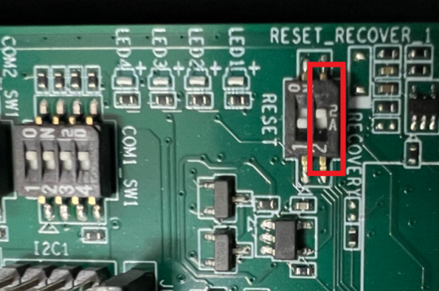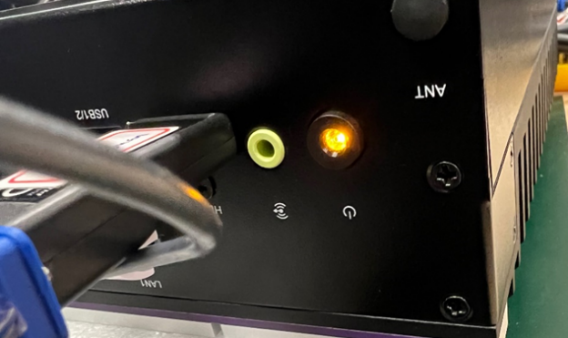
- Depressed your Image files from Docker
$ sudo tar -zxvf air030_image_*.tar.gz
$ cd Linux_for_Tegra
- Flash emmc/nvme
#emmc
$ sudo ./flash.sh jetson-agx-orin-devkit mmcblk0p1
#nvme
$ sudo ./tools/kernel_flash/l4t_initrd_flash.sh --external-device nvme0n1p1 -p "-c ./bootloader/generic/cfg/flash_t234_qspi.xml" -c ./tools/kernel_flash/flash_l4t_t234_nvme.xml --showlogs --network usb0 jetson-agx-orin-devkit nvme0n1p1
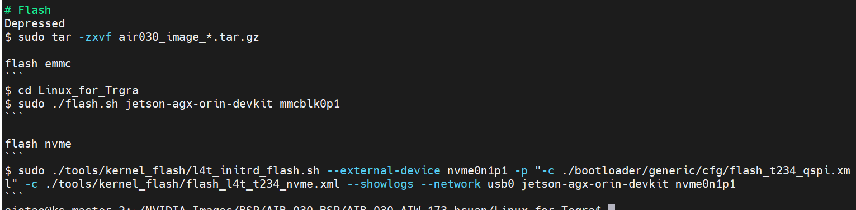
[AFE-R750]
- HW setting recover mode
Change the recover mode "2" to ON and press power button.
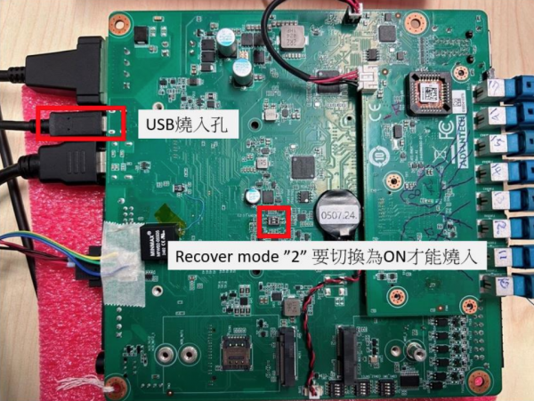
Connect a linux OS host wired AFE-R750 with Flash USB cable.
In the Host PC, make sure the AFE-R750 (NVidia Corp) has detectd.
[ubuntu@linux 11:55:43 ~]$ lsusb
Bus 001 Device 024: ID 0955:7223 NVidia Corp.
2.Extracted tarball file
$ sudo tar -zxvf afer750_image_XXXXXX.tar.gz
$ cd Linux_for_Tegra
3.Flash image to eMMC (AGX ORIN MODULE)
$ sudo ./flash.sh jetson-agx-orin-devkit mmcblk0p1

Build hostapd and wpa_supplicant
(Local Device build only)
- Install related tool packages:
$ sudo apt install libssl-dev libdbus-1-dev flex bison libnl-3-dev libnl-genl-3-dev libnl-route-3-dev
- Copy whole AIW_173_Driver package from Docker to your local device
- Build hostapd
$ cd /home/adv/BSP/AIW_173_driver_XXX /AIO/apps/hostap/hostapd
$ sudo make clean
$ sudo cp defconfig .config
$ make KERNELARCH=arm64 ARCH=arm64

- Build wpa_supplicant
$ cd /home/adv/BSP/AIW_173_driver_XXX/AIO/apps/hostap/wpa_supplicant
$ sudo make clean
$ sudo cp defconfig .config
$ make KERNELARCH=arm64 ARCH=arm64
- Rename original “wpa_supplicant” tool and replace your rebuild version under specific path (/sbin)
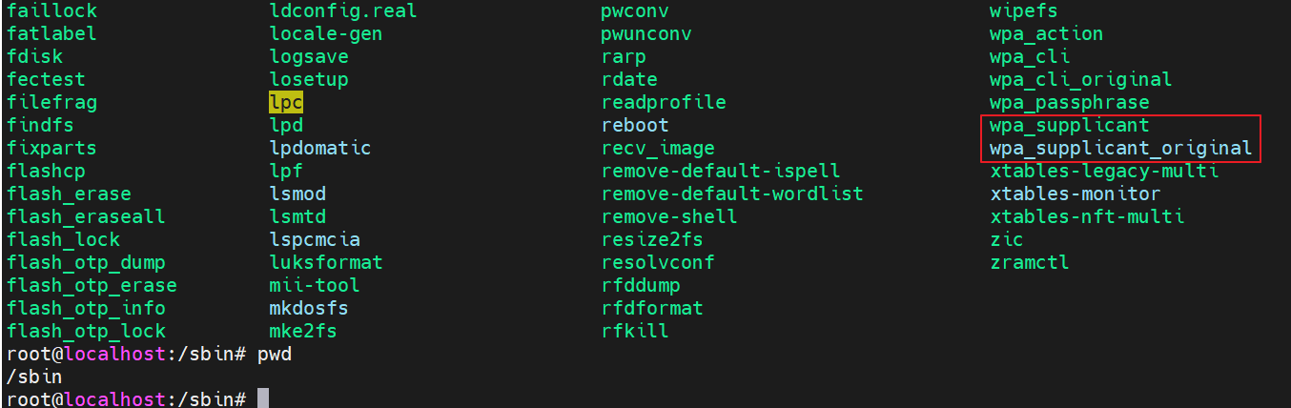
- Confirm “wpa_supplicant” version if is 2.11 version and reboot your system

Install Driver
Copy firmware files to device:
$sudo cp -rf /AIW-173_driver_XXX /AIO/rootfs-tr-f10.build/lib/firmware/WLAN-firmware/* /lib/firmware/
$sudo cp -f /AIW-173_driver_XXX /AIO/ rootfs-tr-f10.build/lib /firmware/BT_firmware/usb/* /lib/firmware/qca
Insmod driver:
$ sudo modprobe cfg80211
$ sudo insmod <path to .ko>/wlan_cnss_core_pcie.ko
$ sudo insmod <path to .ko>/wlan.ko country_code=US

Check Device After installed driver
# ifconfig -a
# ifconfig wlan0 up
The result should like below:
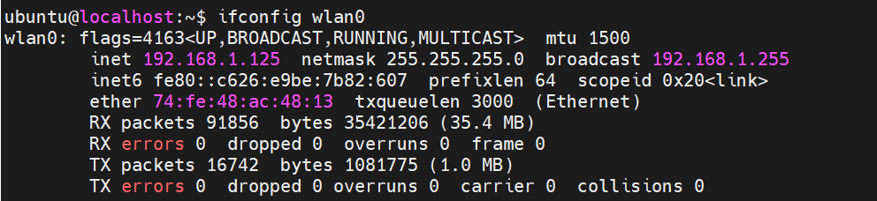
# iw wlan0 scan
You will get scan result in the screen.

<Appendix>
Step 1
Establish 6Ghz STA mode by wpa_supplicant utility without using NetworkManager
- sudo lsmod | grep wlan
- sudo iw list | grep -A20 Frequencies
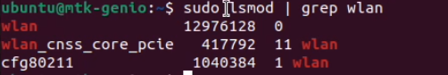
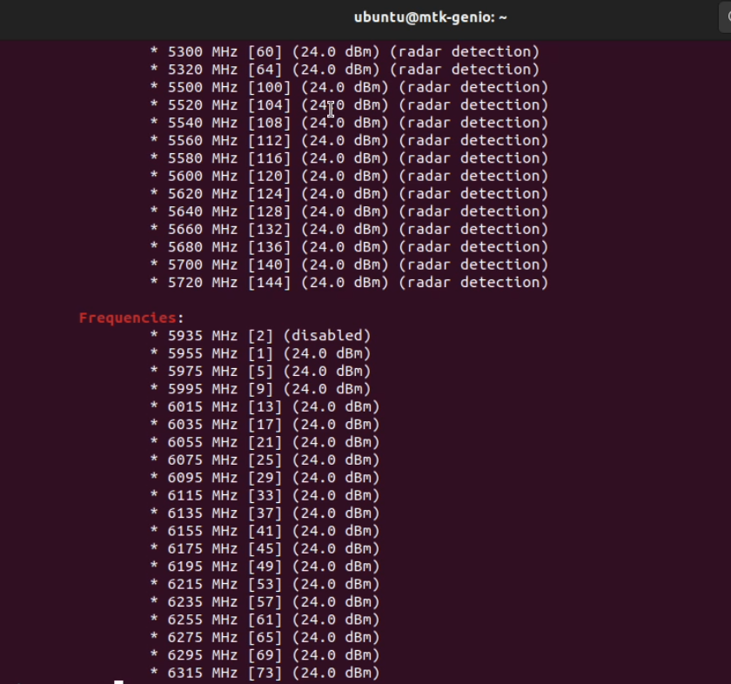

Step 2
Confirm your wifi interface name by specific command
- sudo iw dev
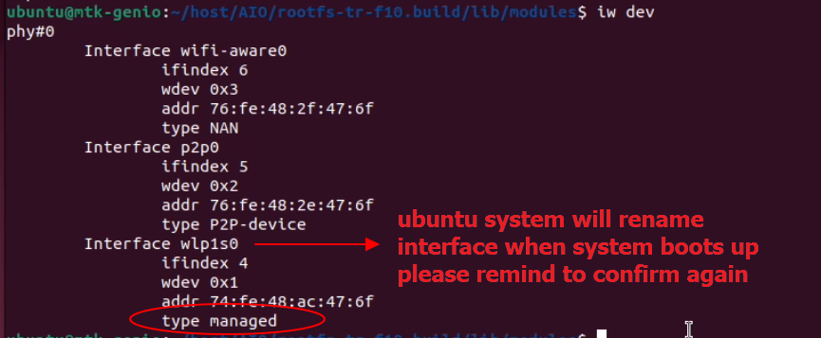
Step 3
Before running wpa_supplicant, please stop following system network service to avoid service conflict
• Stop NetworkManager service
- sudo systemctl stop NetworkManager.service
• Stop wpa_supplicant service
- sudo systemctl stop wpa_supplicant.service
Step 4
Copy WPA3 config file into your system and rewrite ssid/psk which you would like to connect WiFi AP’s SSID& Password
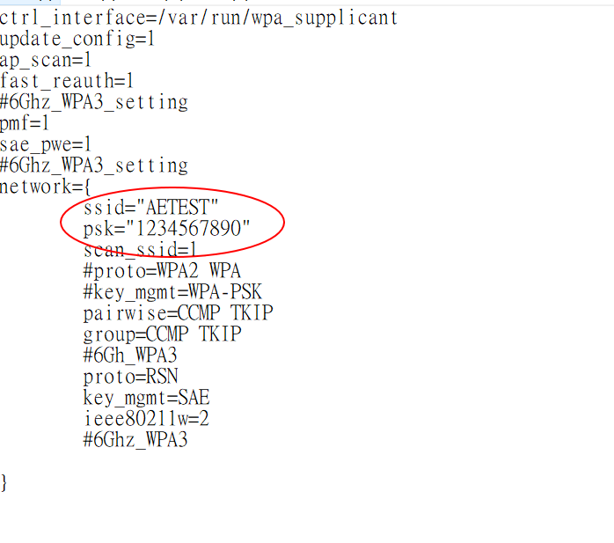
Step 5
clean remaining service before executing wpa_supplicant
- sudo killall wpa_supplicant
Step 6
Enter following command to run wpa_supplicant with your configuration file
- sudo ./wpa_supplicant -d -Dnl80211 -i wlp1s0 -c wpaXXX.conf &
Note: add “&” symbol in the end of command which will execute in background system.
For debugging, please remove it for further log tracking
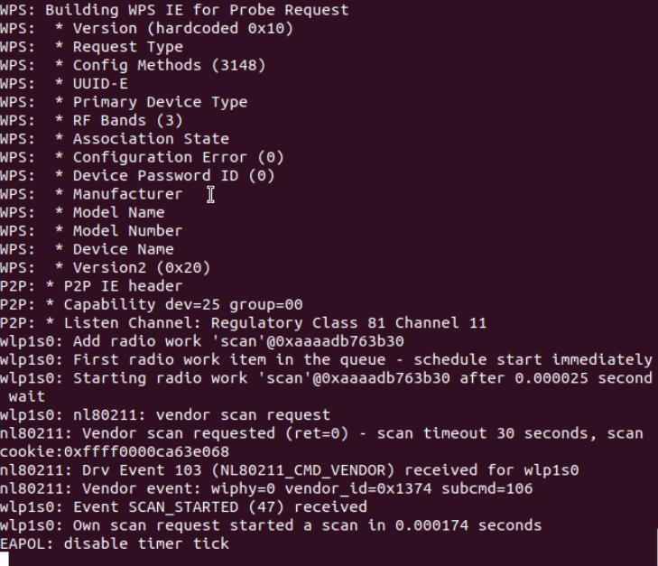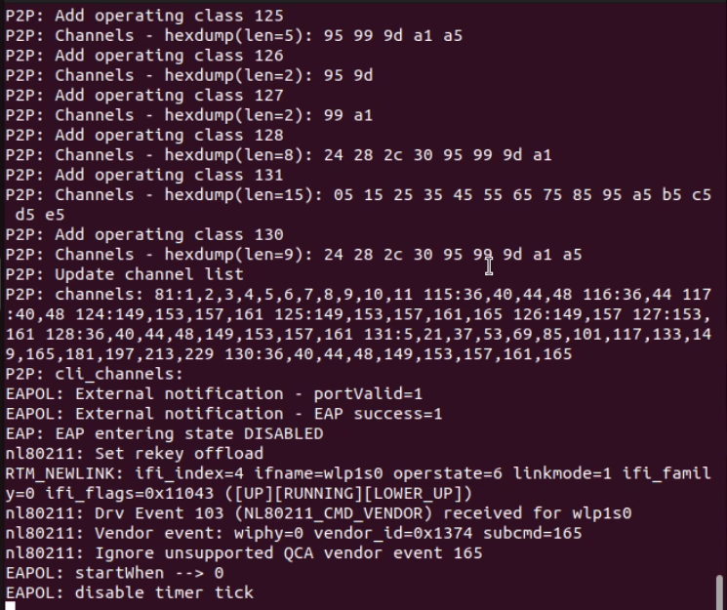
Step 7
Request DHCP assignment to WiFI AP and confirm if ip has assigned successfully
- sudo dhclient wlp1s0
- sudo ifconfig wlp1s0
Note: please open another terminal to assign DHCP if wpa_supplicant is not running in background
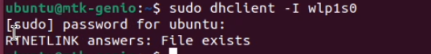
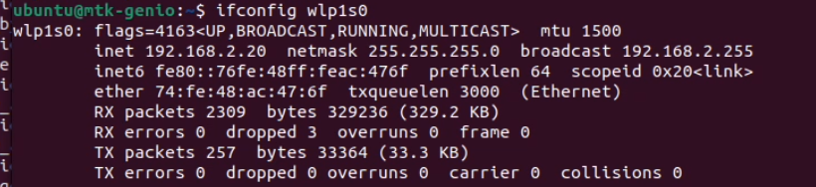
Step 9
Confirm the connection is established & do ping testing
- sudo iw dev wlp1s0 link
- ping 192.168.2.21 -I wlp1s0
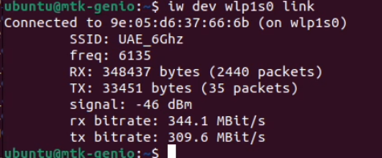
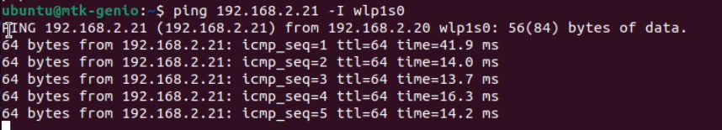
Step 10
We also verify 5Ghz connection with WPA3 encryption and it also work fine

