AIW FAQ
How to bring up AIW-173 BlueTooth feature with RSB-3720
Category | AIW | Date | 2025/12/9
Keyword | AIW-173(WiFi 7),RSB-3720(Yocto 5.2 LTS) with linux kernel 6.6.23)
Catergory:
1. Check Device 2
2. Build Environment on Host 2
3. Getting Linux Code and Setting Environment 2
4. Build Kernel Image and build Tool-Chain 5
5. Flash Image 10
6. Install Driver 11
Appendix: File transfer via BT 12

Check Device
Before driver installed, you will see the device as below by “lspci”.

$ lspci
01:00.0 Network controller: Qualcomm Technologies, Inc WCN785x Wi-Fi 7(802.11be) 320MHz 2x2 [FastConnect 7800] (rev 01)

Build Environment on Host
[RSB-3720]
https://ess-wiki.advantech.com.tw/view/IoTGateway/BSP/Linux/iMX8/Yocto_LBVF_User_Guide
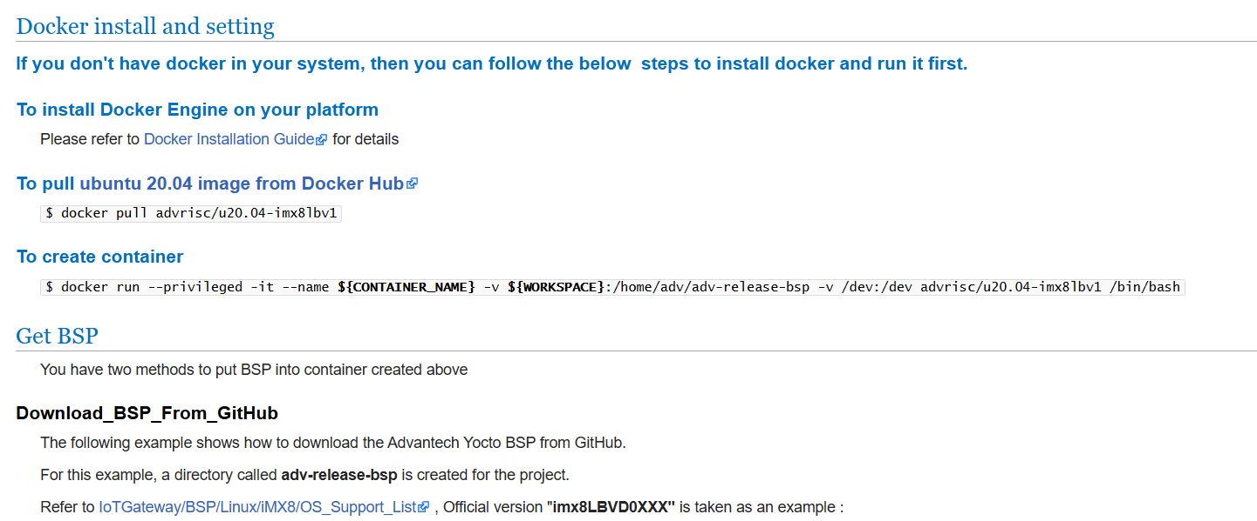

Getting Linux Code and Setting Environment
[RSB-3720]
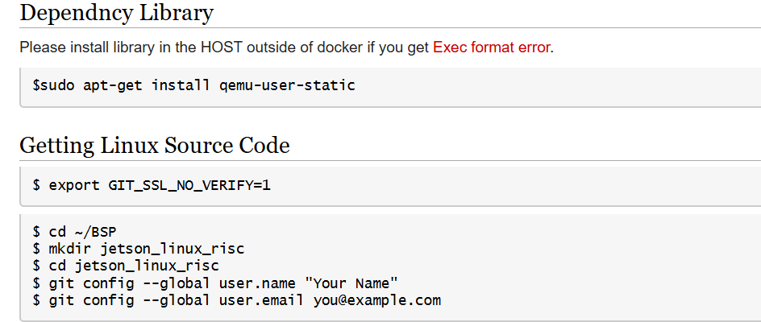
$ repo init -u git://github.com/ADVANTECH-Corp/adv-arm-yocto-bsp.git -b imx-linux-kirkstone -m imx8LBVF0071.xml
$ repo sync
$ MACHINE=imx8mprsb3720a2 UBOOT_CONFIG=6G DISTRO=fsl-imx-xwayland source imx-setup-release.sh -b build_x11
$ bitbake virtual/kernel

$ mkdir -p ~/adv-release-bsp/sources/meta-advantech/meta-fsl-imx/recipes-kernel/linux/files
Move below file in the “/adv-release-bsp/sources/meta-advantech/meta-fsl-imx/recipes-kernel/linux/files”

$ mkdir -p ~/adv-release-bsp/sources/meta-advantech/meta-fsl-imx/recipes-kernel/linux/linux-imx/
Move below file in the “~/adv-release-bsp/sources/meta-advantech/meta-fsl-imx/recipes-kernel/linux/linux-imx/”
$ mv fragment.cfg ~/adv-release-bsp/sources/meta-advantech/meta-fsl-imx/recipes-kernel/linux/linux-imx/

$ nano ~/adv-release-bsp/sources/meta-advantech/meta-fsl-imx/recipes-kernel/linux/linux-imx_6.6.bbappend
Add content below at the end of this file.
FILESEXTRAPATHS:prepend := "${THISDIR}/files:"
SRC_URI += "file://0001-kernel-mods-for-6.6.23.patch"
KCONFIG_MODE = "merge"
SRC_URI += "file://fragment.cfg"
do_configure:append () {
cat ${WORKDIR}/*.cfg >> ${B}/.config
}
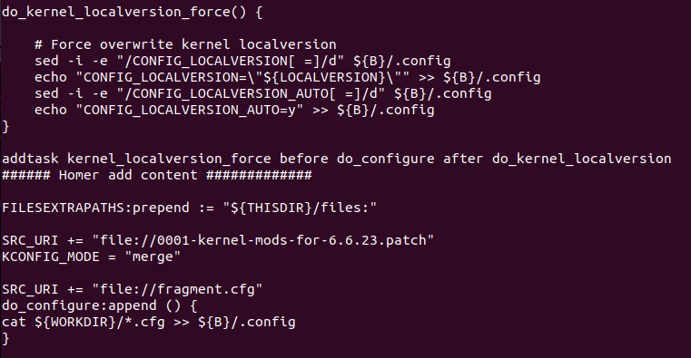

For enable Bluetooth test, you will need add below tool in the local config
$ cd /home/adv/adv-release-bsp/build_x11/conf
$ vi local.conf
Add below content at the end of “local.conf”
DISTRO_FEATURES:append = “ bluetooth”
IMAGE_INSTALL:append = ” bluez5 bluez5-noinst-tools bluez5-obex dbus-wait”
PACKAGECONFIG:append:pn-bluez5 = “ obex-profiles”
# Enable UTF-8 locale support
IMAGE_LINGUAS = " en-us zh-tw"
GLIBC_GENERATE_LOCALES = " en_US.UTF-8 zh_TW.UTF-8"

IMAGE_INSTALL:append = " \
glibc-utils \
locale-base-en-us \
locale-base-zh-tw \
glibc-gconvs \
glibc-gconv-utf-16 \
"
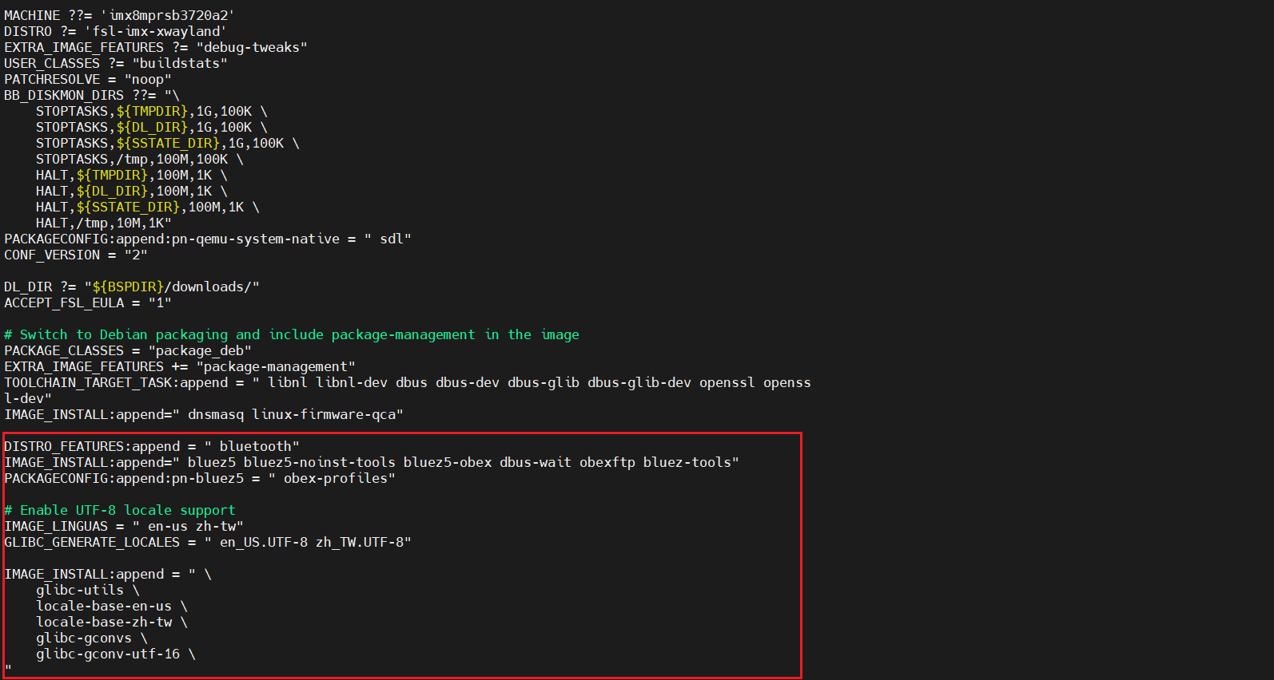
Rebuild kernel
$ bitbake -c cleansstate virtual/kernel
$ bitbake virtual/kernel

Build Kernel Image and build Tool-Chain
[RSB-3720]

$ vi /home/adv/adv-release-bsp/sources/meta-imx/meta-imx-ml/recipes-nnstreamer/nnshark/nnshark_2023.11.imx.bb
Modify
NNSHARK_SRC ?= "gitsm://github.com/nxp-imx/nnshark.git;protocol=https"
to
NNSHARK_SRC ?= "git://github.com/nxp-imx/nnshark.git;protocol=https"

add below content in the nnshardk_2023.11.imx.bb
do_configure[network]="1"
do_configure:prepend() {
cd ${S}
echo ">>> Fixing GStreamer common submodule URL"
if grep -q "anongit.freedesktop.org" .gitmodules; then
sed -i 's#git://anongit.freedesktop.org/gstreamer/common#https://gitlab.freedesktop.org/gstreamer/common.git#g' .gitmodules || true
fi
git submodule sync --recursive || true
git submodule update --init --recursive || true
echo ">>> Submodule fix done."
}
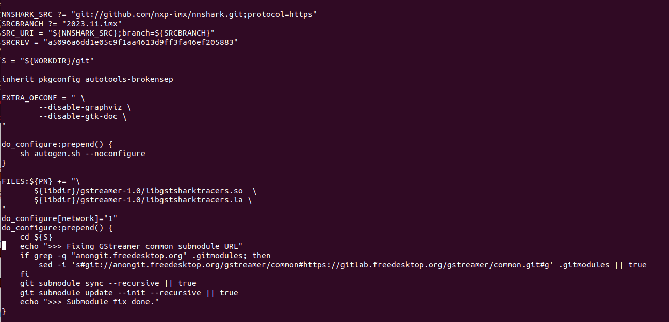

$ vi ~/adv-release-bsp/sources/meta-imx/meta-imx-ml/recipes-libraries/onnxruntime/onnxruntime_1.17.1.bb
Add below function as below
DEPENDS = "libpng zlibi libeigen"

EXTRA_OECMAKE += "\
-DFETCHCONTENT_FULLY_DISCONNECTED=OFF \
-DCMAKE_BUILD_TYPE=RelWithDebInfo \
-Donnxruntime_BUILD_UNIT_TESTS=ON \
-Donnxruntime_USE_PREINSTALLED_EIGEN=ON\
-Deigen_SOURCE_PATH=${STAGING_INCDIR}/eigen3\

"

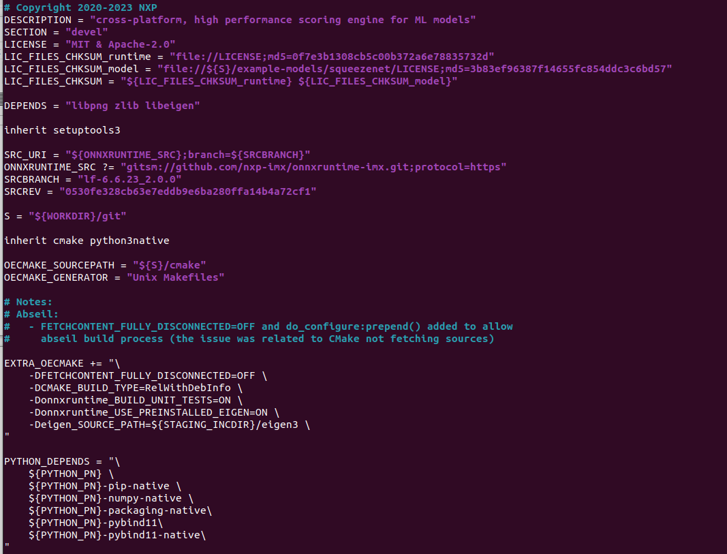
$ cd ~/adv-release-bsp/build_x11
$ bitbake imx-image-full
The full image will in the “./tmp/deploy/img”

Flash Image
[RSB-3720]
Flash image to SD card
OS image path “/home/adv/adv-release-bsp/build_x11/tmp/deploy/images/imx8mprsb3720a2”
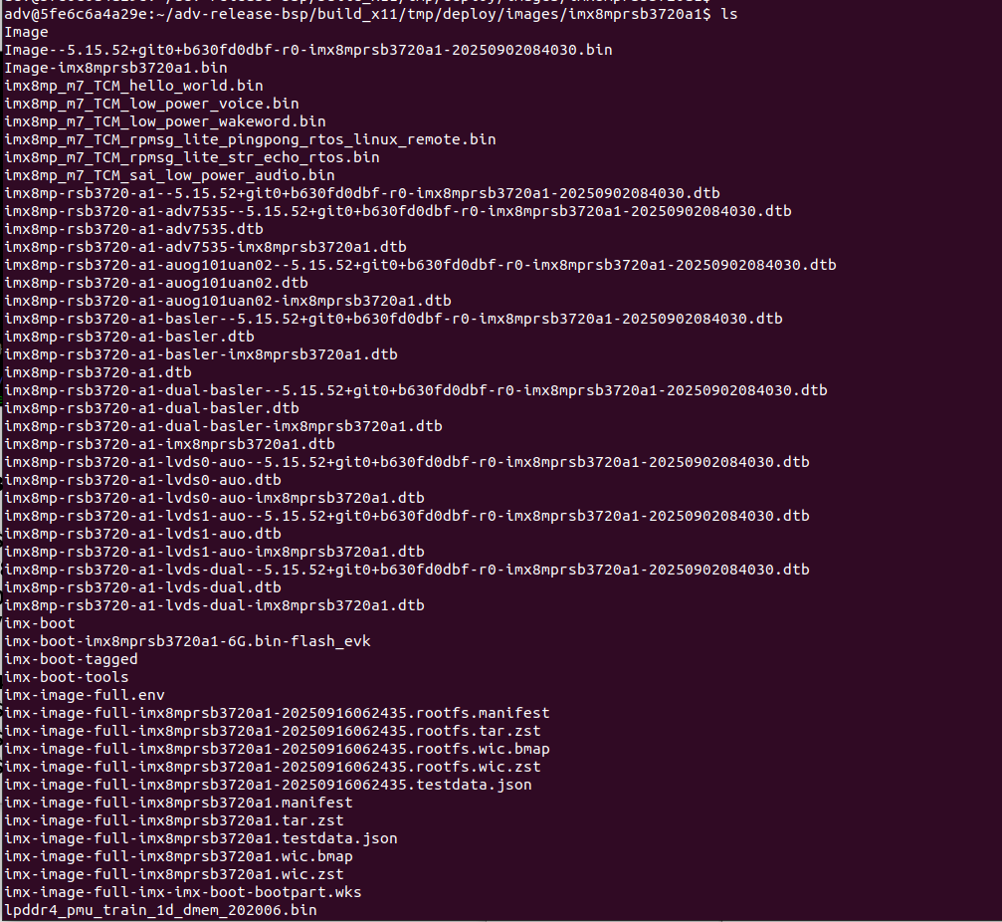

.wic.zst if full OS image
You need copy it to your system.
$ maker p ~/adv-release-bsp/Temp/SD_img
$ cp imx-image-full-imx8mprsb3720a2-20251209023921.rootfs.wic.zst ~/adv-release-bsp/Temp/SD_img

Change to your real system(Not in the docker)
- $ cd ~/Downloads/adv-release-bsp/Temp/SD_img
- $ zstd -d imx-image-full-imx8mprsb3720a1-xxxx.rootfs.wic.zst (Example: imx-image-full-imx8mprsb3720a2-20251209023921.rootfs.wic.zst)
- $ sudo dd if=imx-image-full-imx8mprsb3720a1-xxxx.rootfs.wic of=/dev/sdb bs=4M status=progress conv=fsync

Install Driver and firmware
Download the driver source code from git server
[RSB-3720]
AIW_173_driver.tar.gz
$ cd /
$ sudo git clone ssh://adv_ae@172.22.24.155:/volume1/git-server/AIW_173_driver
$ sudo mv /AIW_173_driver /173
$ cd /173/
NOTE: the password for adv_ae is “123456”

Copy firmware files to device:
$ sudo cp /173/AIO/build/bt_firmware/usb/* /lib/firmware/qca/

Appendix: File transfer via BT
RSB-3720(Yocto 5.0) transfer file to laptop(Windows)
$ /usr/libexec/bluetooth/obexd -r /tmp -a -n -d&
$ bluetoothctl
[bluetooth]# power on
[bluetooth]# agent on
[bluetooth]# discoverable on
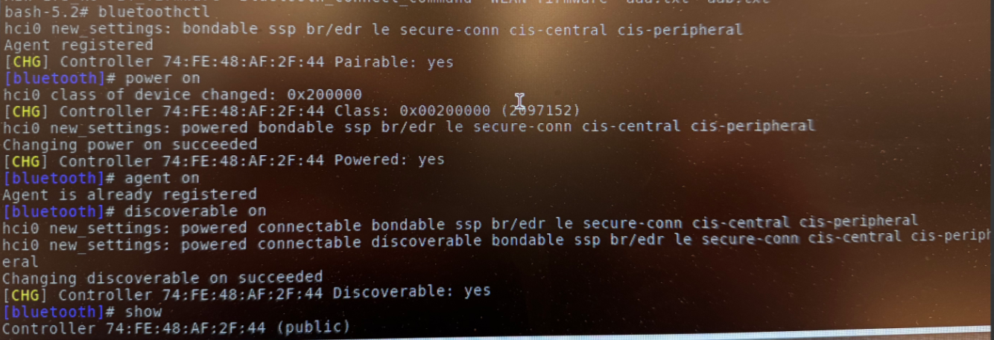 [bluetooth]# scan on

check your bluetooth mac in the list
[bluetooth]# pair {your bluetooth mac}
[bluetooth]# scan off
[bluetooth]# exit

In the Windows side open receive file via bluetooth
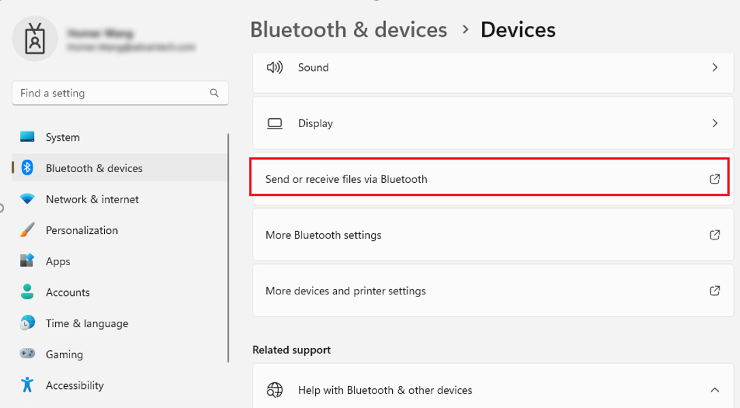

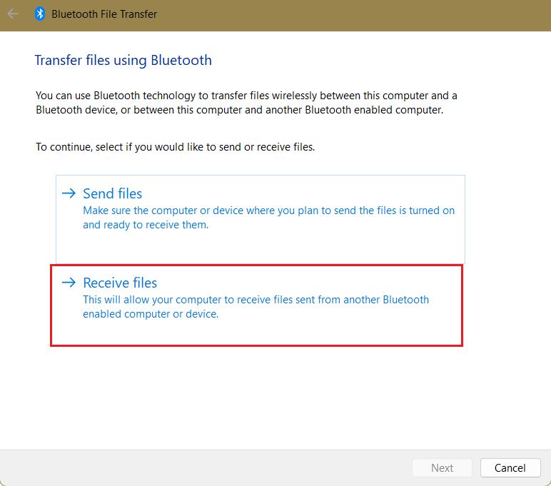

When your windows system shows
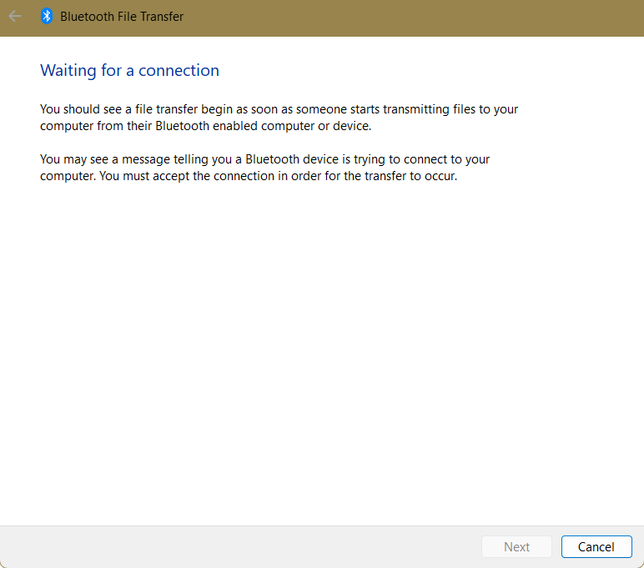
Go back to RSB-3720 and issue below command
$ obexctl
[obex]# connect {your bluetooth mac}
[obex]# send {file name}
In the windows system, you will see the progress bar shows as below
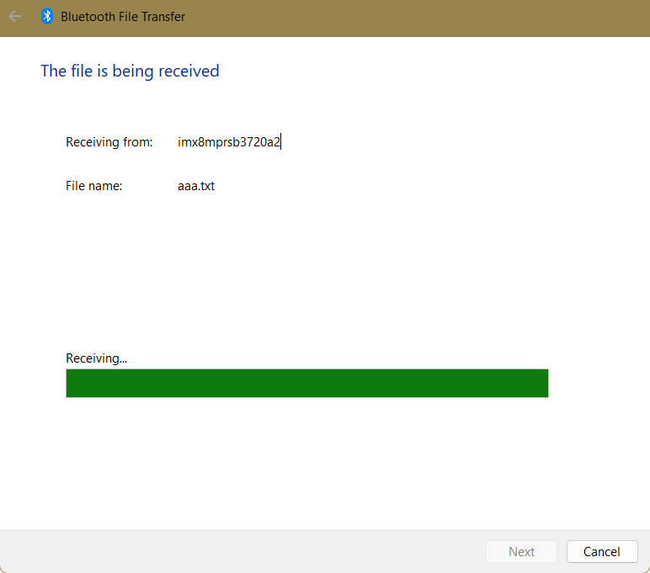
[obex]# disconnect

In the windows system, you need select store path
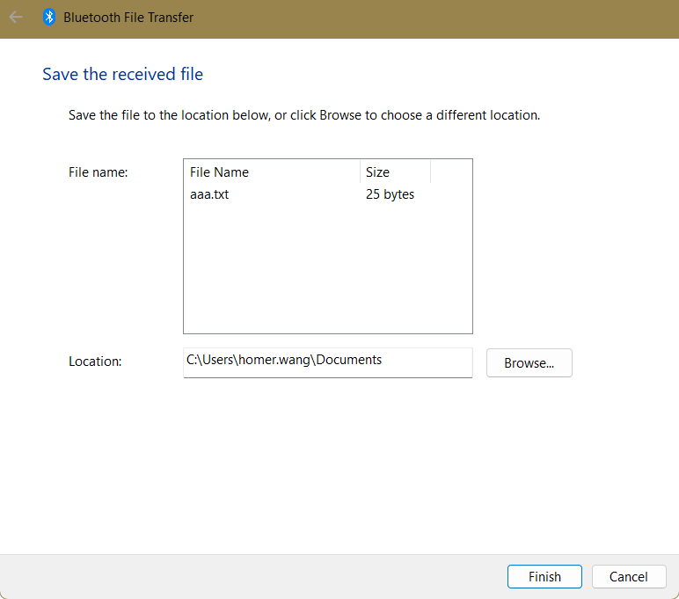
You will see the file in the windows Documents folder
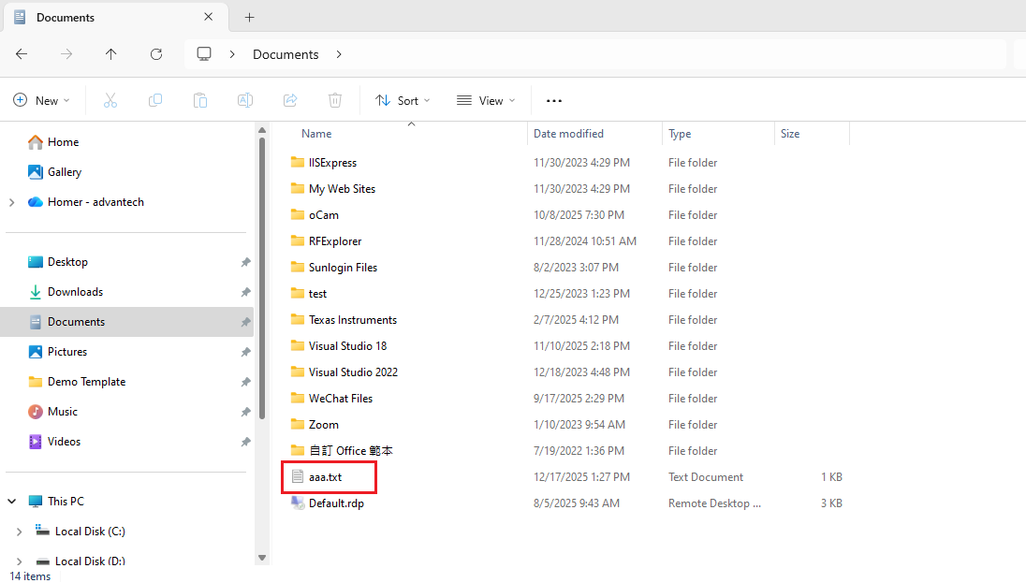

laptop(Windows) transfer file to RSB-3720(Yocto 5.0).
In the RSB-3720, you need issue below command at beginning.
$ /usr/libexec/bluetooth/obexd -r /tmp -a -n -d&
$ bluetoothctl
[bluetooth]# power on
[bluetooth]# agent on
[bluetooth]# discoverable on
[bluetooth]# scan on
check your bluetooth mac in the list or use #devices to check the devices mac
[bluetooth]# pair {your bluetooth mac}
[bluetooth]# scan off
[bluetooth]# exit

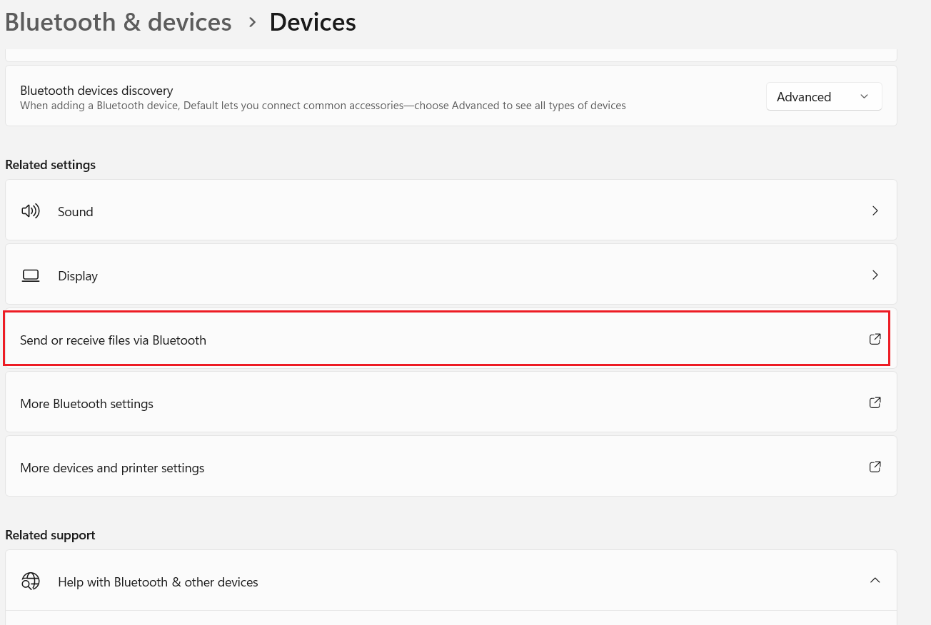

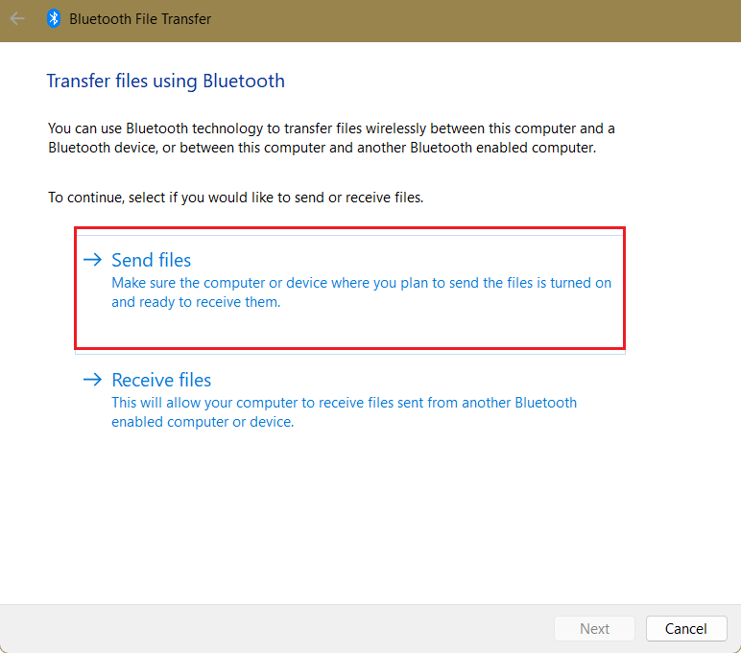

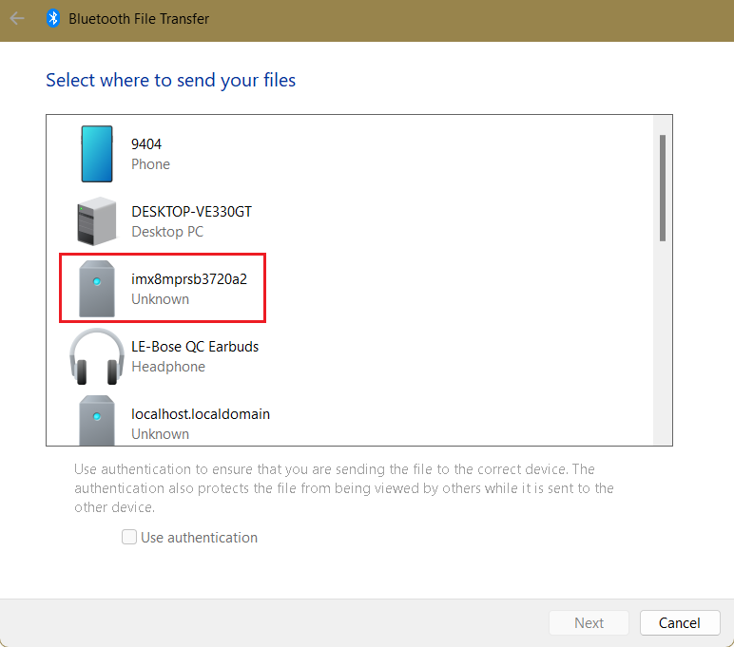
Select transfer file
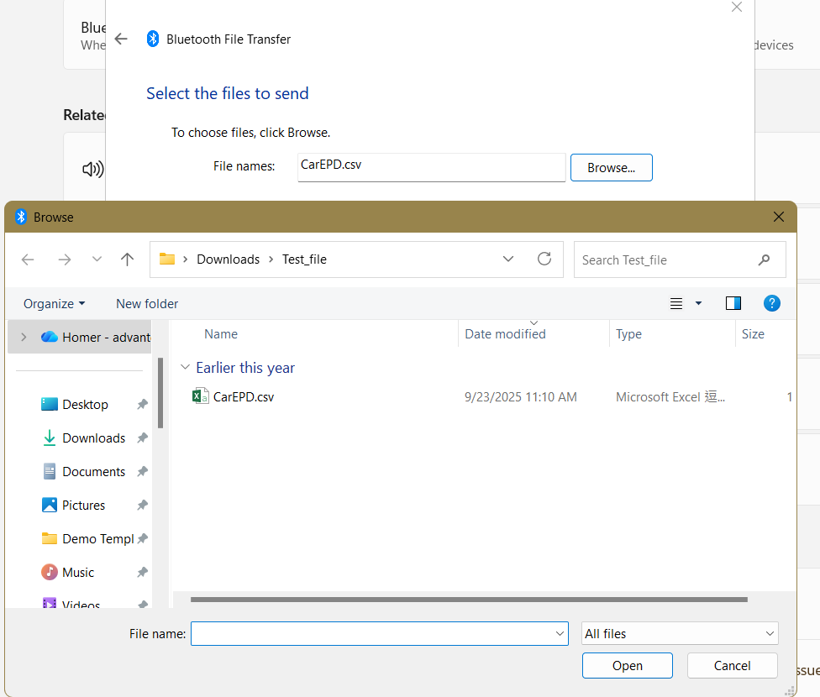

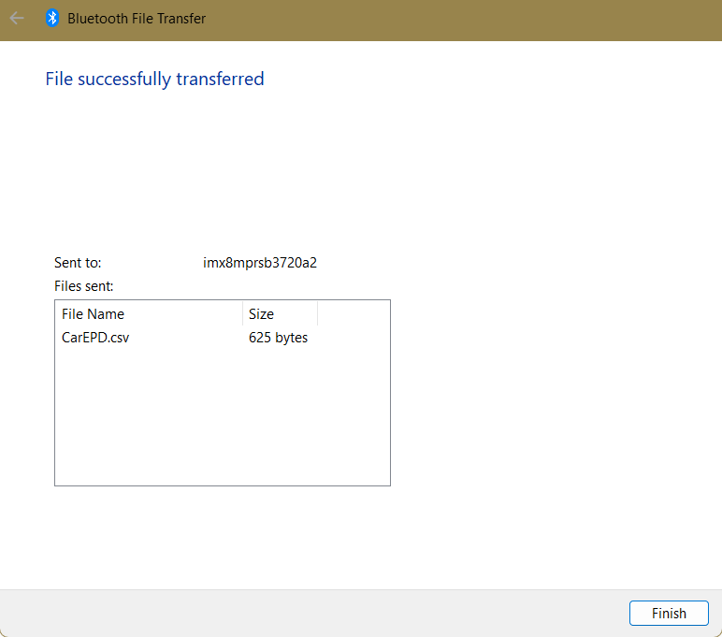
Check the file in the RSB-3720
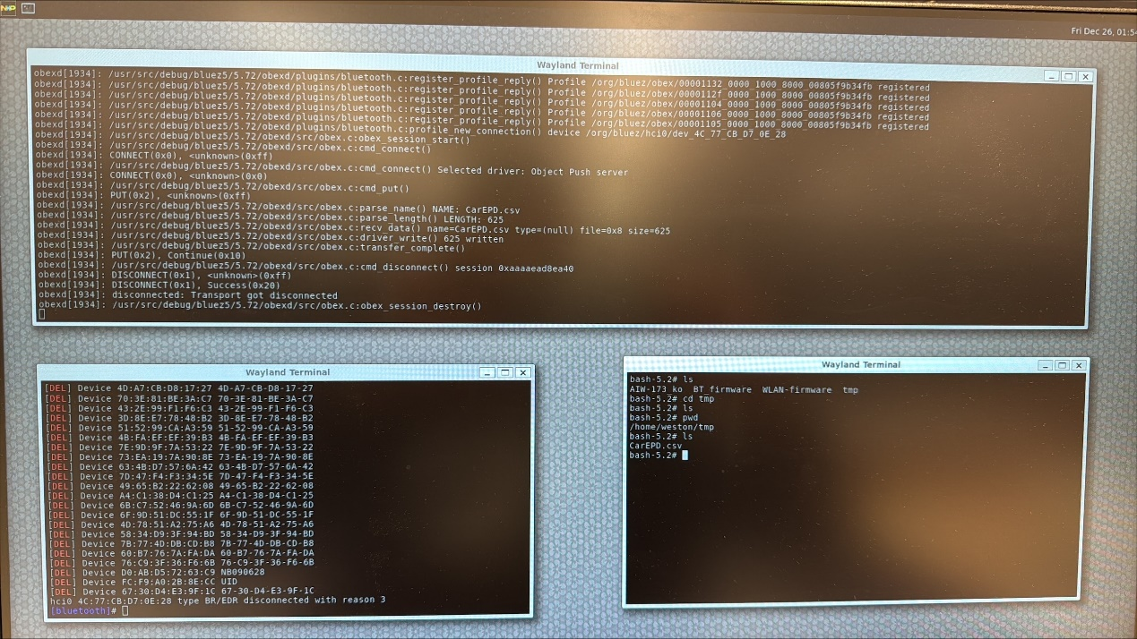
bluetoothctl
Obexd

