AIW FAQ
How to bring up AIW-172 Wifi feature with RSB-3720
Category | AIW | Date | 2026/4/19
Keyword | AIW-172(WiFi 7),RSB-3720(Yocto 5.2 LTS) with linux kernel 6.6.23)
Catergory:
1. Check Device 2
2. Build Environment on Host 2
3. Getting Linux Code and Setting Environment 2
4. Build Kernel Image and build Tool-Chain 5
5. Build WLAN Driver and network tool(hostapd and wpa_supplicant) 7
6. Flash Image 11
7. Install Driver 12
8. Check Device After installed driver 12
Appendix: 12

Check Device
Before driver installed, you will see the device as below by “lspci”.

$ lspci
00:00.0 PCI bridge: Synopsys, Inc. DWC_usb3 / PCIe bridge (rev 01)
01:00.0 Network controller: Qualcomm Technologies, Inc Device 1112 (rev 01)

Build Environment on Host
[RSB-3720]
https://ess-wiki.advantech.com.tw/view/IoTGateway/BSP/Linux/iMX8/Yocto_LBVF_User_Guide
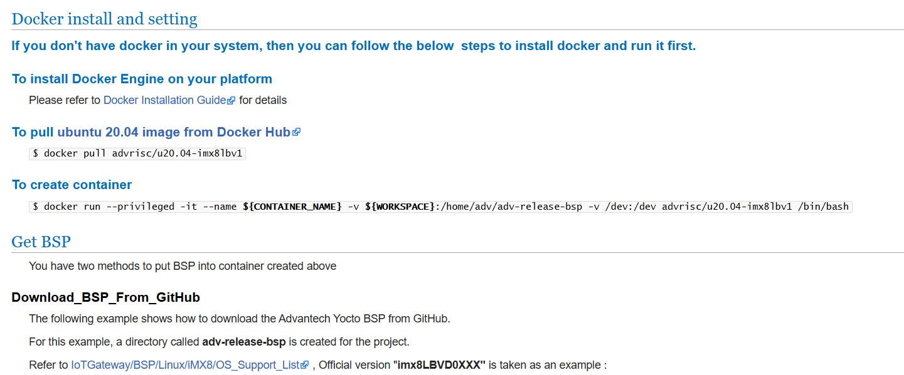

Getting Linux Code and Setting Environment
[RSB-3720]
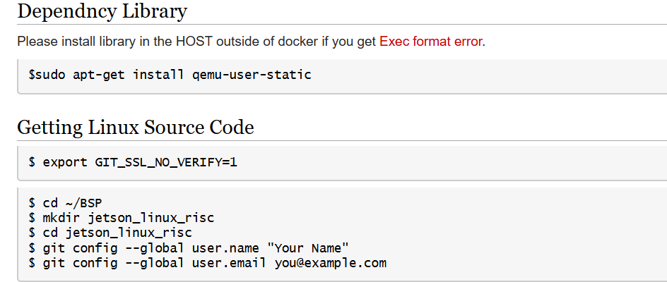
$ repo init -u git://github.com/ADVANTECH-Corp/adv-arm-yocto-bsp.git -b imx-linux-kirkstone -m imx8LBVF0071.xml
$ repo sync
$ MACHINE=imx8mprsb3720a2 UBOOT_CONFIG=6G DISTRO=fsl-imx-xwayland source imx-setup-release.sh -b build_x11
$ bitbake virtual/kernel

Copy the 0001-AIW-172-fix.patch to below path .
Download below file and untar it.
$ mkdir /home/adv/adv-release-bsp/sources/meta-advantech/meta-fsl-imx/recipes-kernel/linux/files
$ mv 0001-AIW-172-fix.patch /home/adv/adv-release-bsp/sources/meta-advantech/meta-fsl-imx/recipes-kernel/linux/files
Modify the .bbappend file
$ cd /home/adv/adv-release-bsp/sources/meta-advantech/meta-fsl-imx/recipes-kernel/linux
$ vi linux-imx_6.6.bbappend
Add below content in the end of the .bbappend file.

FILESEXTRAPATHS:prepend := "${THISDIR}/files:"
SRC_URI += "file://0001-AIW-172-fix.patch"
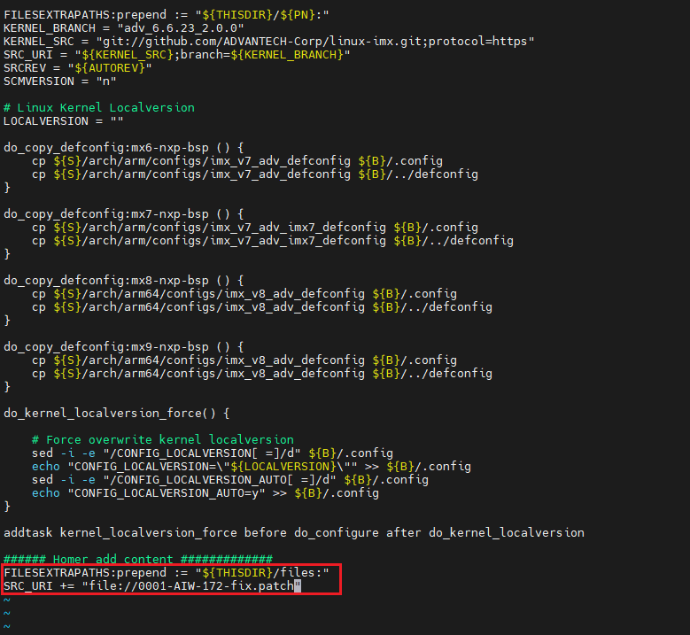

$ vi /home/adv/adv-release-bsp/build_Yocto5/conf/local.conf
Add below content in the end of this file.
IMAGE_INSTALL:append = " iperf3"
IMAGE_INSTALL:append=" dnsmasq linux-firmware-qca"

Build Kernel Image and build Tool-Chain
[RSB-3720]
$ vi /home/adv/adv-release-bsp/sources/meta-imx/meta-imx-ml/recipes-nnstreamer/nnshark/nnshark_2023.11.imx.bb
Modify
NNSHARK_SRC ?= "gitsm://github.com/nxp-imx/nnshark.git;protocol=https"
to
NNSHARK_SRC ?= "git://github.com/nxp-imx/nnshark.git;protocol=https"

add below content in the nnshardk_2023.11.imx.bb
do_configure[network]="1"
do_configure:prepend() {
cd ${S}
echo ">>> Fixing GStreamer common submodule URL"
if grep -q "anongit.freedesktop.org" .gitmodules; then
sed -i 's#git://anongit.freedesktop.org/gstreamer/common#https://gitlab.freedesktop.org/gstreamer/common.git#g' .gitmodules || true
fi
git submodule sync --recursive || true
git submodule update --init --recursive || true
echo ">>> Submodule fix done."
}
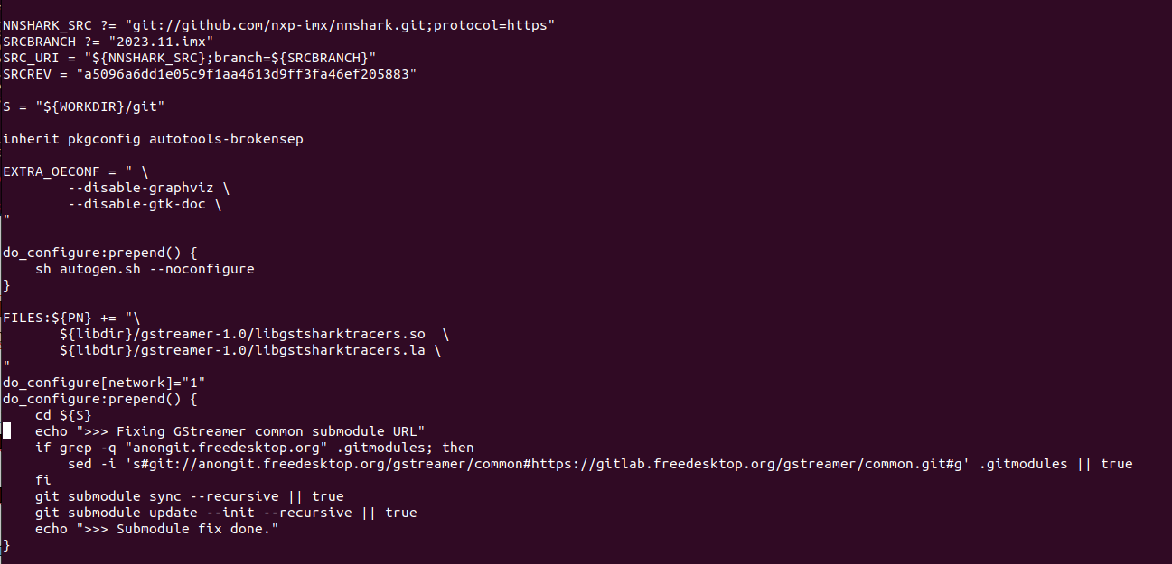

$ vi ~/adv-release-bsp/sources/meta-imx/meta-imx-ml/recipes-libraries/onnxruntime/onnxruntime_1.17.1.bb
Add below function as below
DEPENDS = "libpng zlibi libeigen"

EXTRA_OECMAKE += "\
-DFETCHCONTENT_FULLY_DISCONNECTED=OFF \
-DCMAKE_BUILD_TYPE=RelWithDebInfo \
-Donnxruntime_BUILD_UNIT_TESTS=ON \
-Donnxruntime_USE_PREINSTALLED_EIGEN=ON\
-Deigen_SOURCE_PATH=${STAGING_INCDIR}/eigen3\

"

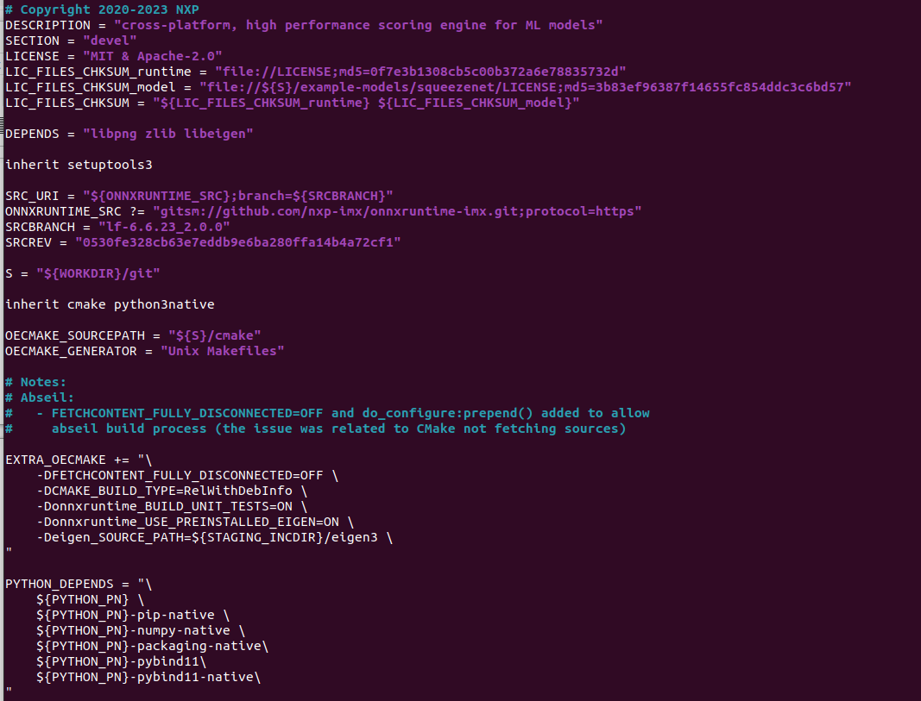
$ cd ~/adv-release-bsp/build_x11
$ bitbake imx-image-full

$ vi /home/adv/adv-release-bsp/build_Yocto5/conf/local.conf
Add below content in the end of the file
TOOLCHAIN_TARGET_TASK:append = " \
glibc \
glibc-dev \
libbsd \
libbsd-dev \
libnl \
libnl-dev \
libnl-genl \
openssl \
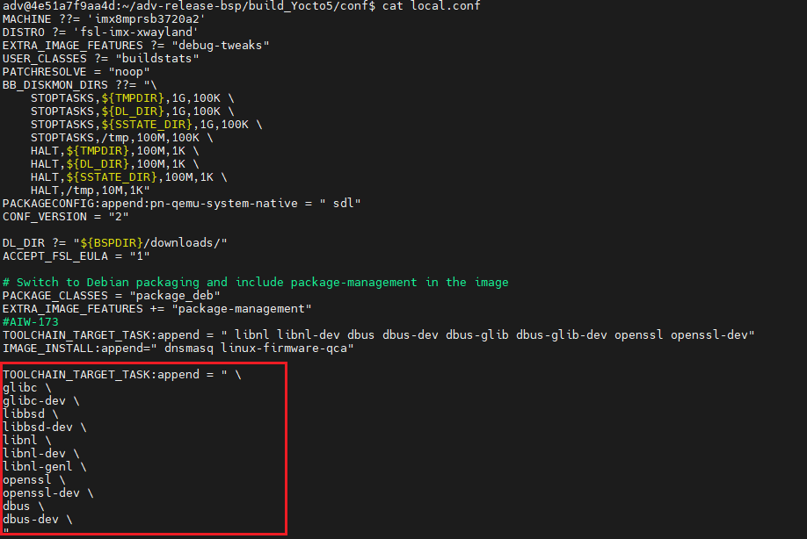
$ bitbake meta-toolchain
The below installer will be located in the directory "./tmp/deploy/sdk".
fsl-imx-wayland-glibc-x86_64-meta-toolchain-armv8a-imx8mp-lpddr4-evk-toolchain-${KERNEL}-scarthgap.sh
You need install the tool chain and source the environment
The full image will in the “./tmp/deploy/img”

Build WLAN Driver and network tool(hostapd and wpa_supplicant)
5.1 Build WLAN Driver
- Download the driver source code from git server
[RSB-3720]
AIW_172_driver.zip
$ cd /
$ sudo git clone ssh://adv_ae@172.22.24.155:/volume1/git-server/AIW_172_driver
$ sudo mv /AIW_172_driver /172
$ cd /172
NOTE: the password for adv_ae is “123456”

- Build driver
$ vim /172/AIO/build/scripts/cgn-f10/config.cgn-f10
Modify below information in the config.cgn-f10
export KERNELPATH=/home/adv/adv-release-bsp/build_Yocto5/tmp/work/imx8mprsb3720a2-poky-linux/linux-imx/6.6.23+git/build
export TOOLCHAIN=/opt/fsl-imx-xwayland/6.6-scarthgap/sysroots/x86_64-pokysdk-linux/usr/bin/aarch64-poky-linux/aarch64-poky-linux-
export KERNELARCH=arm64
export CROSS_COMPILE=${TOOLCHAIN}
export TOOLPREFIX=${CROSS_COMPILE}
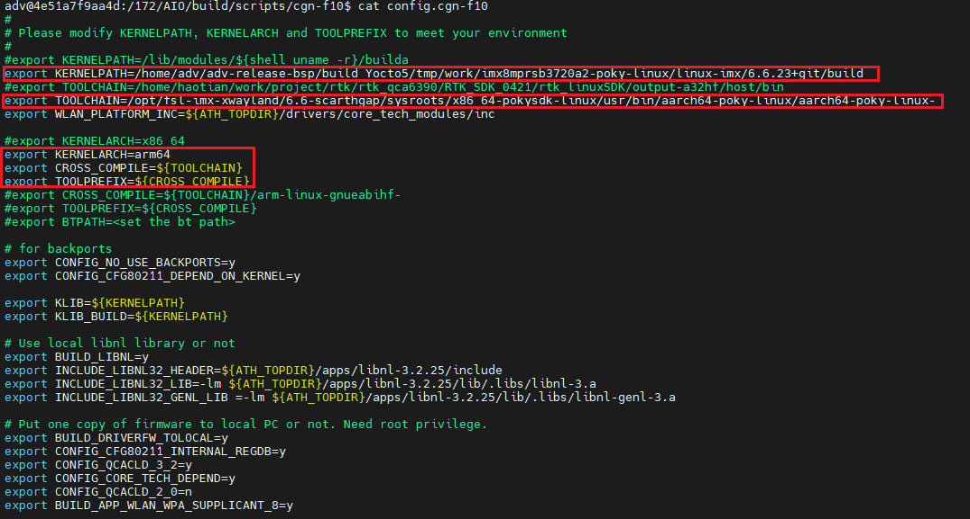

Edit wpa_supplicant config
$ cd /172/AIO/drivers/patches/cgn-f10/supplicant
$vi wpa_supplicant.config
Add below content in the end of the file
CFLAGS += --sysroot=$(SDKTARGETSYSROOT)
LDFLAGS += --sysroot=$(SDKTARGETSYSROOT)
CFLAGS += -I$(SDKTARGETSYSROOT)/usr/include/libnl3
CFLAGS += -I$(SDKTARGETSYSROOT)/usr/include/dbus-1.0
CFLAGS += -I$(SDKTARGETSYSROOT)/usr/lib/dbus-1.0/include
LDFLAGS += -L$(SDKTARGETSYSROOT)/usr/lib -ldbus-1
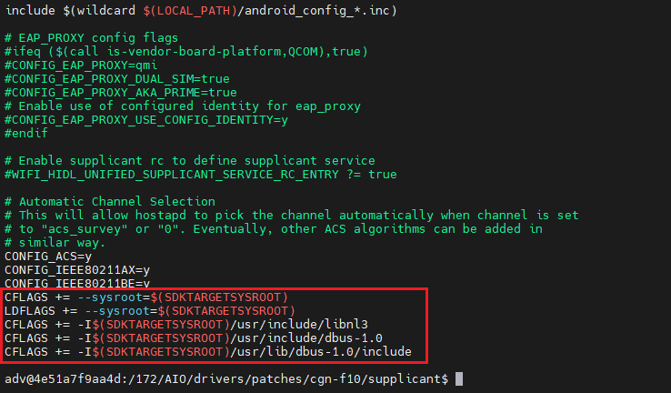

Edit hostapd config
$ vi hostapd.config
Add below content in the end of the file
CFLAGS += --sysroot=$(SDKTARGETSYSROOT)
LDFLAGS += --sysroot=$(SDKTARGETSYSROOT)
CFLAGS += -I$(SDKTARGETSYSROOT)/usr/include/libnl3
CFLAGS += -I$(SDKTARGETSYSROOT)/usr/include/dbus-1.0
CFLAGS += -I$(SDKTARGETSYSROOT)/usr/lib/dbus-1.0/include
LDFLAGS += -L$(SDKTARGETSYSROOT)/usr/lib -ldbus-1
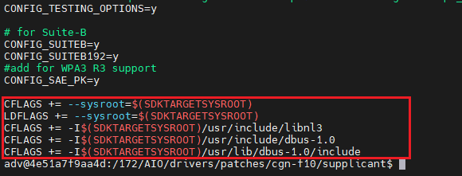
$ cd /172/AIO/build
$ make

- Get wlan_cnss_core_pcie.ko, wlan.ko from specific folder ( /172/AIO/rootfs-cgn-f10.build /lib/modules)
- The FW will in the specific folder
(/172/AIO/rootfs-cgn-f10.build/lib/firmware/WLAN-firmware)

  - hostapd and wpa_supplicant
- After build the driver, wpa_supplicant and hostapd will in the below path
/172/AIO/rootfs-cgn-f10.build/sbin

After built hostapd and wpa_supplicant, you need copy it to the SD card and boot up the RSB-3720. You need confirm “wpa_supplicant” version if is 2.11 version
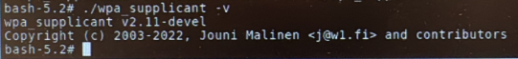

Flash Image
[RSB-3720]
Flash image to SD card
OS image path “/home/adv/adv-release-bsp/build_x11/tmp/deploy/images/imx8mprsb3720a2”
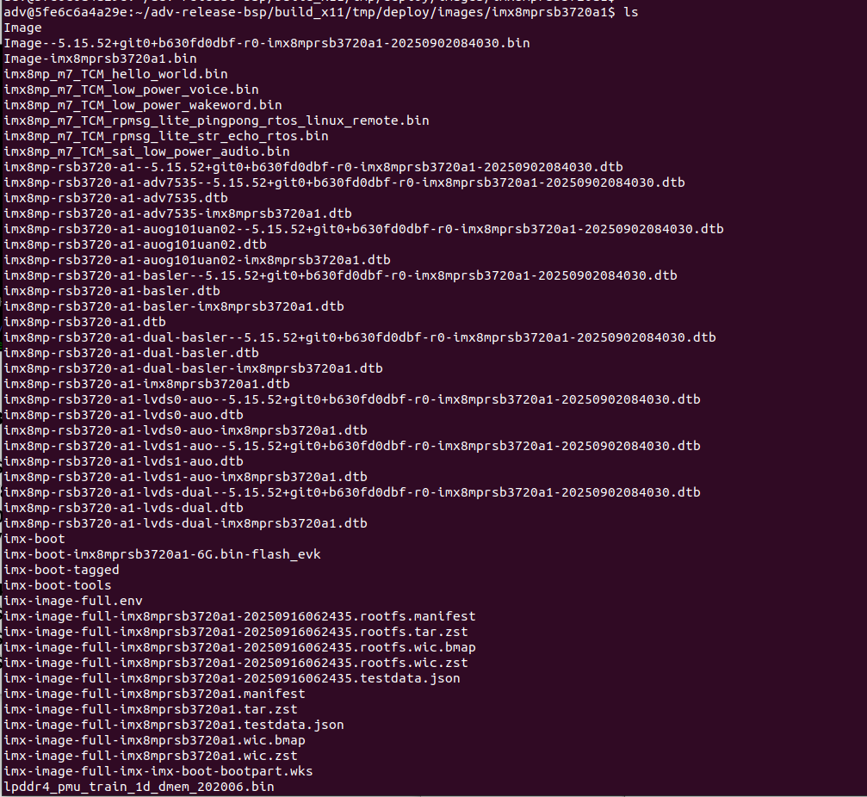

.wic.zst if full OS image
You need copy it to your system.
$ maker p ~/adv-release-bsp/Temp/SD_img
$ cp imx-image-full-imx8mprsb3720a2-20251209023921.rootfs.wic.zst ~/adv-release-bsp/Temp/SD_img

Change to your real system(Not in the docker)
- $ cd ~/Downloads/adv-release-bsp/Temp/SD_img
- $ zstd -d imx-image-full-imx8mprsb3720a1-xxxx.rootfs.wic.zst (Example: imx-image-full-imx8mprsb3720a2-20251209023921.rootfs.wic.zst)
- $ sudo dd if=imx-image-full-imx8mprsb3720a1-xxxx.rootfs.wic of=/dev/sdb bs=4M status=progress conv=fsync

Install Driver
Copy firmware files to device:
$sudo cp -rf /172/AIO/rootfs-cgn-f10.build/lib/firmware/WLAN-firmware/* /lib/firmware/
Insmod driver:
$ sudo insmod <path to .ko>/wlan_cnss_core_pcie.ko
$ sudo insmod <path to .ko>/wlan.ko country_code=US

Check Device After installed driver
# ifconfig -a
# ifconfig wlan0 up
The result should like below:
