AIW FAQ
Category | AIW | Date | 2025/04/18
Keyword | AIW-173(WiFi 7), RSB-3810(MTK Genio 1200), Ubuntu OS 22.04.3, linux kernel 5.15.0-1029-mtk,WPA3 encryption, Ubiquiti U7 Pro AP

- Question:
How to establish 6Ghz connection on RSB-3810 when running with AIW-173?

- Instructions :
Step 1
Please refer following URL SOP to flash the OS and copy related files into your platform
RSB-3810
Step 2
Add new config and paramter in qcom.cfg.ini (/lib/firmware/wlan)
- # sudo nano qcom_cfg.ini
g11dSupportEnabled=1
gindoor_channel_support=1
scan_mode_6ghz=2
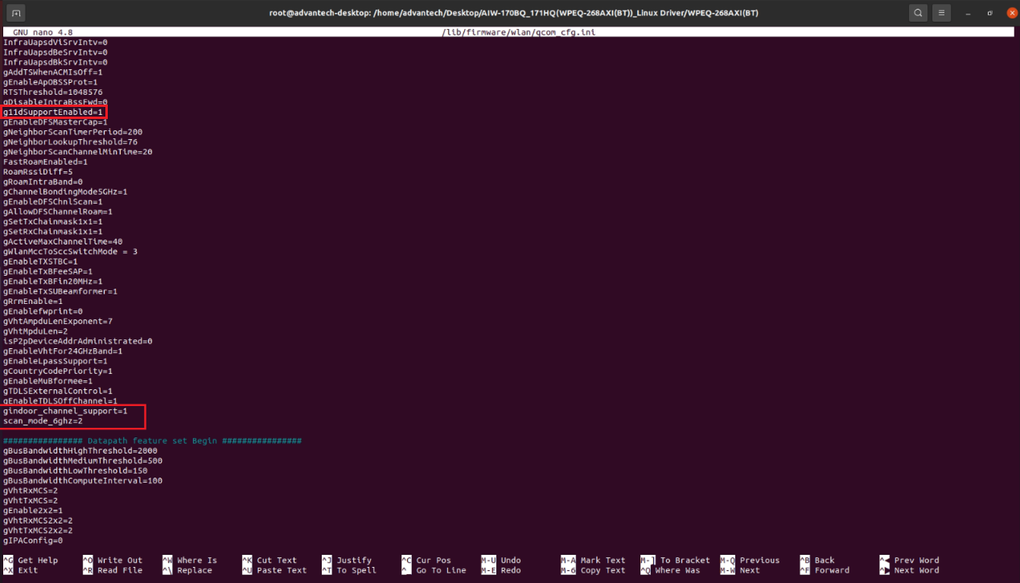
Step 3
For Medtronic project’s modification, please add country code in current “wlan-load.service” to ensure 6Ghz channels are available
- sudo systemctl restart wlan-load.service
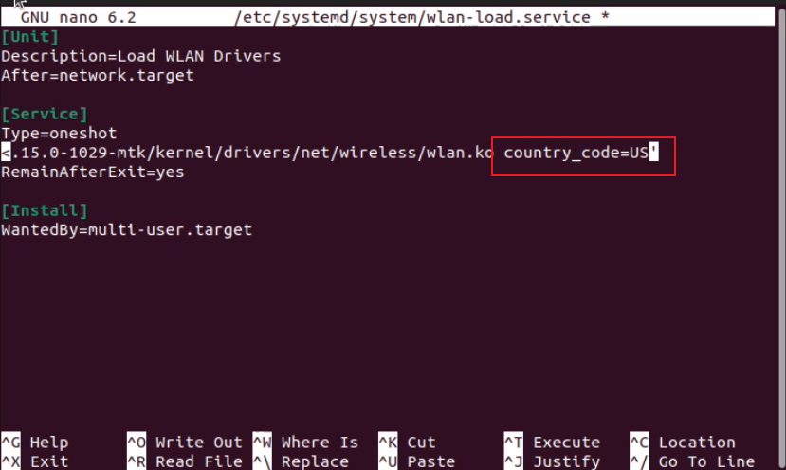
Step 4
For Medtronic project, reboot your system and confirm if the drive can be executed automatically and 6Ghz channel will be available now
- sudo lsmod | grep wlan
- sudo iw list | grep -A20 Frequencies
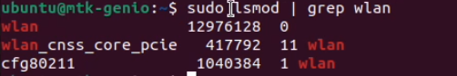
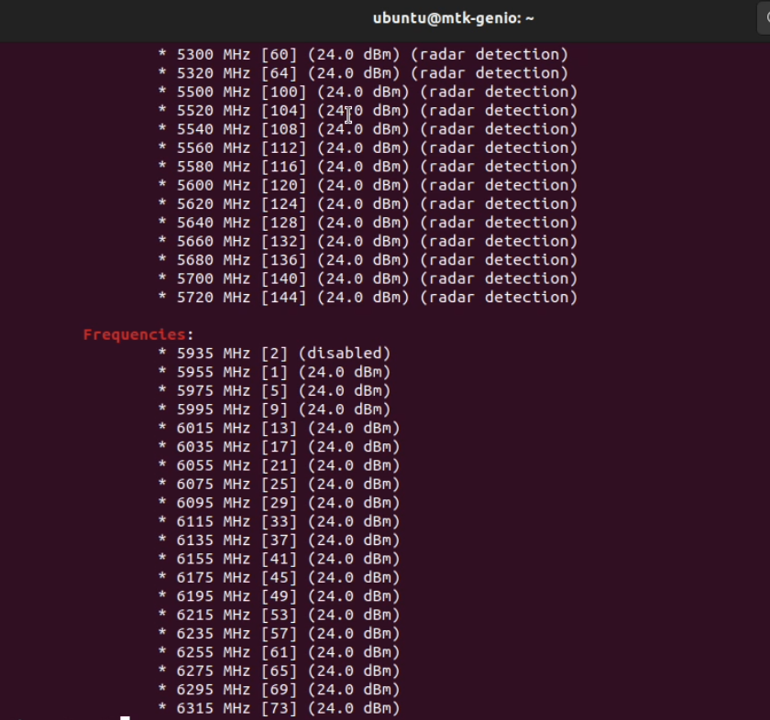

Step 5
Confirm your wifi interface name by specific command
- sudo iw dev
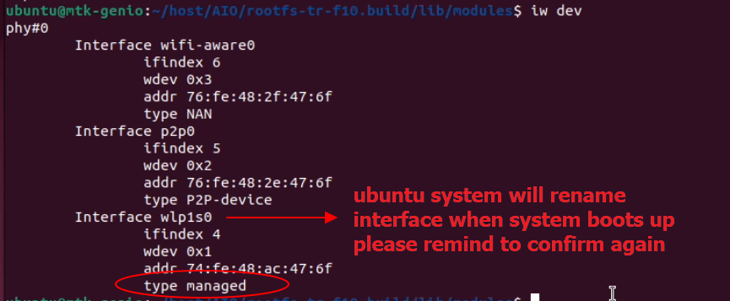
Step 6
Before running wpa_supplicant, please stop following system network service to avoid service conflict
• Stop NetworkManager service
- sudo systemctl stop NetworkManager.service
• Stop wpa_supplicant service
- sudo systemctl stop wpa_supplicant.service
Step 7
Enter to AIW-173 software package to check specific wpa_supplicant instead of original build-in wpa_supplicant

Step 8
Copy WPA3 config file into your system and rewrite ssid/psk which you would like to connect WiFi AP’s SSID& Password
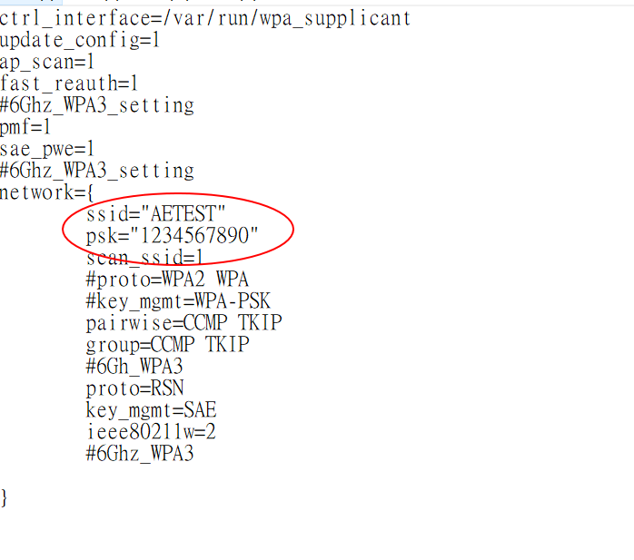
Step 9
clean remaining service before executing wpa_supplicant
- sudo killall wpa_supplicant
Step 10
Enter following command to run wpa_supplicant with your configuration file
- sudo ./wpa_supplicant -d -Dnl80211 -i wlp1s0 -c wpaXXX.conf &
Note: add “&” symbol in the end of command which will execute in background system
For debugging, please remove it for further log tracking
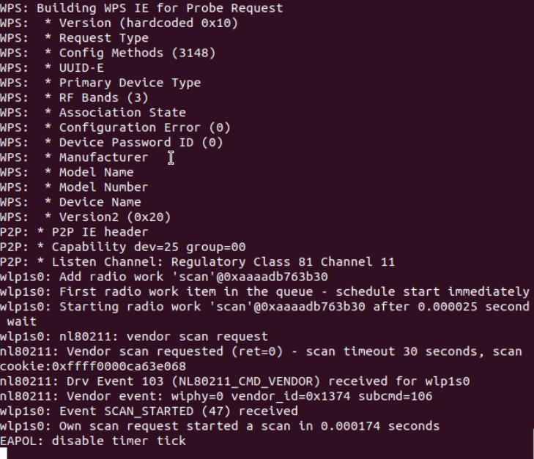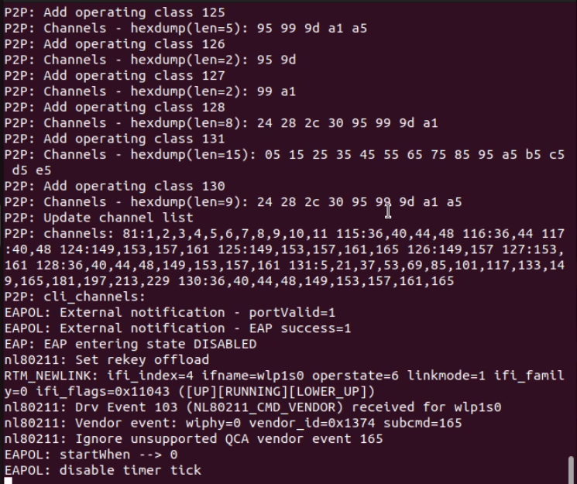

Step 11
Request DHCP assignment to WiFI AP and confirm if ip has assigned successfully
- sudo dhclient wlp1s0
- sudo ifconfig wlp1s0
Note: please open another terminal to assign DHCP if wpa_supplicant is not running in background

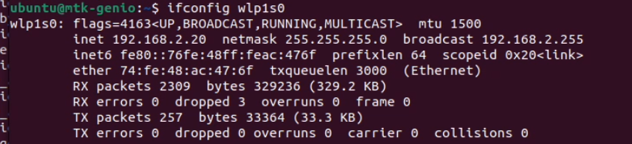
Step 12
Confirm the connection is established & do ping testing
- sudo iw dev wlp1s0 link
- ping 192.168.2.21 -I wlp1s0
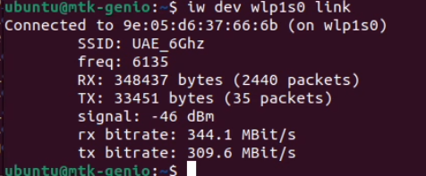
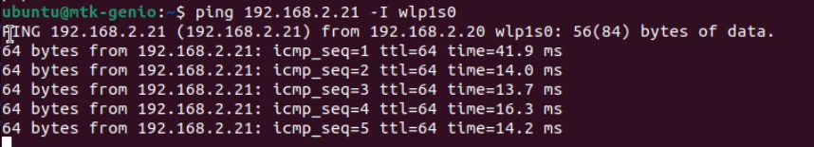
Step 13
We also verify 5Ghz connection with WPA3 encryption and it also work fine
