EWM FAQ
Category | EWM | Date | 2018/04/10
Keyword | EWM-G108H01E ,GPS,u-center,windows OS

- Question:
How to verify GPS module functions on u-center utility?

- Instructions :

Step 1
Download related utilities below and decompress the file at local device

Step 2
Install u-center utility at your desktop and connect GPS module to your host device

Step 3
Select corresponding model on the section of receiver

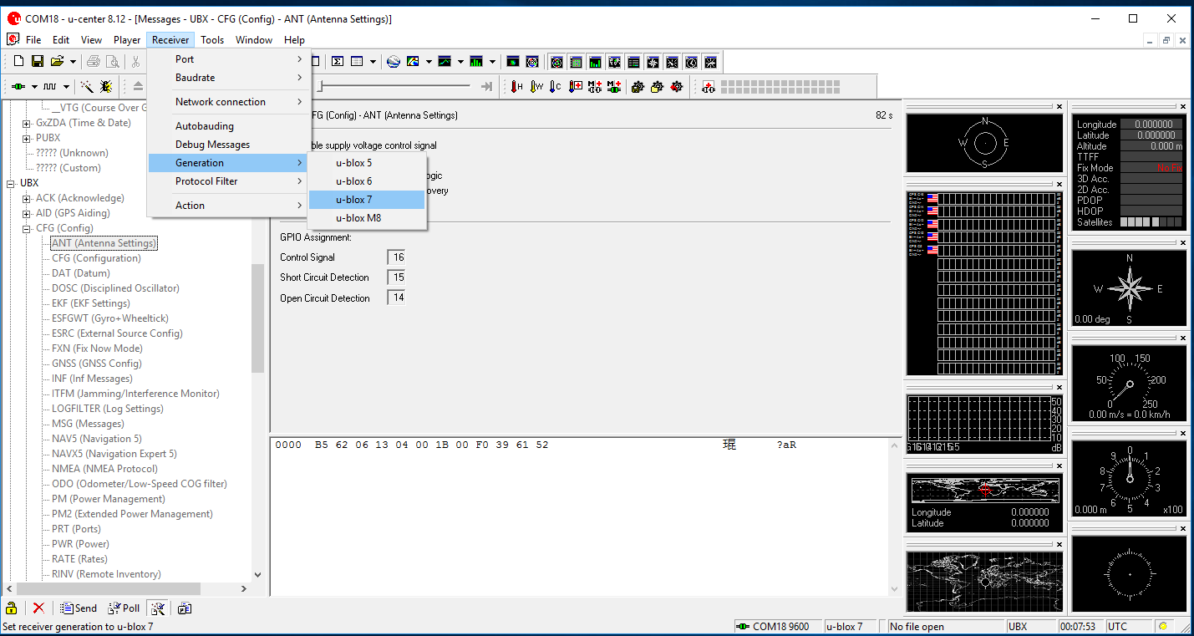

Step 4
Check current GPS module version
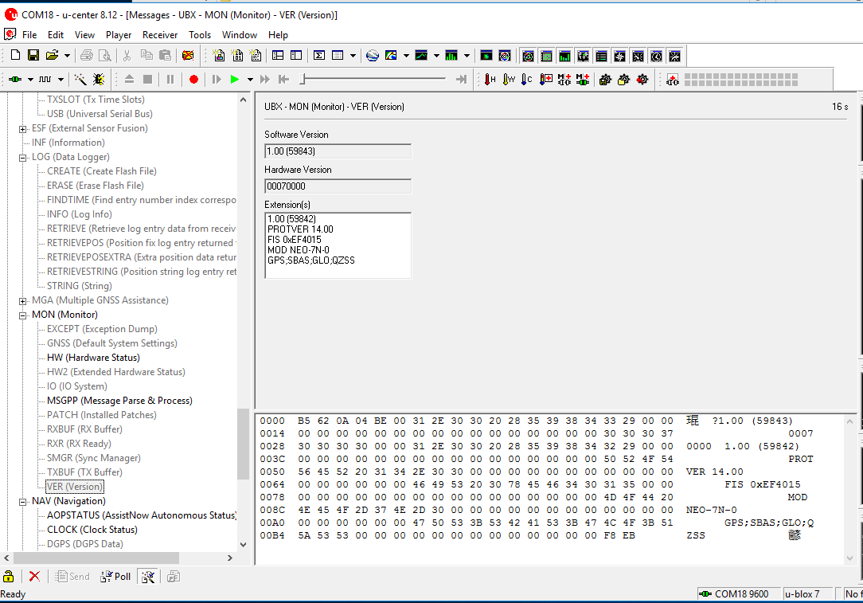

Step 5
Assign specific Com port to connect GPS module on u-center utility
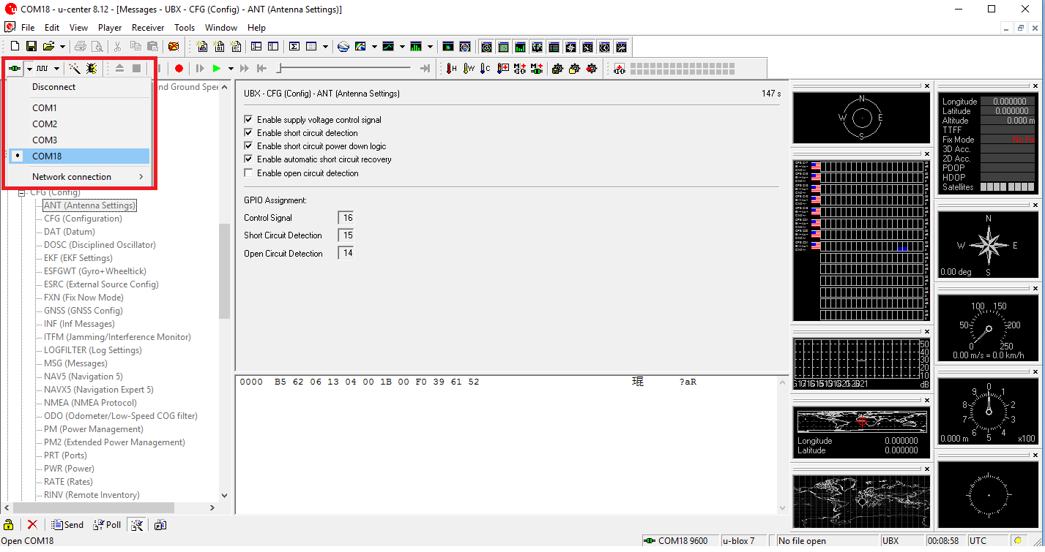
Step 6
Cross check these functions if work fine on u-center utility or not
