EWM FAQ
Category | EWM | Date | 2018/09/27
Keyword | EWM-G109H01E, GPS Positioning,Windows OS (7/10)

- Question:
How to verify EWM-G109H01E GPS Positioning on u-center utility?

- Instructions :

Step 1
Download “u-center utility”by following attached file and install both of module’s driver and utility before executing

Step 2
Simply confirm following diagram on u-center to make sure if your GPS Positioning is done or not
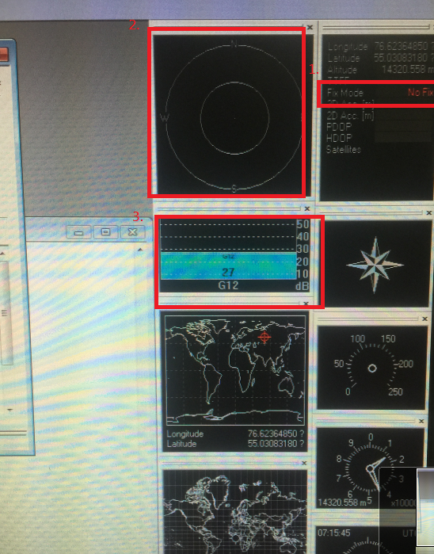
- The field of fix mode is to check current module locates or not
Failure: “no fix” means
Success: the field will appear “2D”, “3D”wording in green color
- This icon is used to detect module relative position for current satellites which will mark in green color.
- This icon will display current signal quality of satellite (the value will be around 35~40 DB which may be easier to locate on your device)

Step 3
For u-center utility, please reset the GPS module to factory default before verify GPS positioning feature

(1)Connect to u-center utility by assigning COM port (pleas ensure the icon will change to green color for connecting successfully)
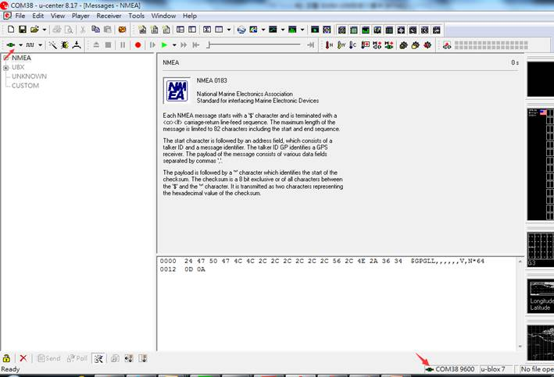
(2) Enter“F9”hotkey on keyboard and enable the message by clicking mouse right-clicking on
following two options which mark in red arrow

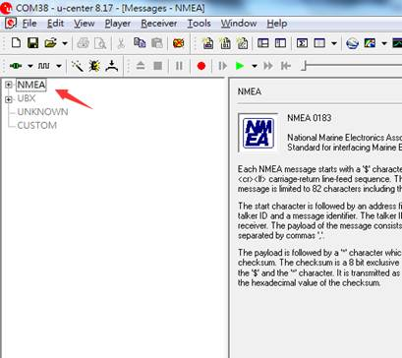

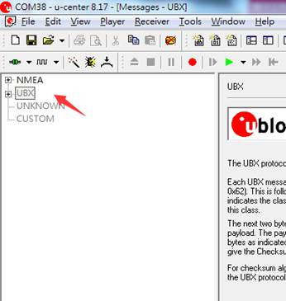
(3)Enter to the item of “UBX->CFG”,and select the option ”Revert to default configuration”,then click the “send” button in bottom left corner to activate it
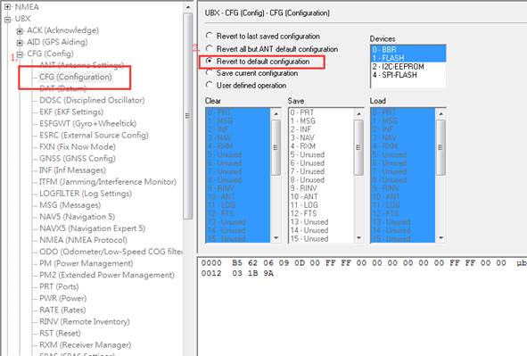
- Erase previous GPS positioning by clicking this yellow icon
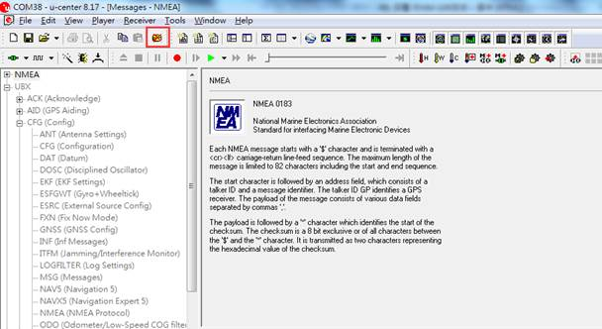
(5)Switch back ”Save current configuration” option in item of “UBX->CFG” and click the “send” button in bottom left corner to activate it
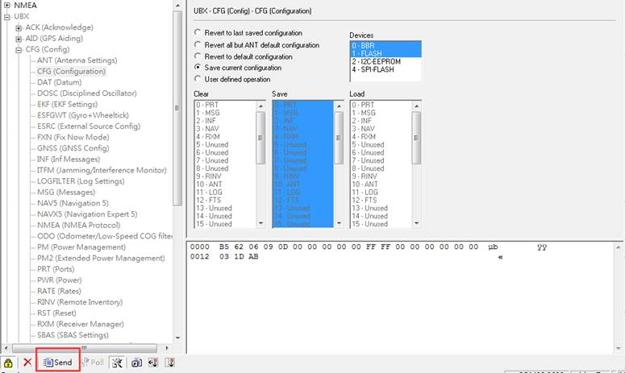
- Move your platform/device to open area which didn’t have shading object in the top of device
and the positioning action will be done after 1 minute later.
