EWM FAQ
Category | EWM | Date | 2018/04/13
Keyword | EWM-G108H01E ,GPS,u-center,windows OS

- Question:
How to get binary code on u-center utility?

- Instructions :

Step 1
Download u-center utility from u-blox’s website
https://www.u-blox.com/en/product/u-center-windows

Step 2
Install u-center utility at your desktop and connect GPS module to your host device

Step 3
Select corresponding model on the section of receiver

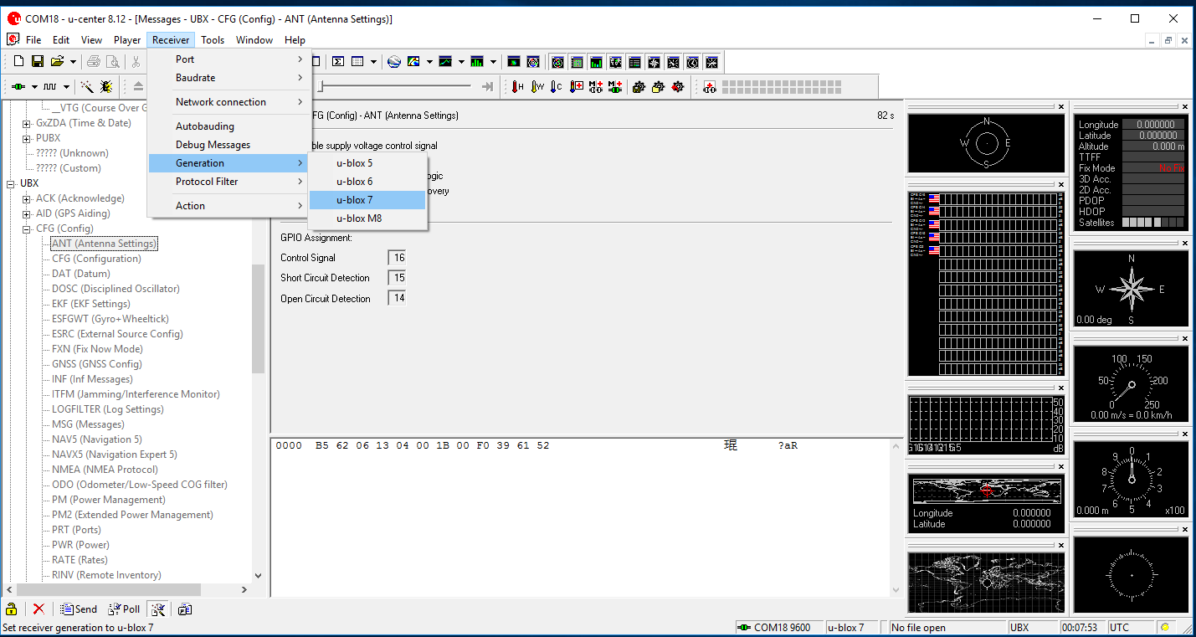

Step 4
Check current GPS module version
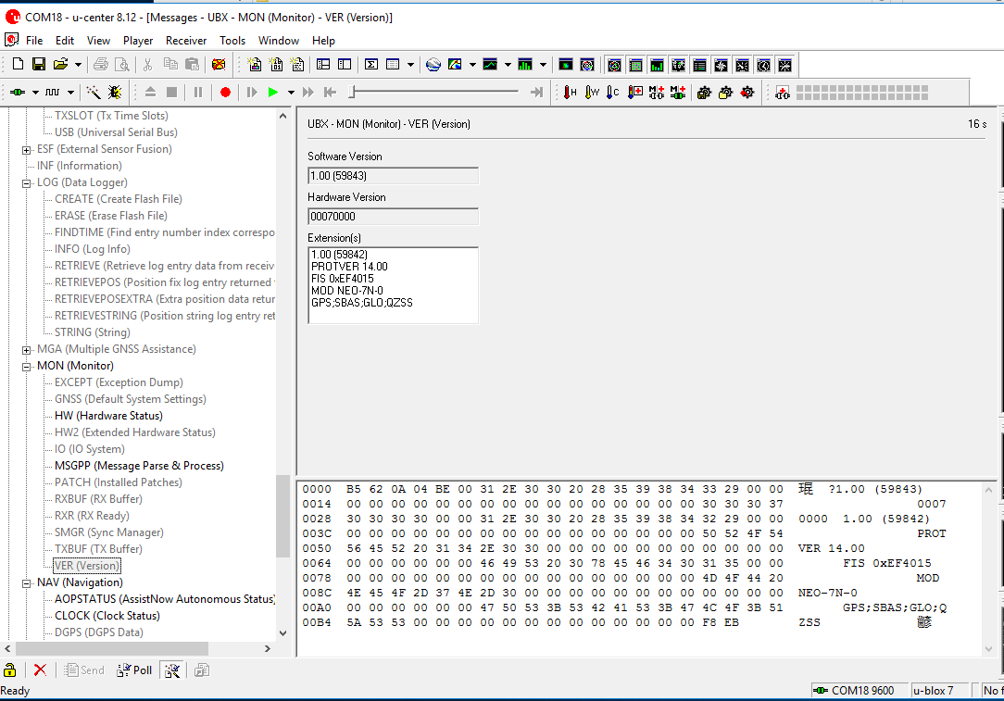

Step 5
Assign specific Com port to connect GPS module on u-center utility
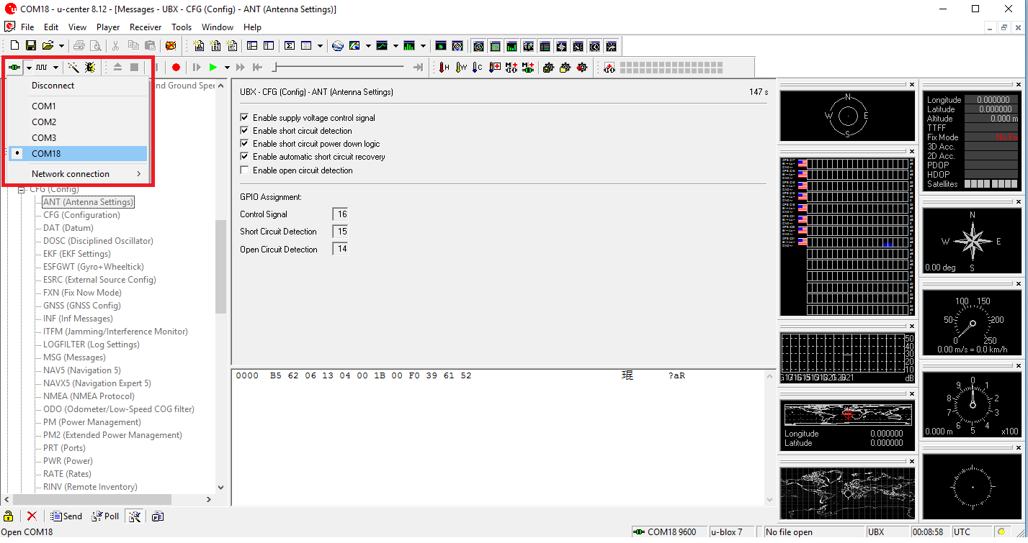

Step 6
Enable binary console to get binary code
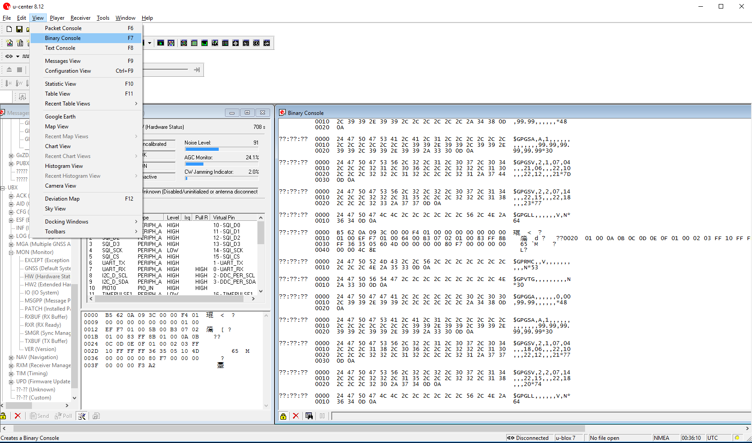
Step 7
Enable “MON-HW” status message and check binary code
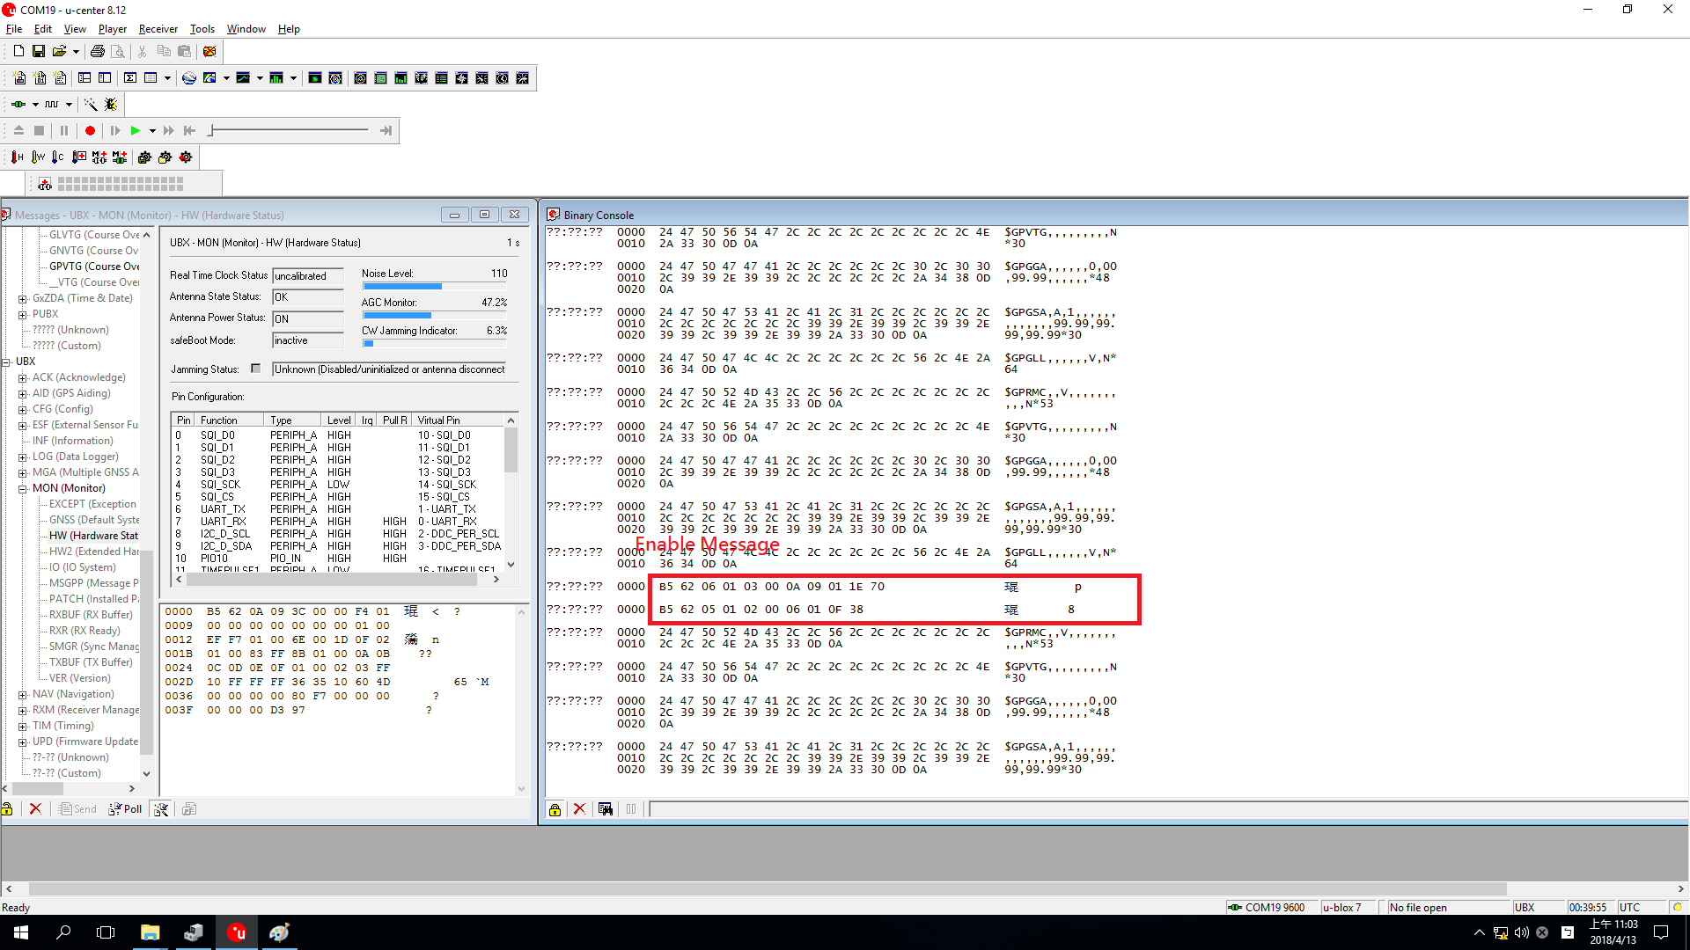

Step 8
Disable “MON-HW” status message and check binary code again

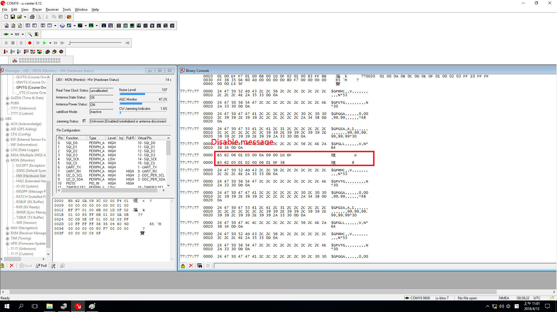
Step 9
Verify Binary code on linux platform and check the output message for sure
