AIW(EWM) FAQ
Category | AIW | Date | 2022/02/21
Keyword | AIW-166, Ubuntu, Wake-on WLAN

- Question:
How to enable and test Wake-on WLAN(WoWLAN) function on Ubuntu?

- Instructions :

Step 1
Input command “iw dev” to list wireless devices. Find the target wireless adapter which we’re going to test.
*Please remember name “phy0” because we will use it in the following step.
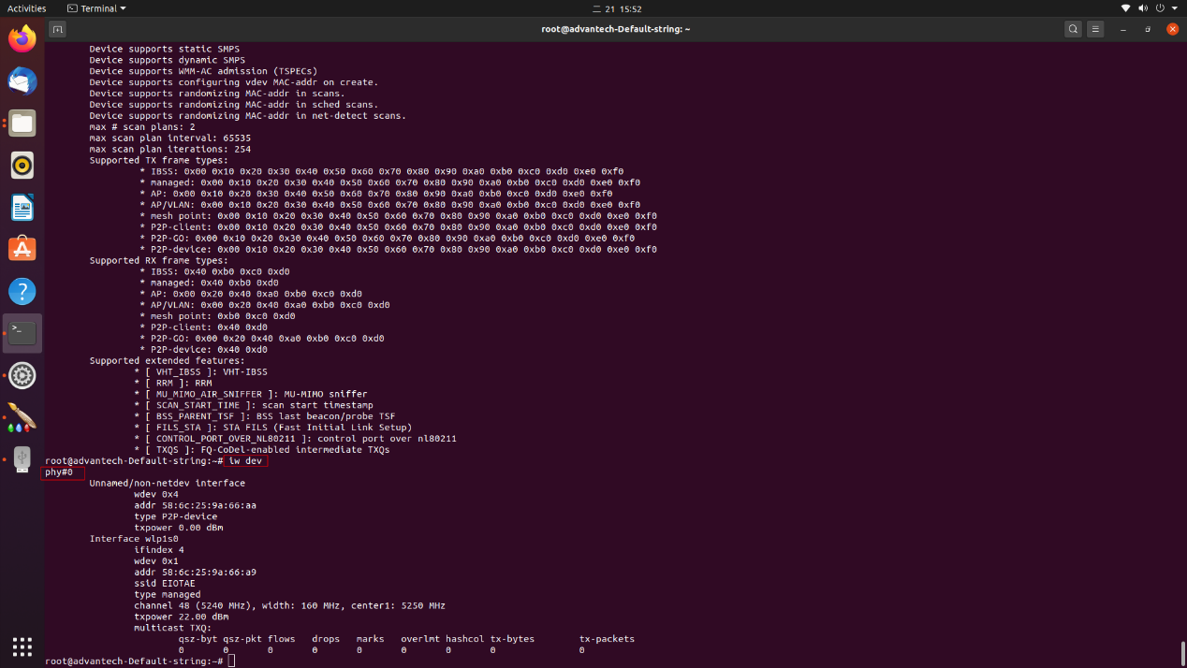
Step 2
Input command “iw phy0 wowlan show” to check current WoWLAN function status.
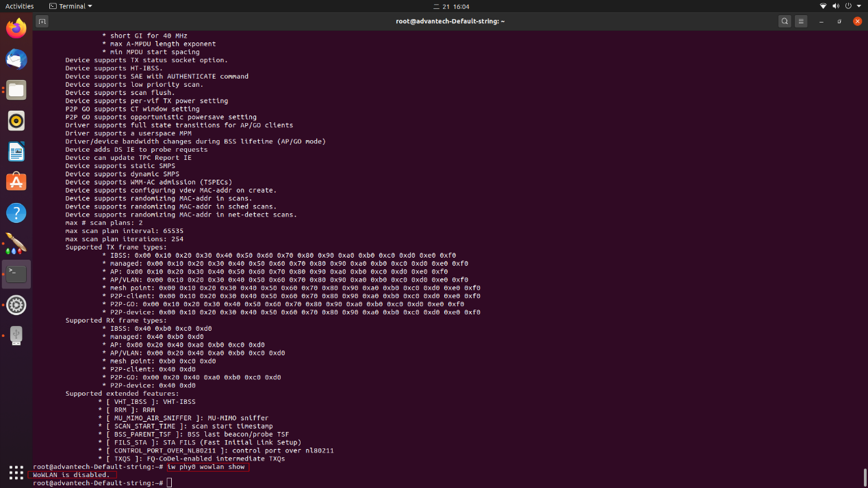
Step 3
Input command “sudo iw phy0 wowlan enable magic-packet” to enable WoWLAN function.
Then, using command “iw phy0 wowlan show” to check the status again and will see like below screenshot.
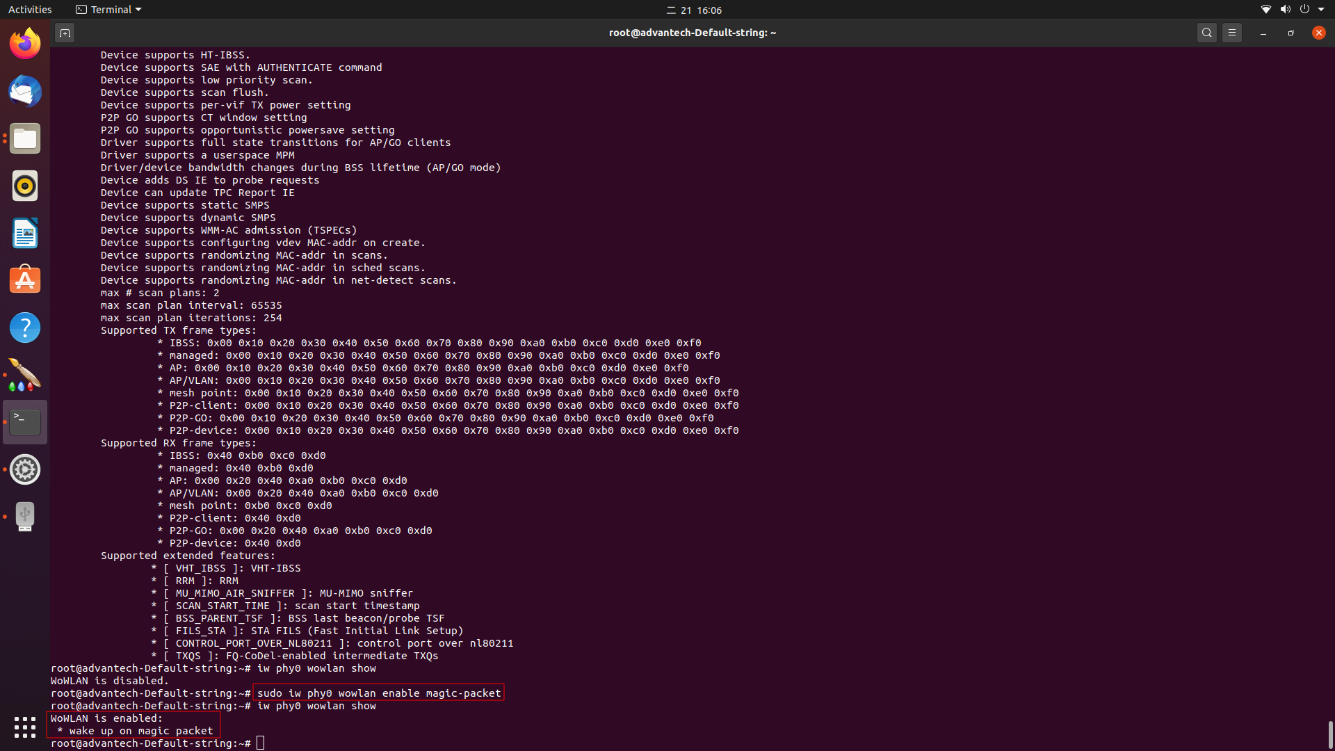

Step 4
Next, we’re going to test WoWLAN function. Make Ubuntu to suspend. (like the sleep mode(S3) on Windows)
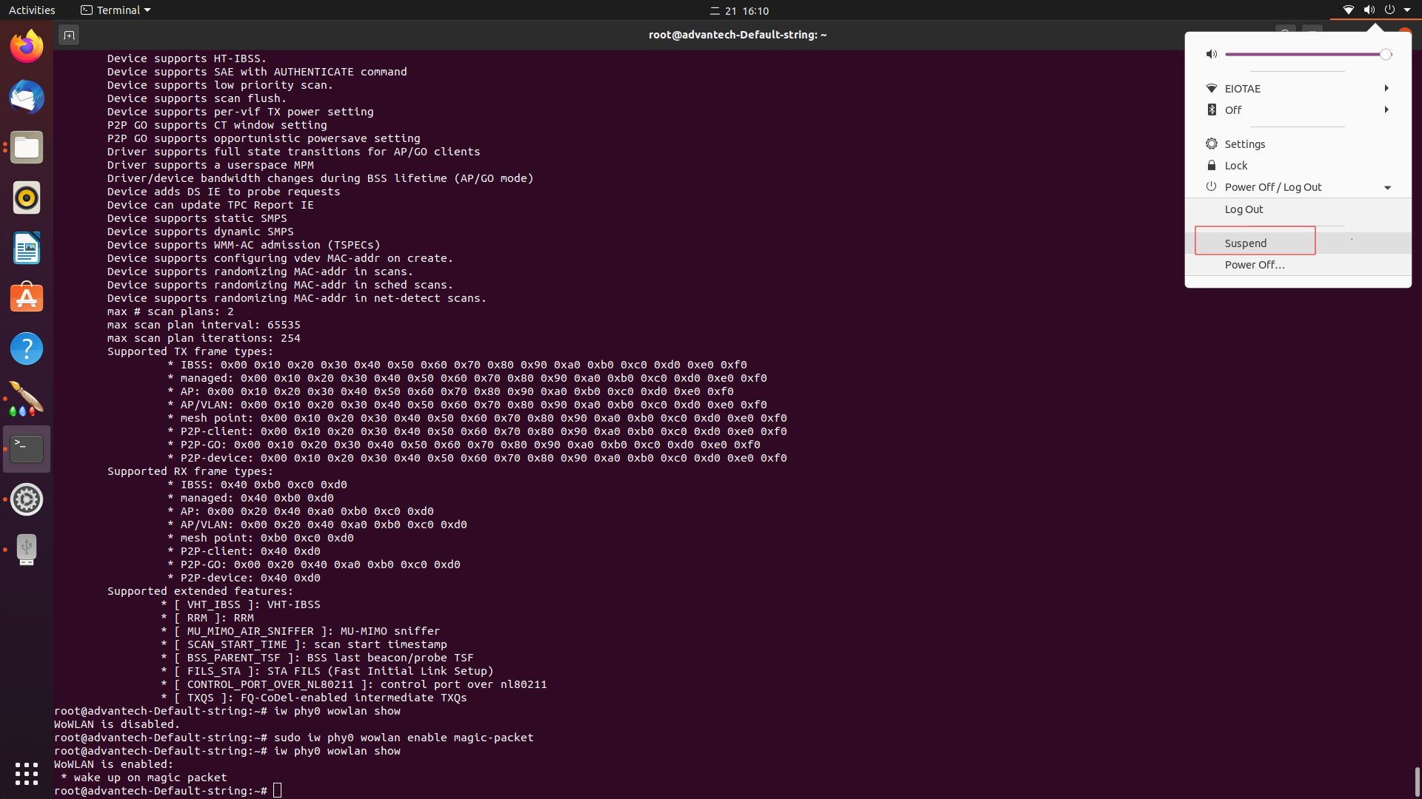
Step 5
Prepare the other laptop and execute the Magic Packet Utility, then input the MAC Address of the target wireless adapter.
Remember to connect to the same SSID for both Ubuntu PC and this laptop.
Click “Send” button to wake up Ubuntu.
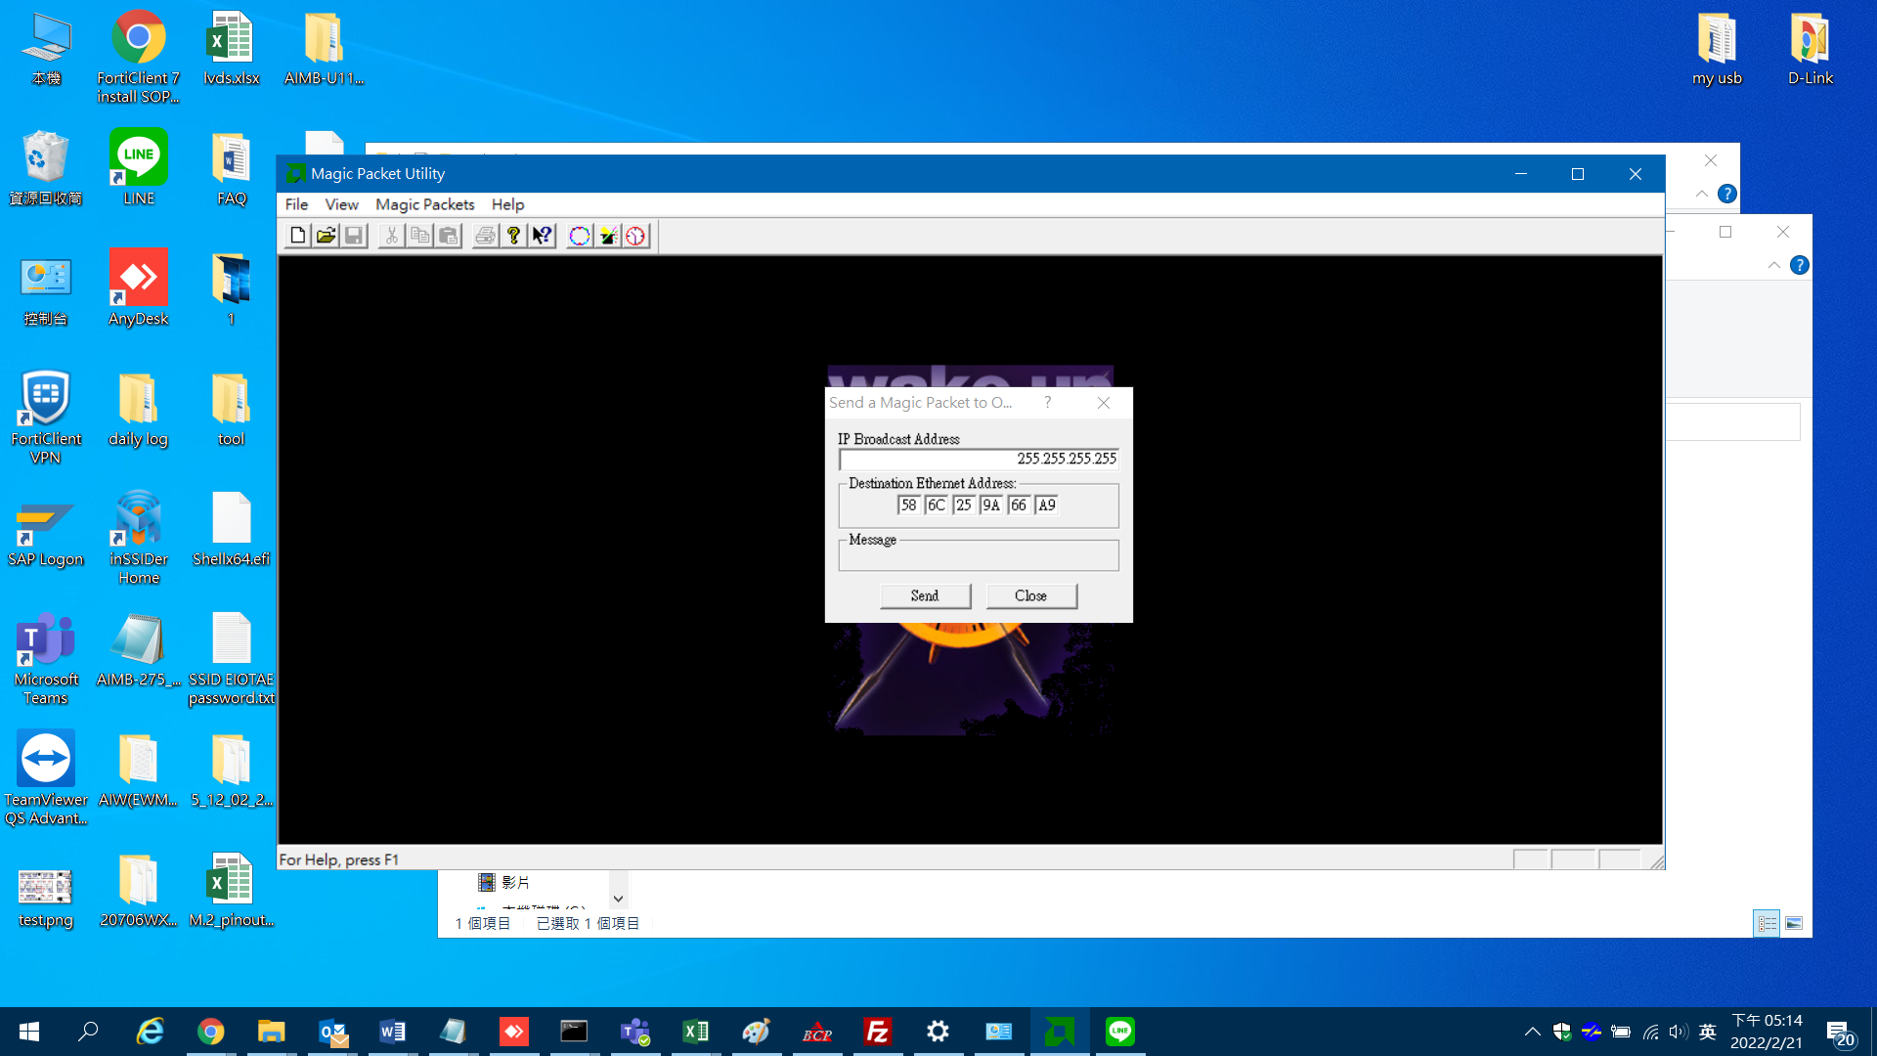

Note:
Using below command is able to check whether wireless adapter supports WoWLAN function or not.
iw list | grep WoW -A10
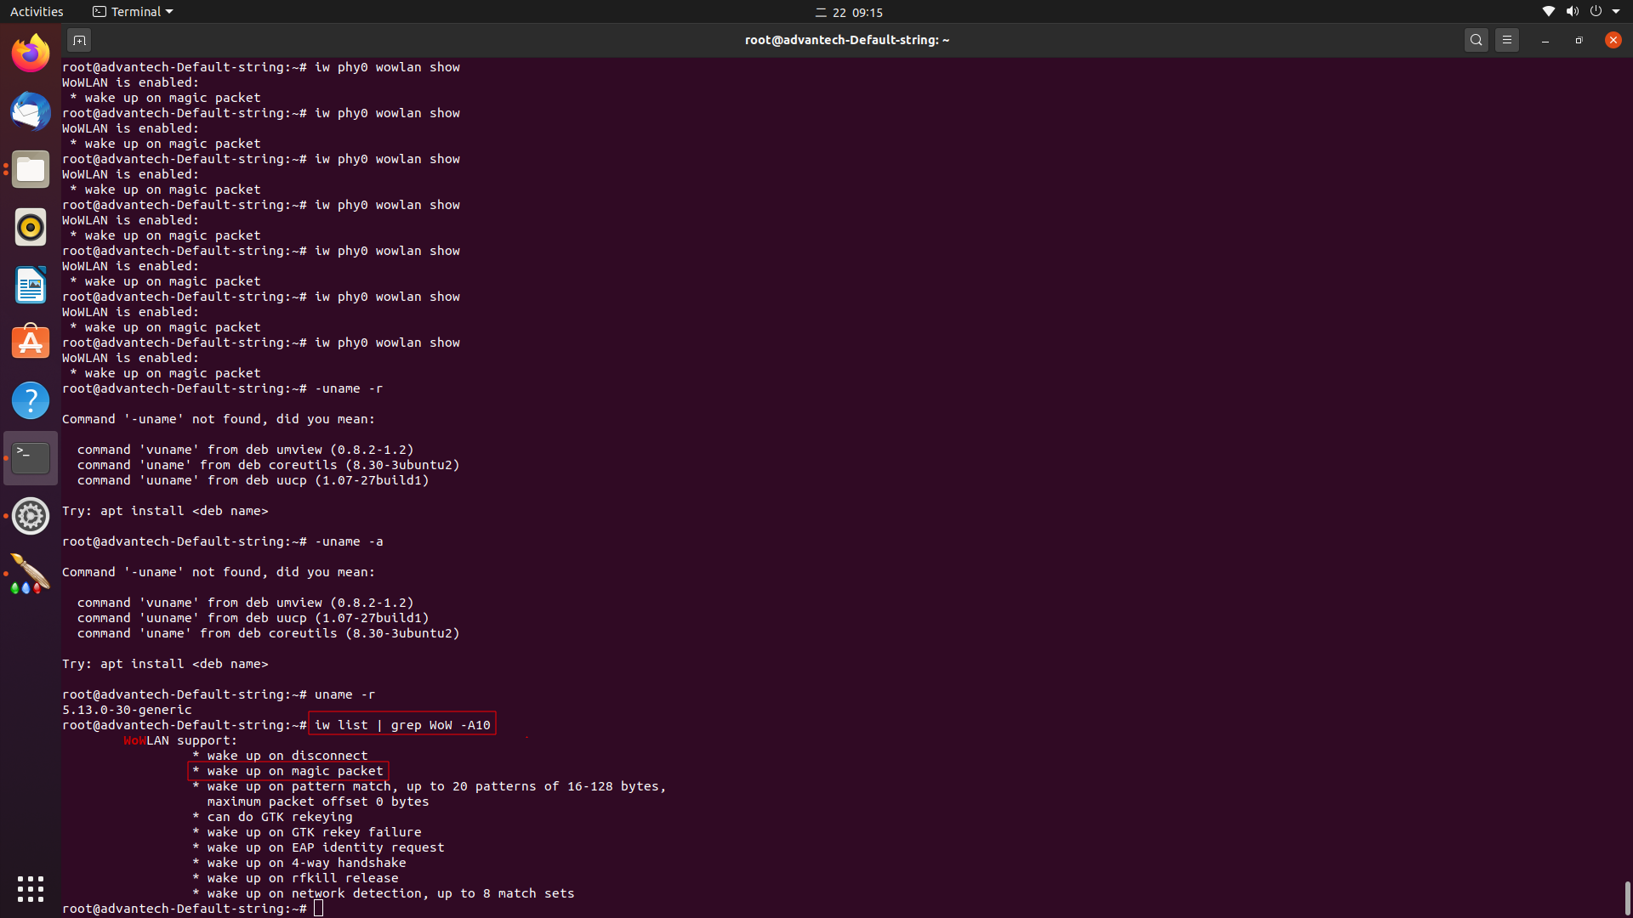

*Test environment:
Ubuntu 20.04.1 LTS x64 platform with kernel version 5.13.0-30-generic
AIW-166(Intel AX210), Wireless adapter driver/firmware version : 59.601f3a66.0
