EWM FAQ
Category | EWM | Date | 2018/02/01
Keyword | EWM-C160M201E, ARK-2151V

- Question:
How to connect LTE with EWM-C160M201E on ARK-2151V?

- Instructions :

Step 1
Because of ARK-2151V doesn’t have m.2 B key communication interface, you have to connect a mini-PCIE to m.2 B key adapter for using.


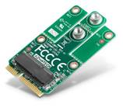

Step 2
For EWM-C141/ EWM-C160/ EWM-C163 4G modules, the windows OS only support up to 8.1 version and up to 4.2 version for android OS.

Step 3
Insert wifi module into ARK-device and make sure the LED indicator lights up when entering system OS.

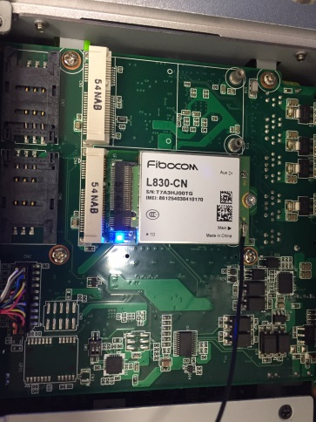

Step 4
Enter to Setting section and enable cellular mode for connecting
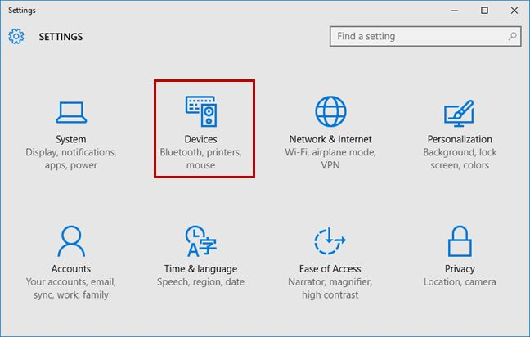
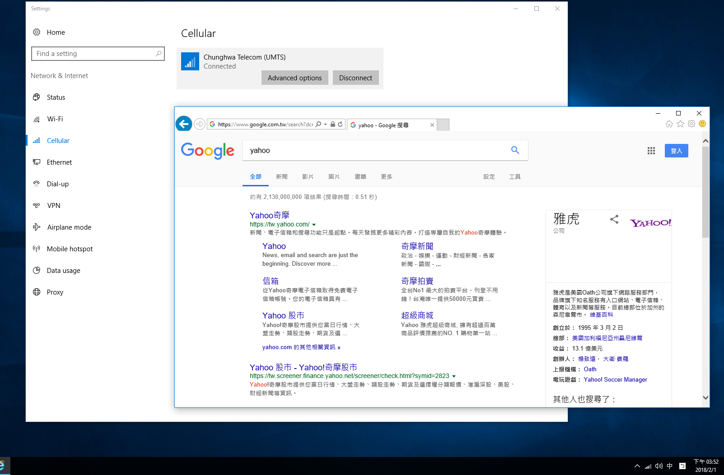
Step 5
After enabling, the cellular function will auto-search 3G/4G signal around your place to establish connection.

