How to Setup Network with AIW-341
Prerequisite
- ARK-1251 and setup Windows 11 on it
Please refer to the below picture for checking the jumper setting of M2_SEL1 pin1-2 to NC to support USB interface on ARK-1251.
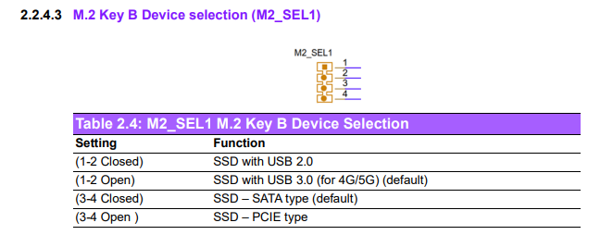

Check Device
Before driver installed, you will see the snapshot as below.
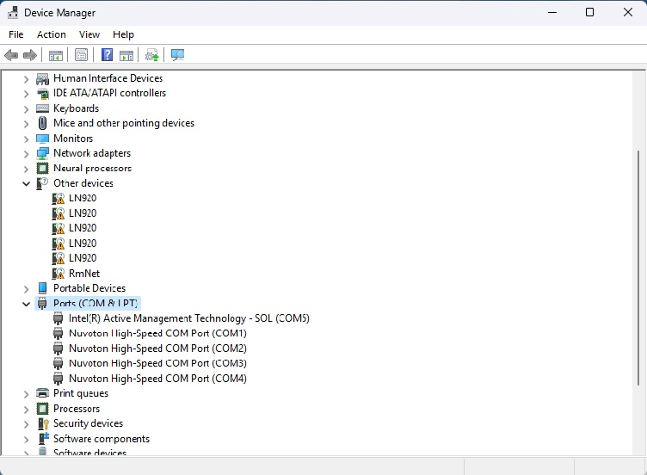

Install Driver
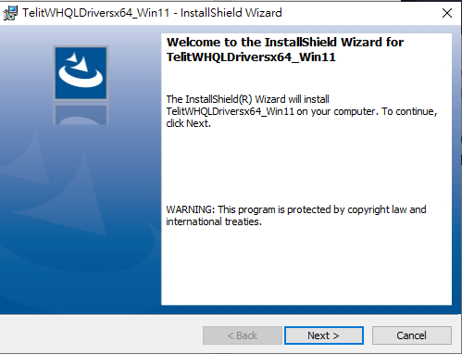
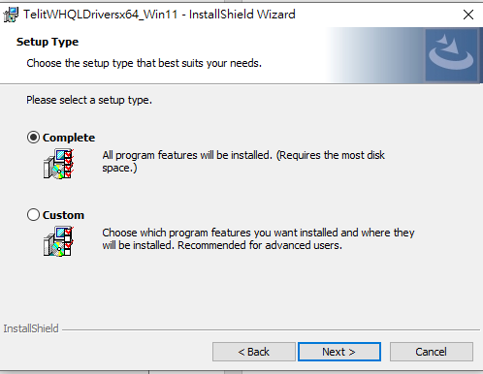

Check Device After installed driver
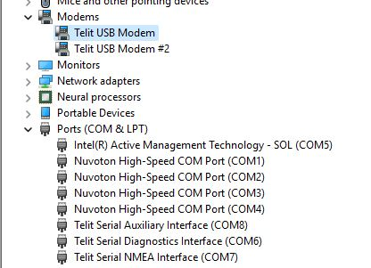
Function Test
- Access AT port
- Check the number of COM port with AIW-341 in device manager.

- Access to AT command through terminal like putty.
Please make setting as below:
  - Baud Rate “115200”
  - Data bits "8"
  - Stop bits "1"
  - Parity "None"
  - Flow Control "None"
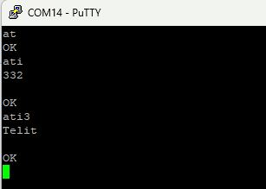

- Set USB configuration on the modem device.
  - at#usbcfg
    - Set USB to RMnet
      - at#usbcfg=1
    - Set USB to MBIM
      - at#usbcfg=2

Example:
at#usbcfg?
#USBCFG: 1
OK
- list of PDP addresses for the specified context identifiers.
  - at+cgpaddr=<cid>

Example:
at+cgpaddr=1
+CGPADDR: 1,"10.131.111.42","32.1.180.0.227.218.248.48.80.36.142.70.93.113.197.2"

- Reports the device board serial number.
  - at+gsn

Example:
at+gsn
352214163199574

- Selects a network operator and registers the module.
  - at+cops?

Example:
at+cops?
+COPS: 0,0,"Chunghwa Telecom",7

- Reads current network status.
  - at#rfsts

at#rfsts
#RFSTS: "466 92",1400,-98,-72,-9,3391,255,22,640,3,2,4F65A0C,"466924103488171","Chunghwa Telecom",3,3

- Specifies the SIM detection mode.
  - AT#SIMDET=<mode>

at#simdet?
#SIMDET: 0,1

- Selects RF bands
  - AT#BND=<GSM_band>[,<UMTS_band>[,<LTE_band>[,<LTE_band_ext>]]]
- Set LTE bnad 1 and bnad 17
Example:
AT#BND?
#BND: 0,0,10001,0

- GNSS test
Please follow the below steps to test GNSS.
Noted that please use passive antenna on AIW-341.
- Enable GNSS by at command
# AT$GPSP=1
# AT$GPSNMUN=1,0,0,1,0,0,0

- Connect to nmea port, then you will see the GNSS log.
