AIW(EWM) FAQ
Category | AIW | Date | 2026/02/04
Keyword | AIW-163BR, EWM-W179M201E, STA+SAP concurrent, Ubuntu 22.04.5, kernel 6.8.0-90-generic, MIO-5377R

Category:
1. Compile hostapd to support 802.11ax 2
2. Compile Wi-Fi driver 4
3. Unload inbox rtw89 driver and load driver 8852be.ko manually 5
4. Establish station connection 6
5. SoftwareAP setup 8

Compile hostapd to support 802.11ax
$ sudo apt update
$ sudo apt install build-essential
$ sudo apt install libnl-3-dev
$ sudo apt install libnl-genl-3-dev
$ sudo apt install pkg-config
$ sudo apt install libssl-dev
$ sudo apt install libdbus-1-dev
$ sudo apt install libreadline-dev
$ sudo apt install libnl-genl-3-dev

- Download hostapd-2.11 source code and decompress it then put it on Ubuntu system.
https://w1.fi/releases/
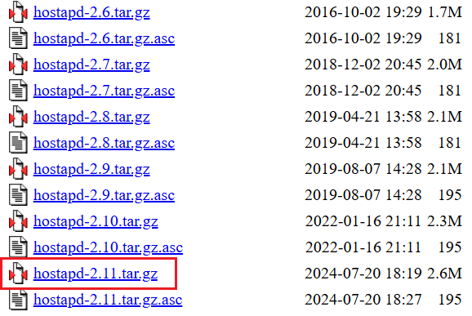

- Modify config and add make sure following configs are enabled.
$ cd hostapd-2.11/hostapd
$ cp defconfig .config
$ sudo nano .config
CONFIG_ACS=y
CONFIG_IEEE80211AC=y
CONFIG_IEEE80211AX=y
CONFIG_HE=y
CONFIG_SAE=y
CONFIG_SAE_PK=y
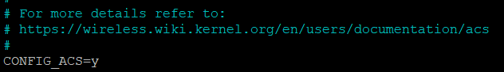
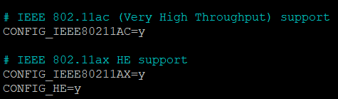
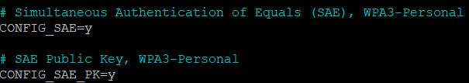

- Compile hostapd.
$ sudo make -j2
$ sudo make install

- Check hostapd version.
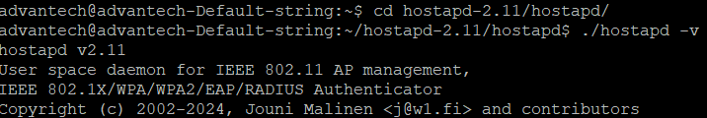

Compile Wi-Fi driver
$ sudo apt update
$ sudo apt install make
$ sudo apt install build-essential
$ sudo apt install gcc-12 g++-12
- Download driver package and decompress then place it under /home/advantech/Desktop/.
rtl8852BE_WiFi_linux_v1.19.11-248-gf8ef8b7d8.20250221_sparklan_v1.0.tar.gz

- Edit Makefile and modify CONFIG_CONCURRENT_MODE option.
$ cd /home/advantech/Desktop/rtl8852BE_WiFi_linux_v1.19.11-248-gf8ef8b7d8.20250221_sparklan_v1.0/rtl8852BE_WiFi_linux_v1.19.11-248-gf8ef8b7d8.20250221/
$ sudo nano Makefile
CONFIG_CONCURRENT_MODE = y
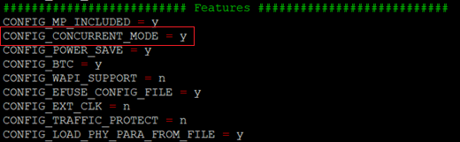
- Compile Wi-Fi driver.
$ sudo make
After driver successfully compiled, there will be 8852be.ko appears

Unload inbox rtw89 driver and load 8852be.ko manually
$ sudo rmmod rtw89_8852be
$ sudo rmmod rtw89_8852b
$ sudo rmmod rtw89_core
$ sudo rmmod rtw89_pci
$ lsmod | grep rtw89

- Load Wi-Fi driver.
$ cd /home/advantech/Desktop/rtl8852BE_WiFi_linux_v1.19.11-248-gf8ef8b7d8.20250221_sparklan_v1.0/rtl8852BE_WiFi_linux_v1.19.11-248-gf8ef8b7d8.20250221/
$ sudo insmod 8852be.ko rtw_country_code=TW

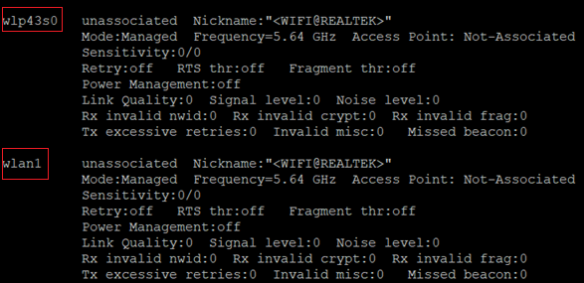
There will be two wireless interfaces after driver successfully loaded.

Establish station connection
- Edit wpa_supplicant config.
$ sudo systemctl stop NetworkManager.service
$ sudo systemctl stop wpa_supplicant.service
$ sudo nano /home/advantech/Desktop/wpa.conf

wpa.conf:
pmf=2
sae_pwe=1
network={
ssid="MLO-AP-433"
key_mgmt=SAE
ieee80211w=1
sae_password="1234567890"
pairwise=CCMP
}
- *Above wpa_supplicant config is for WPA3-SAE SSID. Please refer to following wpa_supplicant config of WPA2-PSK.
pmf=1
network={
scan_ssid=1
ssid="RF_5G"
psk="1234567890"
proto=RSN
key_mgmt=WPA-PSK
pairwise=CCMP
}

- Execute wpa_supplicant to establish Wi-Fi connection.
$ sudo wpa_supplicant -Dnl80211 -i wlan1 -c /home/advantech/Desktop/wpa.conf
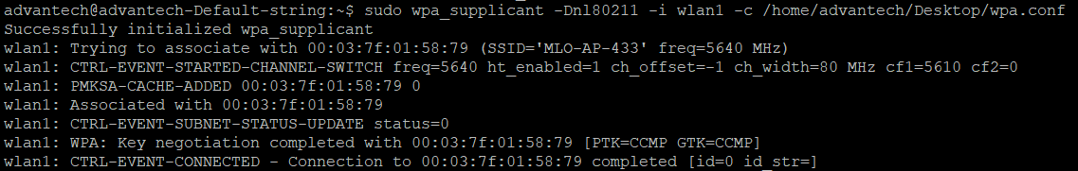

- Request DHCP IP.
$ sudo dhclient wlan1
$ ifconfig
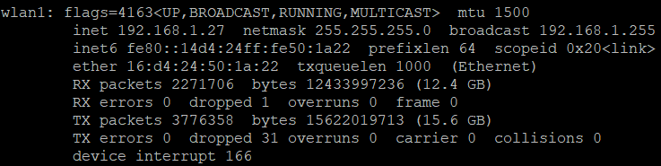

wpa_supplicant version:

SoftwareAP setup
- Edit hostapd config.
$ sudo nano /home/advantech/Desktop/hostapd.conf
hostapd.conf:
ctrl_interface=/var/run/hostapd
interface=wlp43s0
driver=nl80211
ctrl_interface_group=0
ssid=_8852_aptest
hw_mode=a
channel=36
wpa_passphrase=1234567890
wpa=2
wpa_key_mgmt=WPA-PSK
rsn_pairwise=CCMP

ieee80211n=1
ht_capab=[HT40+][HT40-][SHORT-GI-20][SHORT-GI-40]
ieee80211ac=1
vht_oper_chwidth=1
vht_oper_centr_freq_seg0_idx=42
ieee80211ax=1
he_oper_chwidth=1
he_oper_centr_freq_seg0_idx=42
country_code=TW

- Edit DHCP server.
$ sudo apt install isc-dhcp-server
$ sudo nano /etc/default/isc-dhcp-server
INTERFACESv4=”wlp43s0”
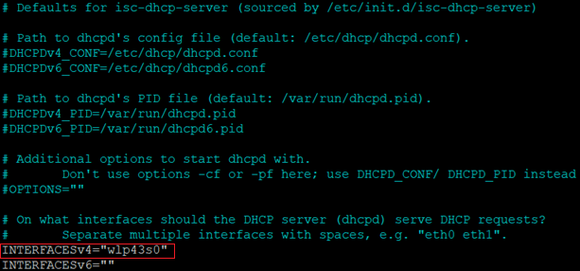
- Assign DHCP clients IP range.
$ sudo nano /etc/dhcp/dhcpd.conf
dhcpd.conf:
subnet 10.10.0.0 netmask 255.255.255.0 {
range 10.10.0.2 10.10.0.16;
option domain-name-servers 8.8.4.4, 8.8.8.8;
option routers 10.10.0.1;
}
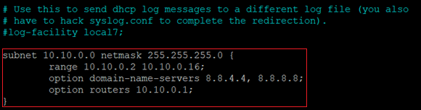

- Specify static IP address for the wireless interface of softwareAP.
$ sudo ifconfig wlp43s0 10.10.0.1
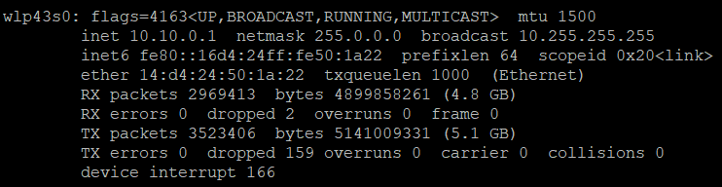

- Start isc-dhcp-server service.
$ sudo service isc-dhcp-server start
$ sudo systemctl status isc-dhcp-server
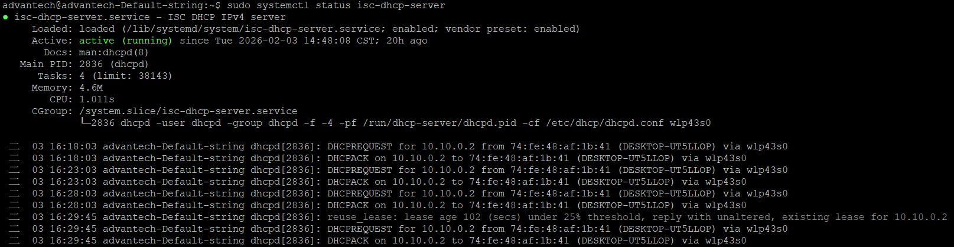

- Execute hostapd to start softwareAP.
$ sudo hostapd-2.11/hostapd/hostapd -dd /home/advantech/Desktop/hostapd.conf

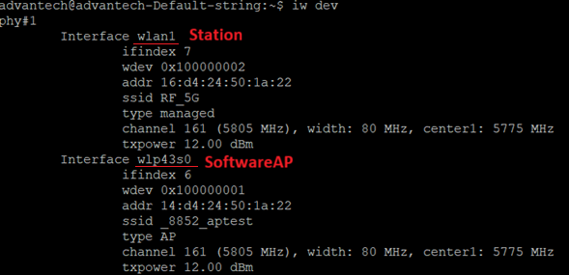

Ubuntu 22.04.5 LTS, kernel 6.8.0-90-generic
