AIW(EWM) FAQ
Category | AIW | Date | 2022/08/17
Keyword | AIW-343, Ubuntu 18.04 NVIDIA Tegra platform, MIC-710AIX-00A1

- Question:
How to setup ​​AIW-343 under Ubuntu 18.04 on MIC-710AIX-00A1?

- Instructions :

In the beginning, we need to add runtime support for serial port manually using below commands.
# modprobe option
# echo 1bc7 1252 > /sys/bus/usb-serial/drivers/option1/new_id
*Please check module’s PID by command lsusb and replace it.
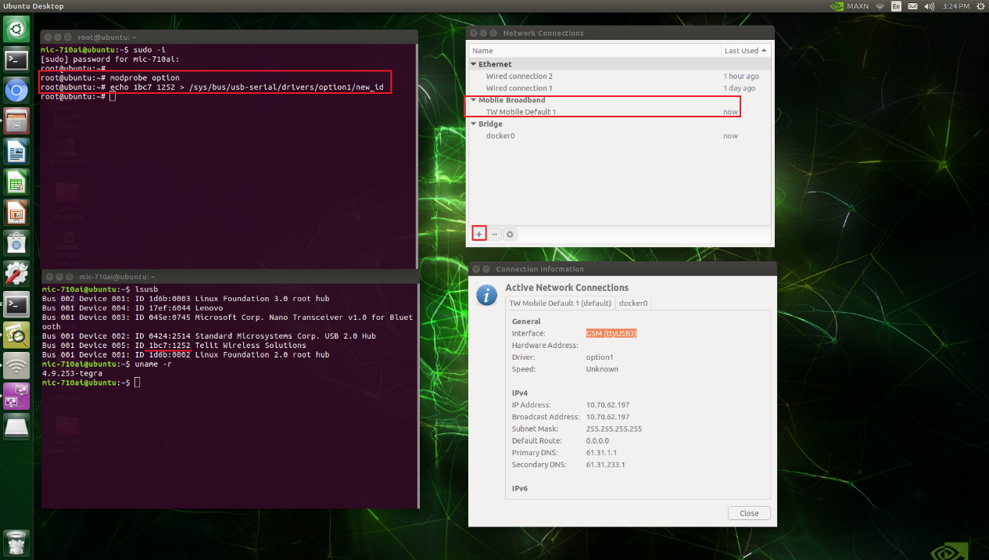
Remember to add a Mobile Broadband interface manually as following steps.
- Go to Network Connection page and add a Mobile Broadband interface.
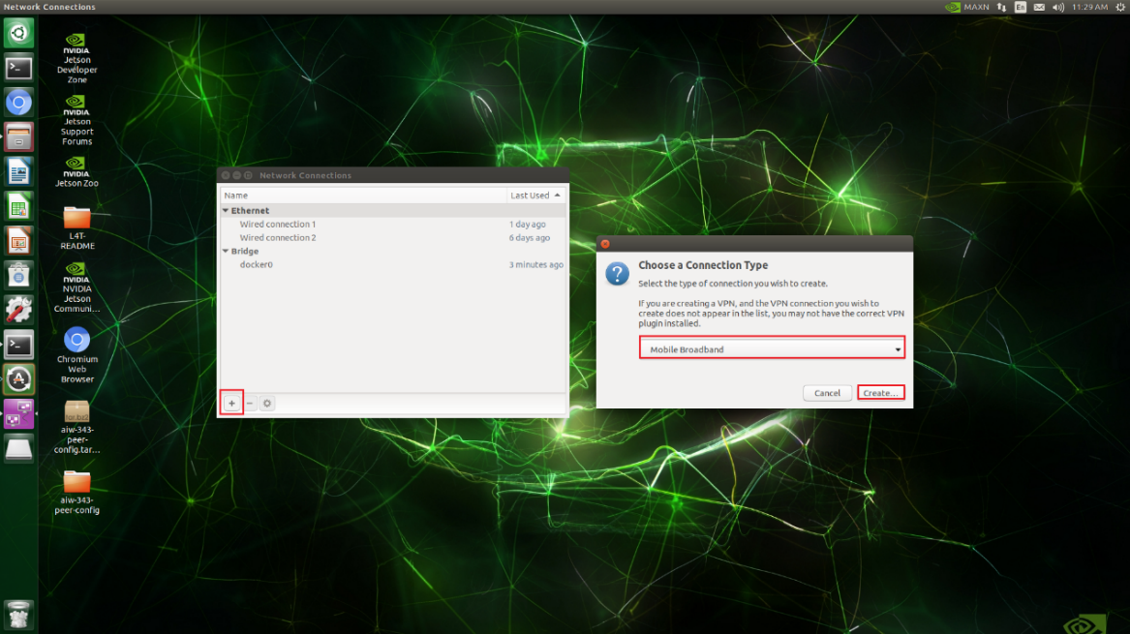
- Click “Next”.
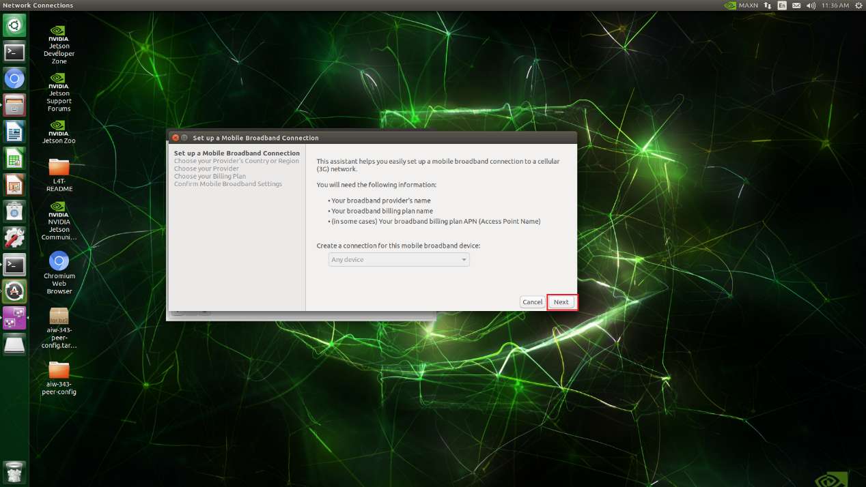

- Select the correct country.
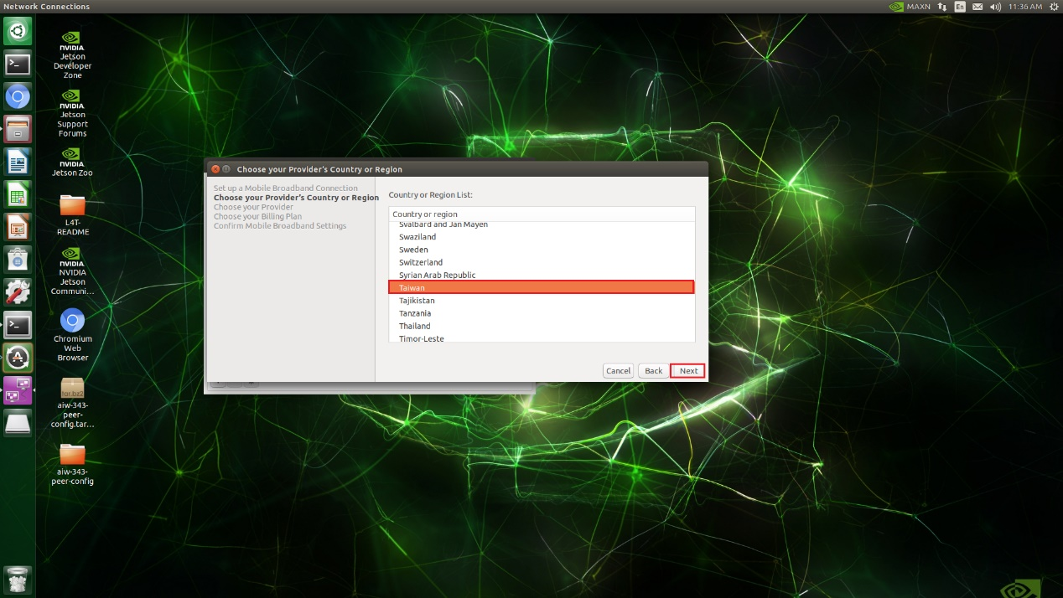
- Select the correct provider.
`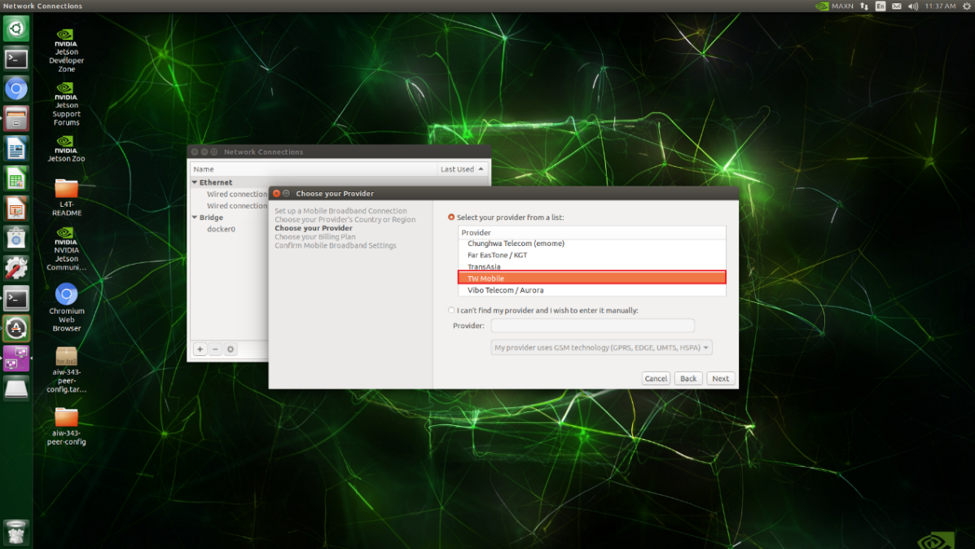
- Select the plan which with correct APN.
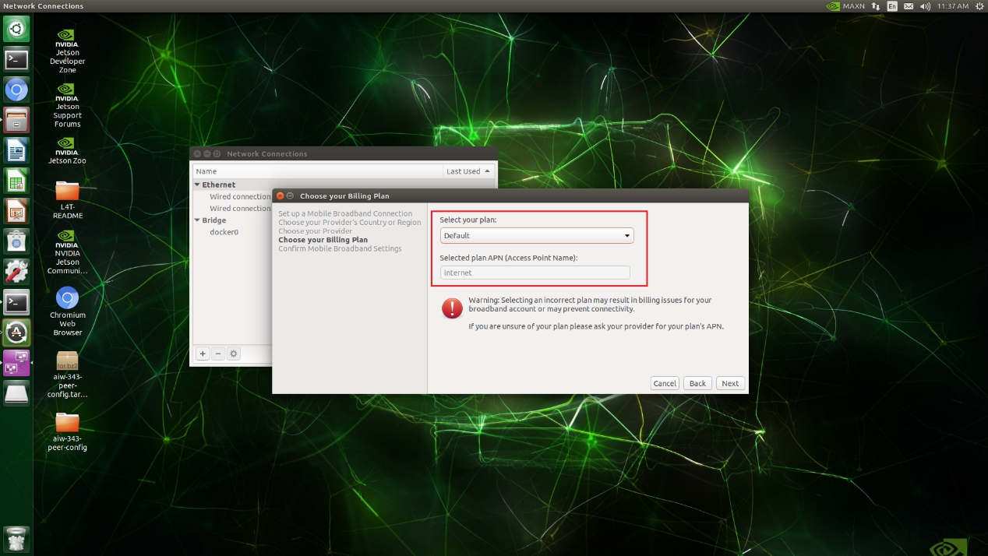

- Click “Apply”.
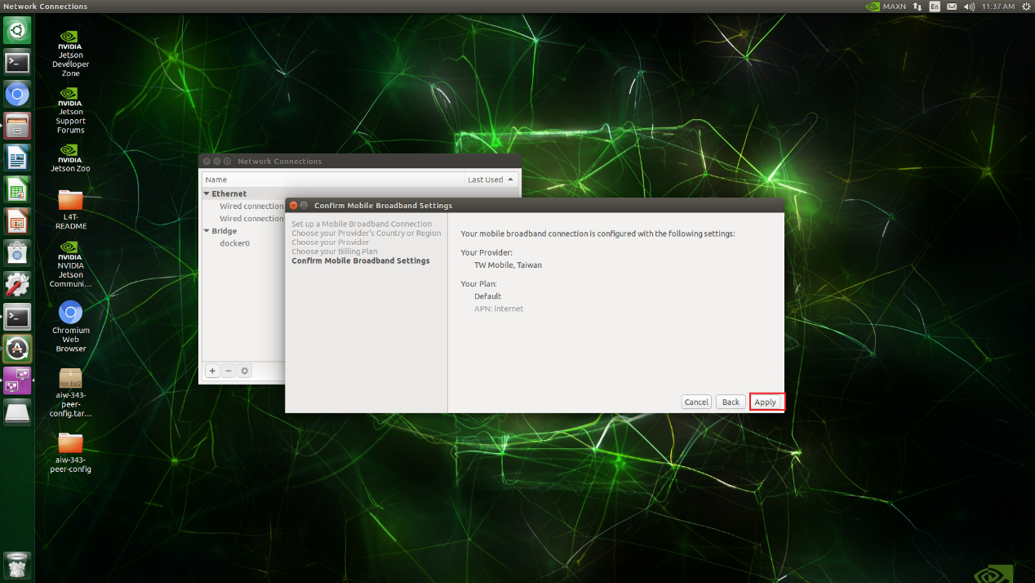
- Click “Save”.
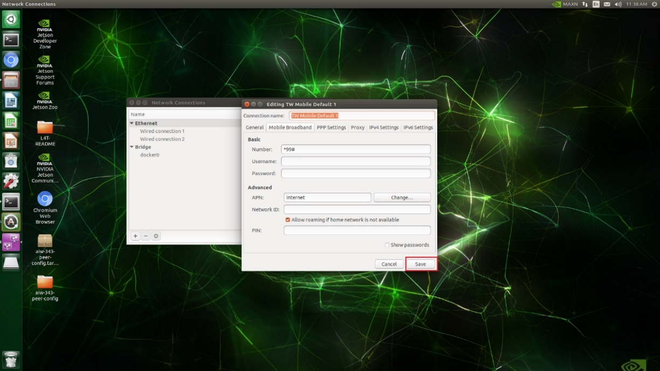
- Finally, mobile broadband interface has been added.
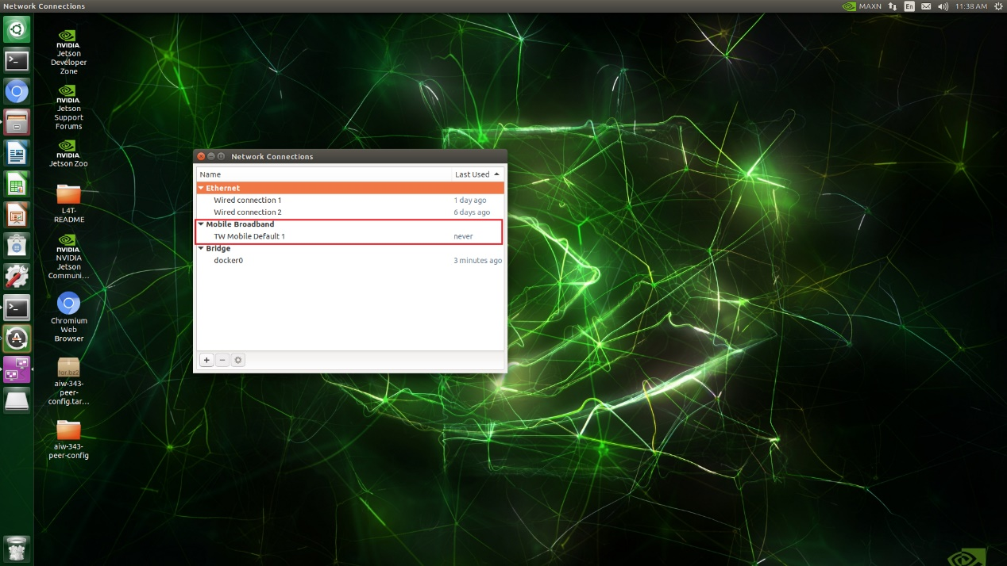

Next, please follow below steps to make it execute automatically so that users don’t need to add runtime support for serial port manually each time after device reboot.

- Create rc-local.service.
# vi /etc/systemd/system/rc-local.service
Then add below contents.
[Unit]
Description=/etc/rc.local Compatibility
ConditionPathExists=/etc/rc.local
[Service]
Type=forking
ExecStart=/etc/rc.local start
TimeoutSec=0
StandardOutput=tty
RemainAfterExit=yes
SysVStartPriority=99
[Install]
WantedBy=multi-user.target

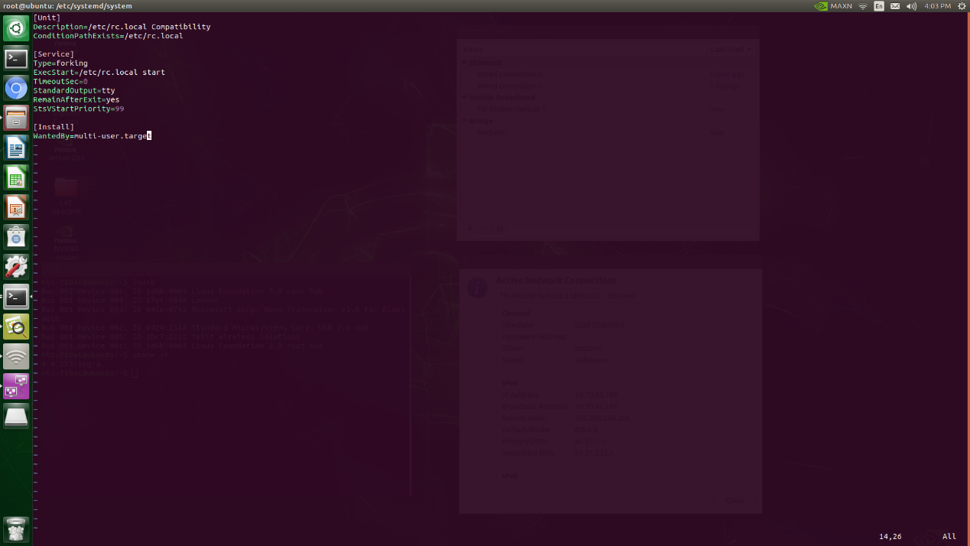
- Create rc.local.
# vi /etc/rc.local
Then add below contents.
#!/bin/bash
modprobe option
echo 1bc7 <PID> > /sys/bus/usb-serial/drivers/option1/new_id
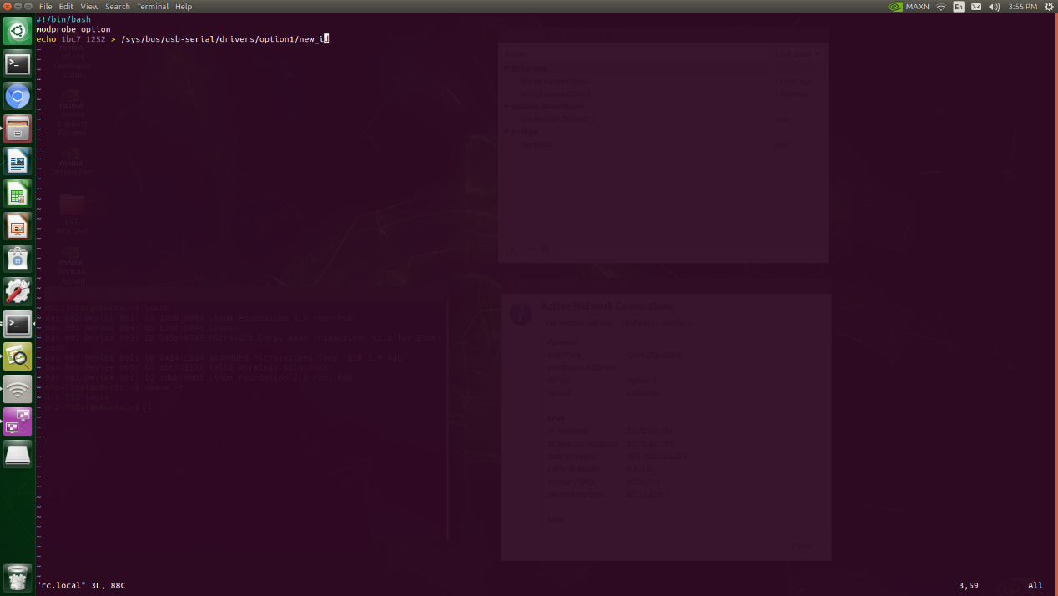
- Modify permission of rc.local.
# chmod +x /etc/rc.local
- Start the service.
# systemctl enable rc-local
# systemctl start rc-local

- Check this item so that users don’t need to do anything then the cellular network will be established automatically after bootup.
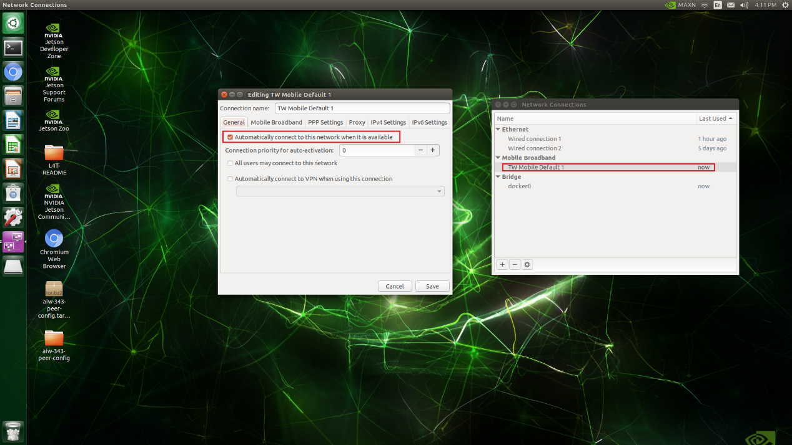
- Reboot and check whether cellular network established.
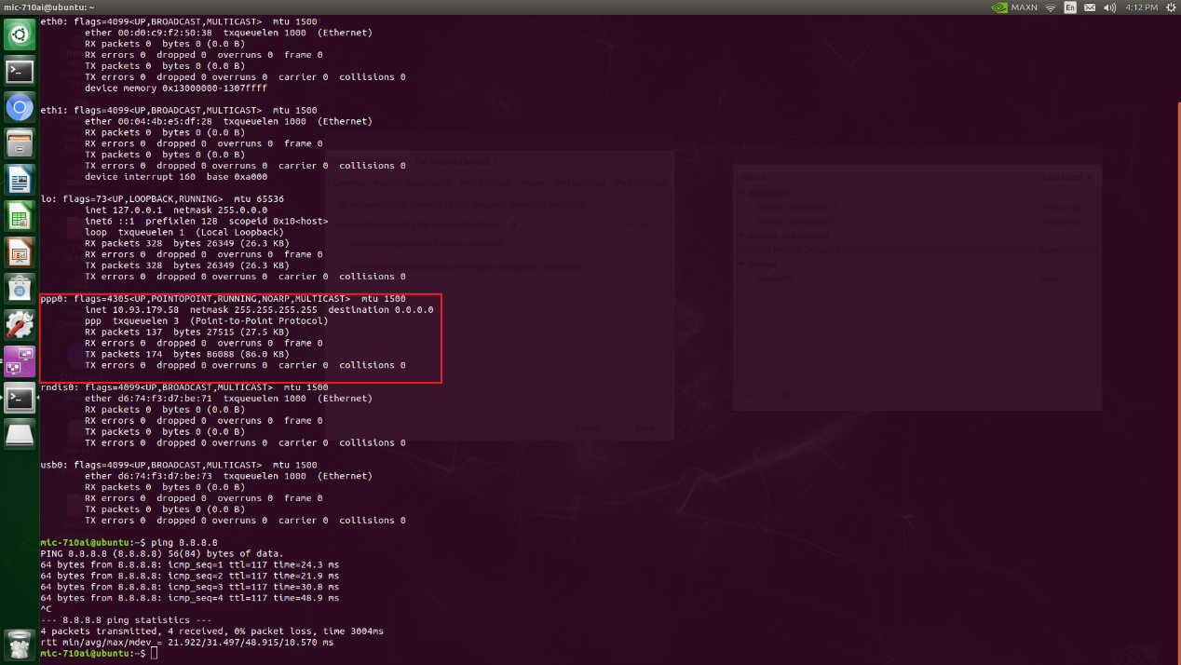

*Test environment:
