AIW(EWM) FAQ
Category | AIW | Date | 2025/01/15
Keyword | AIW-346, Ubuntu 20.04.6, kernel 5.10.120-tegra, MIC-733AO
- Question:
AIW-346 cellular connection troubleshooting on MIC-733AO

- Instructions :
Issue Description#1_Verizon SIM card
There’s SIM slot on the back side of AIW-346. Even SIM card is inserted, but the status shows SIM card is not inserted and no connection is established.
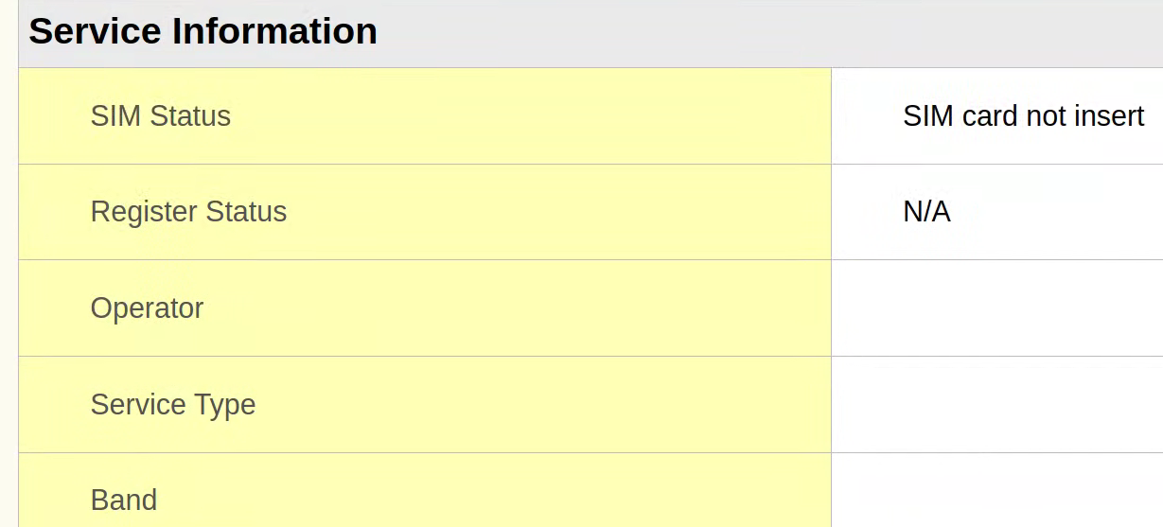
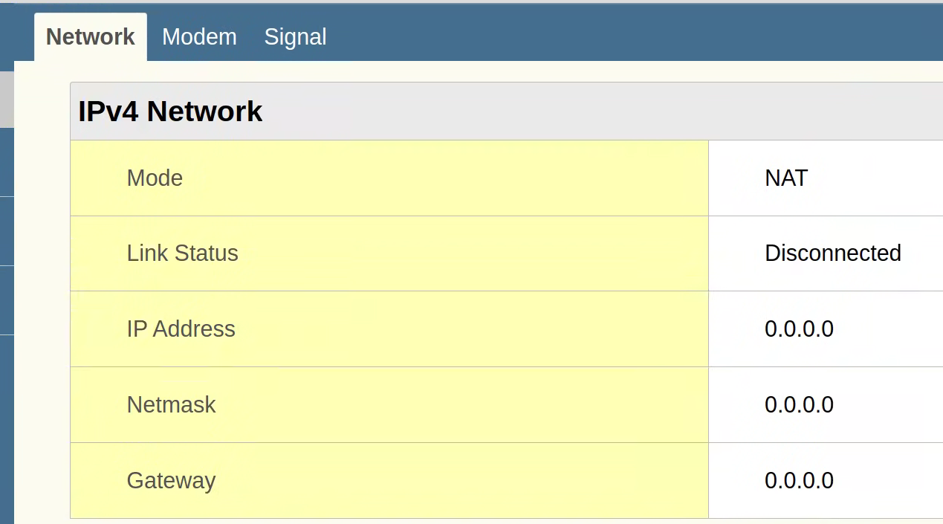

Troubleshooting#1_Verizon SIM card
Because SIM card is inserted on the back side of AIW-346, we need to modify setting on webGUI.
- SIM Select option is configured as Internal.
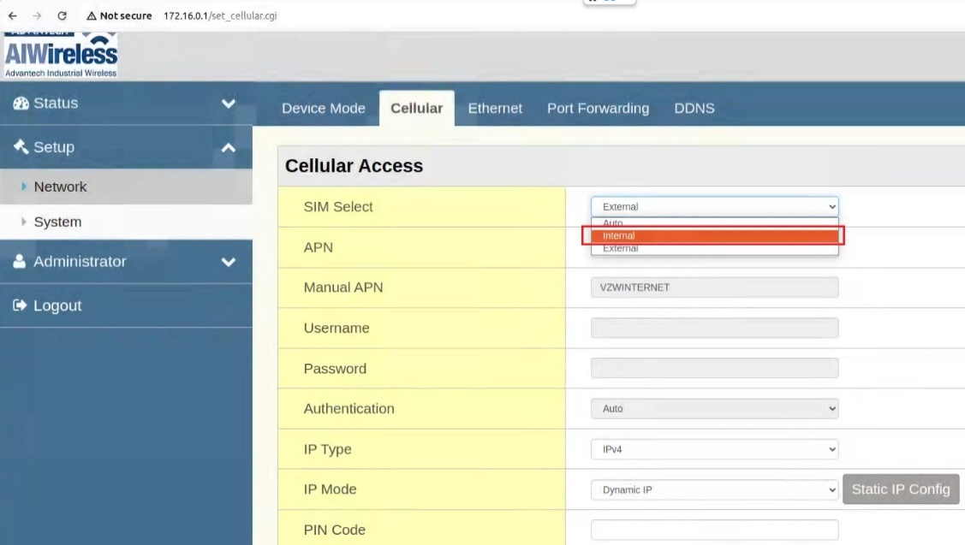
- APN is configured as Auto to let module acquire APN automatically.
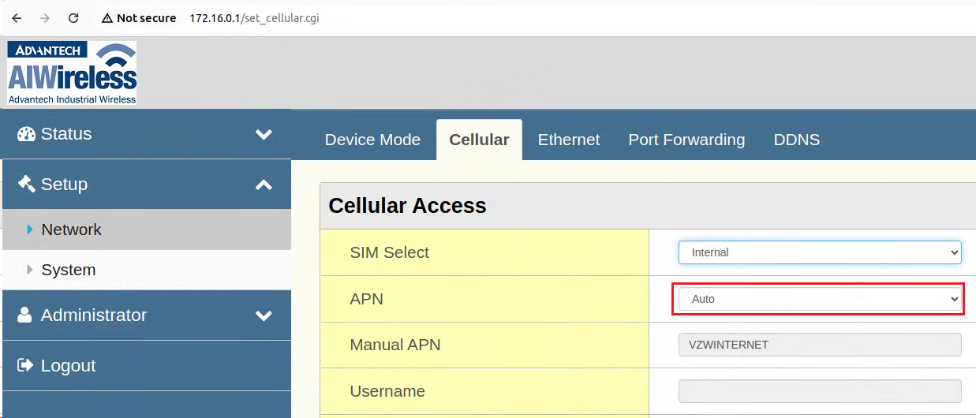

Reboot to make above change take effect.
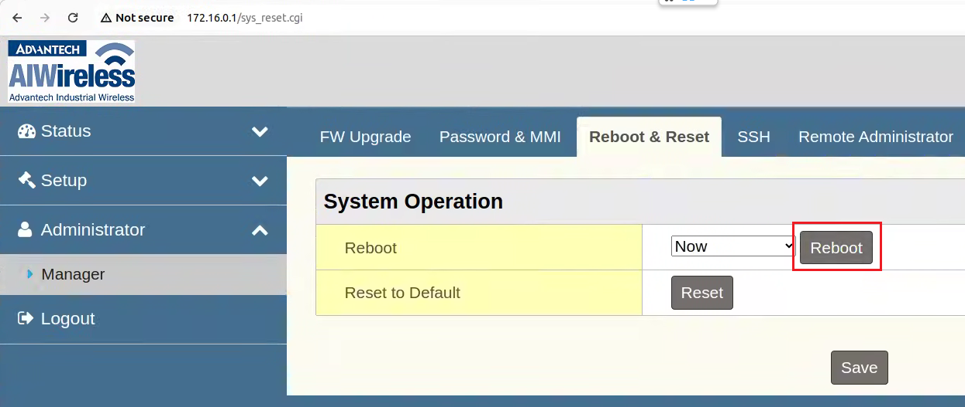
Result#1_Verizon SIM card
After modifying above setting, Verizon SIM is working. It has established cellular connection and get public IP address as following screenshot.
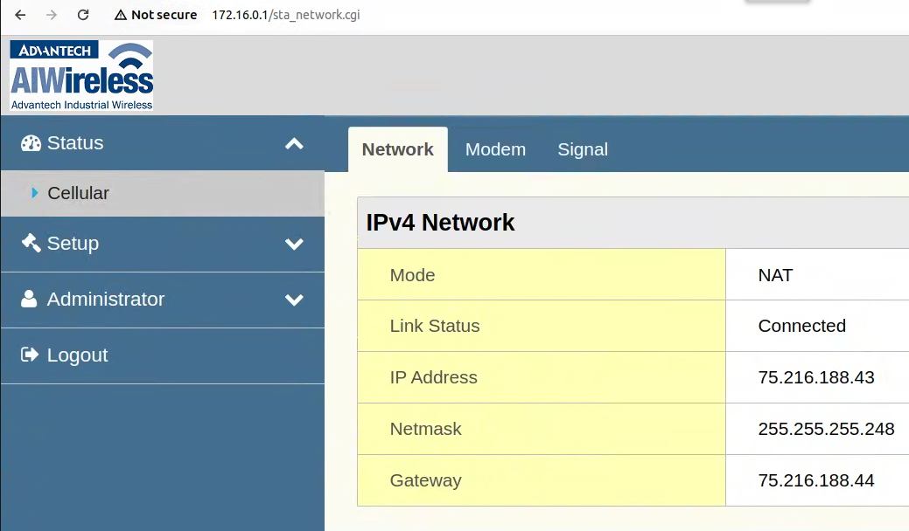

Issue Description#2_T-Mobile SIM card
Customer is going to test T-Mobile SIM and has sent it to ANA for further check. Unfortunately, even with the same steps, it can’t work after replacing Verizon SIM with T-Mobile SIM.
SIM status shows ready but register status shows “Registration denied”, which means that it can’t establish cellular connection.
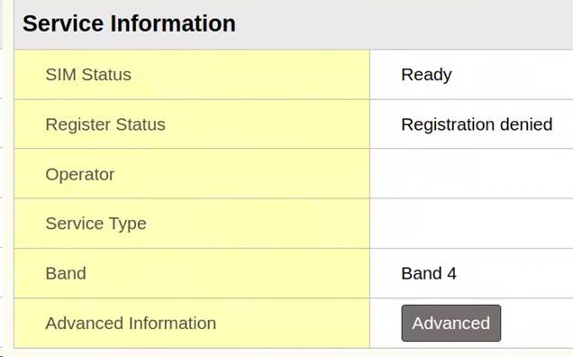

Troubleshooting#2_T-Mobile SIM card
Try to narrow down issue with following questions.
(1)Customer has sent different T-Mobile SIM to ANA for further check.
-> not working with either one T-Mobile SIM

(2)Basically, to rule out whether it’s a T-Mobile SIM card issue, we will check SIM card with our smart phone to verify it’s a working SIM. But in this case, smart phone of ANA FAE is limited to AT&T telecom only. In other words, he can’t use his smart phone to verify T-Mobile SIM card.
-> not able to check

(3)ANA check with T-Mobile, then get static IP address and specific APN shared from T-Mobile.
-> not working with suggested static IP address and specific APN
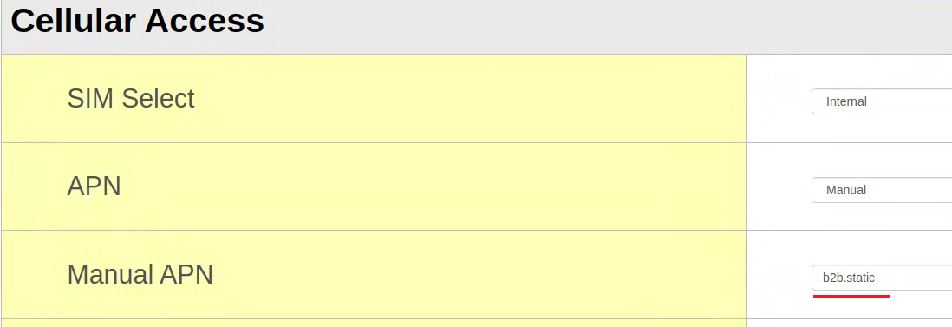

Then, take the remote to check. After debugging with AT command “at+cops=?”, it shows 311480.
The at+cops=? command is used to list all available mobile networks that the modem or module can detect in the current area. It returns information about the networks, including their names and operational statuses.
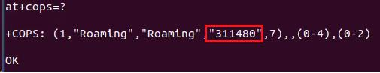
311480 stands for Verizon telecom operator.
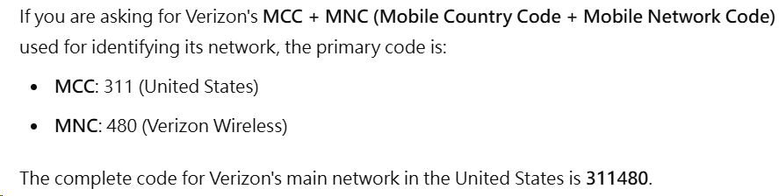

Thus, we suspect that there’s no T-Mobile signal coverage in current area and request ANA FAE to check following.
1.Please help confirm there's T-Mobile signal coverage where you did the test. If yes, please move the whole platform and antenna close the window so that can get better cellular signal.
2.Is there any one has T-Mobile telecom signal with their smart phone in your office?
3.Have you connected all cellular antenna on AIW-346? Which P/N of antenna did you connect?

Result#2_T-Mobile SIM card
Finally, after moving MIC-733AO next to the window, then it’s able to establish cellular connection with T-Mobile SIM.
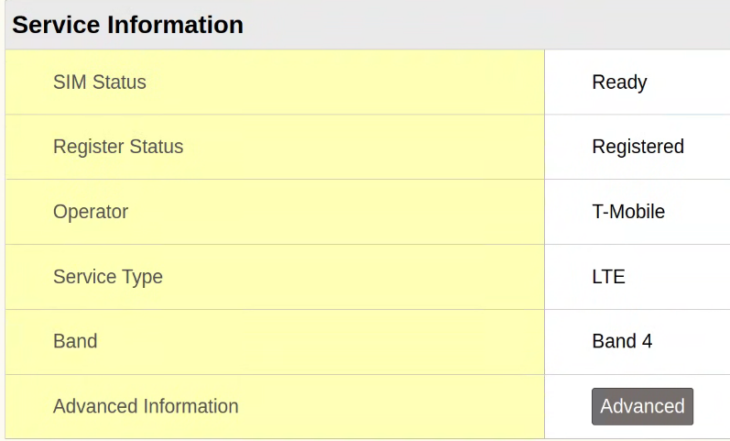
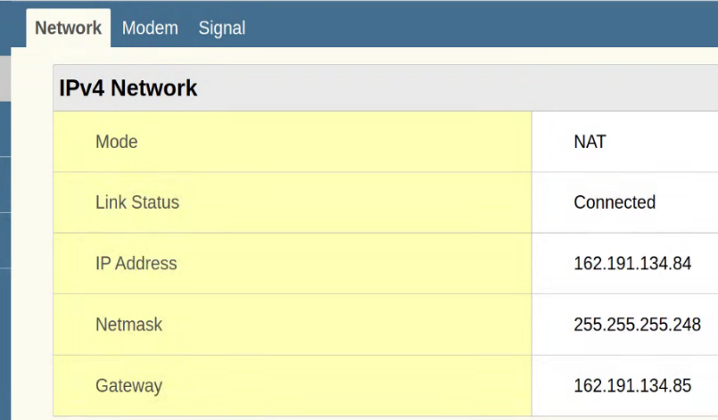

Use AT command “at+cops=?” and we can see T-Mobile telecom information.
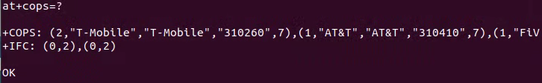
310260 stands for T-Mobile telecom operator.
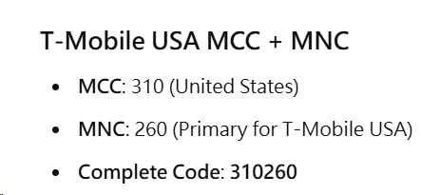

- Conslusion :
About cellular network connection issue, please check whether SIM card is detected.
Before:
After:

If cellular network connection can’t establish even SIM card is detected, please check following items.

1. Insert SIM card to a smart phone to verify SIM card is working in current area.
2. Check with telecom operator whether it requires specific APN or IP address.
3. AT command “at+cops=?” will list available mobile networks in current area.
4. Move DUT next to the window to have better signal coverage.

