AIW FAQ
AIW-172 driver & kernel compile on x86 platform
Category | AIW | Date | 2026/04/09
Keyword | AIW-172, driver, Ubuntu 20.04.6 LTS, Ubuntu 22.04.5 LTS, kernel 5.15.24+, MIO-5377R, ARK-1250L
Category:
1. Prerequisite 2
2. Check Device 2
3. Install Tool Packages 3
4. Compile Kernel 5.15.24+ 5
5. Build WLAN Driver 8
6. Load WLAN Driver 9
7. Establish WLAN Connection 11
8. Build and Load Bluetooth Driver 13
9. Bluetooth test with Fluoride stack 15

Prerequisite
MIO-5377R or ARK-1250L that has been installed Ubuntu 20.04.6 LTS or Ubuntu 22.04.5 LTS with normal installation.

Check Device
- Check PCIe interface for WiFi
$ lspci
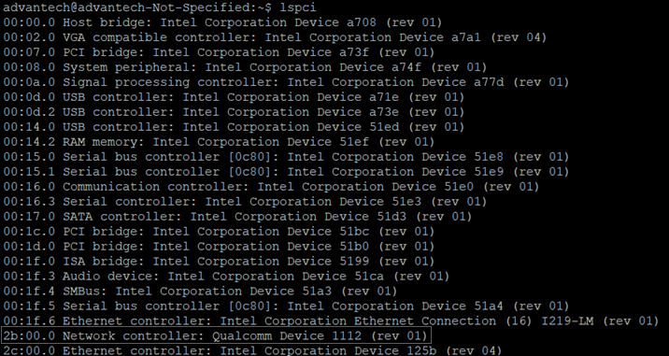

- Check USB interface for BT.
$ lsusb
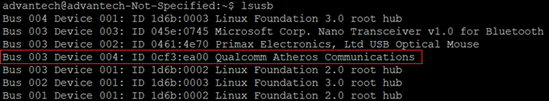

Install Tool Packages
[Ubuntu 20.04.6 LTS]
$ sudo apt-get update
$ sudo apt-get install iperf
$ sudo apt-get install iperf3
$ sudo apt-get install python
$ sudo apt-get install crash
$ sudo apt-get install ssh
$ sudo apt-get install net-tools
$ sudo apt-get install vim
$ sudo apt-get install -y openssh-server dos2unix wireless-tools exfat-utils exfat-fuse
$ sudo apt-get install linux-crashdump
Note that select “Yes” for both the prompts that show during “kexec-tools” and “kdump-tools” installation as below.
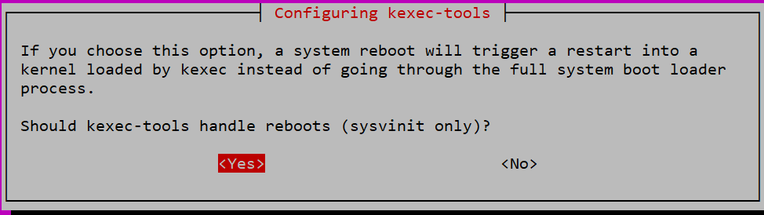
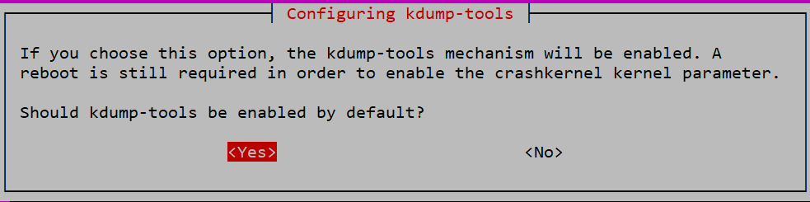
$ sudo apt-get install build-essential libncurses5-dev flex bison libnl-3-dev
$ sudo apt-get install kernel-package openssl
Note that select “Keep the local version currently installed” and press “Enter” to continue.
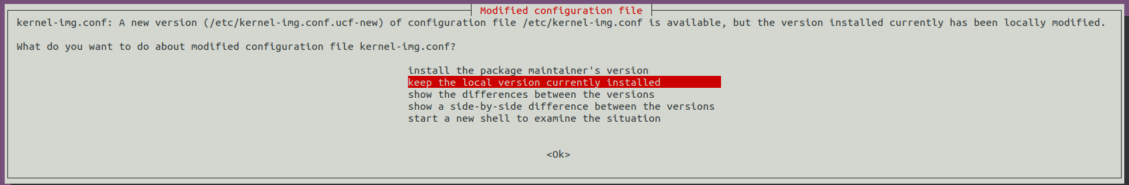
$ sudo apt-get install libssl-dev
$ sudo apt-get install libelf-dev
$ sudo apt-get install -y libnl-genl-3-dev
$ sudo apt-get install libdbus-1-dev
$ sudo apt-get install git
$ sudo apt-get install -y autoconf libtool
$ git config --global user.email "user email address"
$ git config --global user.name "user name"
$ sudo dpkg-reconfigure tzdata

[Ubuntu 22.04.5 LTS]
$ sudo apt-get update
$ sudo apt-get install iperf
$ sudo apt-get install iperf3
$ sudo apt-get install crash
$ sudo apt-get install ssh
$ sudo apt-get install net-tools
$ sudo apt-get install vim
$ sudo apt-get install -y openssh-server dos2unix wireless-tools exfatprogs exfat-fuse
$ sudo apt-get install linux-crashdump
Note that select “Yes” for both the prompts that show during “kexec-tools” and “kdump-tools” installation as below.
$ sudo apt-get install build-essential libncurses5-dev flex bison libnl-3-dev
$ sudo apt-get install openssl
$ sudo apt-get install libssl-dev
$ sudo apt-get install libelf-dev
$ sudo apt-get install -y libnl-genl-3-dev
$ sudo apt-get install libdbus-1-dev
$ sudo apt-get install git
$ sudo apt-get install -y autoconf libtool
$ git config --global user.email "user email address"
$ git config --global user.name "user name"
$ sudo dpkg-reconfigure tzdata

Compile Kernel 5.15.24+
- Download Linux kernel version 5.15.24.
$ git clone git://git.kernel.org/pub/scm/linux/kernel/git/stable/linux-stable.git
$ cd linux-stable
$ git checkout v5.15.24

- Download Linux kernel version 5.15.24 patches.
$ git clone https://git.codelinaro.org/clo/sba-patches/wlan_patches.git

- Apply Linux kernel patches 0001-0179.
- Add the patch.sh file to the linux-stable folder.
$ cd /home/advantech/linux-stable/
$ sudo nano patch.sh

patch.sh:
#!/bin/bash
function patchfile ()
{
for file in `ls $1`
do
if [ -d $1"/"$file ]
then
patchfile $1"/"$file
else
echo $1"/"$file
git apply $1"/"$file
echo `basename $file`
fi
done
}
patchfile $1

- Run “sudo chmod 777 patch.sh”.
$ sudo chmod 777 patch.sh

- Run “./patch.sh wlan_patches/fixce/3rdparty/patches/wlan_patches/kernel/v5.15_cologne/”.
$ ./patch.sh wlan_patches/fixce/3rdparty/patches/wlan_patches/kernel/v5.15_cologne/

- Copy kernel config file from the existing kernel 5.15.24 system to the kernel tree.
$ sudo cp wlan_patches/fixce/3rdparty/patches/wlan_patches/kernel/v5.15_cologne/config-5.15.24+ .config

- Make kernel config.
$ make menuconfig
load > ok > save > ok > exit > exit
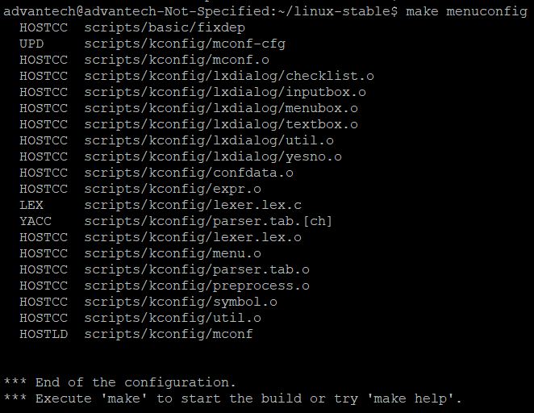

- Build & install the Linux kernel.
$ make -j 2
$ make modules -j 2
$ sudo make modules_install
$ sudo make install

NOTE: make -j 2 -> depends on cpu cores

- Reboot with kernel 5.15.24+.
To make sure that the kernel version 5.15.24+ could be selected after system restart, edit grub setting as following screenshot then save it.
$ sudo nano /etc/default/grub
$ sudo update-grub
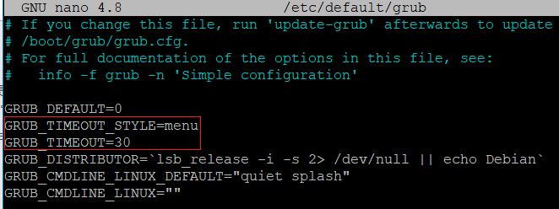
- After system restart, it will pop up grub menu during bootup process so that users could select kernel 5.15.24+ manually.
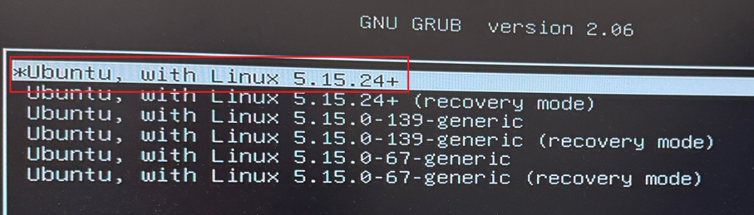

Build WLAN Driver
- Download driver source package, unzip it and copy it to the system.
AIW_172_driver.zip

- Move to the folder that unzipped in last step and download driver codes with script. Here, I put “AIW_172_driver” under /home/advantech/Desktop/.
$ cd /home/advantech/Desktop/AIW_172_driver/AIO/apps/
$ sudo rm -r hostap/
$ cd /home/advantech/Desktop/AIW_172_driver/aio-gen/
$ sudo chmod 777 aio_gen_bit.sh
$ ./aio_gen_bit.sh -r -t cgn-f10
$ cd ../../

- Copy host folder to “/” and modify folder name from AIW_172_driver to 172.
$ sudo cp -fr ./AIW_172_driver /172

- Apply patches
$ cd /172/AIO/build/
$ sudo git config --global user.email "your_email"
$ sudo git config --global user.name "your_name"
$ sudo make drivers_patch
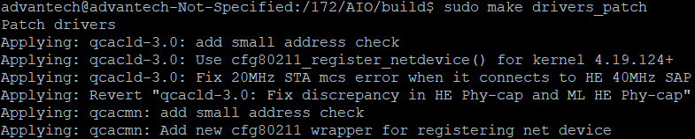

- Build the WLAN driver
$ sudo make

After driver built successfully, then there will be two driver files wlan_cnss_core_pcie.ko & wlan.ko under /172/AIO/rootfs-cgn-f10.build/lib/modules/.

Load WLAN Driver
- Copy firmware from driver source package path to /lib/firmware/. (qcc2072-lea-1-0_qca_standard_oem-r00040.1-b592ec237fb2792b726af7b9905a3822ca65049b is in path /home/advantech/Desktop/.)
qcc2072-lea-1-0_qca_standard_oem-r00040.1-b592ec237fb2792b726af7b9905a3822ca65049b.zip
$ cd /home/advantech/Desktop/qcc2072-lea-1-0_qca_standard_oem-r00040.1-b592ec237fb2792b726af7b9905a3822ca65049b/meta_build/load_meta/wlan_firmware/
$ sudo cp -f ./* /lib/firmware/

- Copy qcom_cfg.ini file to /lib/firmware/wlan/. (qcom_cfg.ini is in path /home/advantech/Desktop/.)
qcom_cfg.ini
$ cd /home/advantech/Desktop/
$ sudo mkdir -p /lib/firmware/wlan/
$ sudo cp -f ./qcom_cfg.ini /lib/firmware/wlan/

- Edit qcom_cfg.ini file and confirm following options are included.
$ sudo nano /lib/firmware/wlan/qcom_cfg.ini
gDot11Mode=0
gindoor_channel_support= 1
scan_mode_6ghz=2

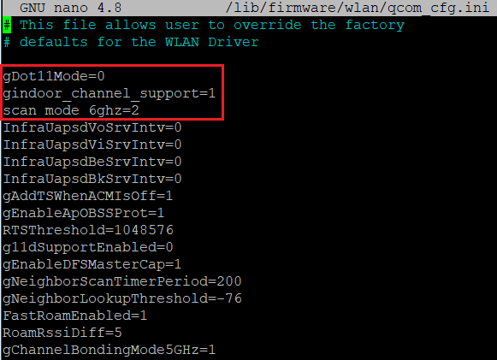

- Load WLAN drivers.
$ sudo modprobe cfg80211
$ cd /172/AIO/rootfs-cgn-f10.build/lib/modules/
$ sudo insmod ./wlan_cnss_core_pcie.ko
$ sudo insmod ./wlan.ko country_code=US
*country_code could be replaced accordingly

Establish WLAN Connection
- Stop NetworkManager & wpa_supplicant service.
$ sudo systemctl stop NetworkManager.service
$ sudo systemctl stop wpa_supplicant.service
- Create wpa_supplicant.conf.
$ sudo nano /etc/wpa_supplicant/wpa.conf
- wpa.conf for 6GHz(WPA3):
ctrl_interface=/var/run/wpa_supplicant
update_config=1
ap_scan=1
fast_reauth=1
#6GHz_setting
pmf=1
sae_pwe=1
#6GHz_setting
network={
ssid="RF_6G"
psk="91779177"
scan_ssid=1
pairwise=CCMP TKIP
group=CCMP TKIP
proto=RSN
key_mgmt=SAE
ieee80211w=1
}

- wpa.conf for 2.4GHz/5GHz(WPA2):
ctrl_interface=/var/run/wpa_supplicant
update_config=1
network={
ssid="RF_5G"
psk="1234567890"
}

- Check WLAN interface name & run wpa_supplicant.
$ iw dev
$ sudo /172/AIO/rootfs-cgn-f10.build/sbin/wpa_supplicant -Dnl80211 -i wlan0 -c /etc/wpa_supplicant/wpa.conf -B
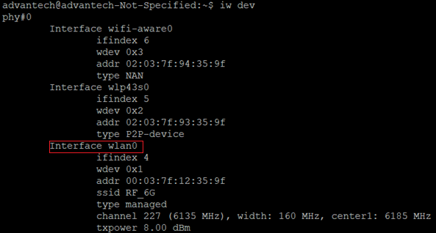

- Get IP address by DHCP and check network connection.
$ sudo dhclient wlan0
$ ping 8.8.8.8 -i wlan0

- Disconnect the current connected SSID.
$ sudo killall wpa_supplicant

Build and Load Bluetooth Driver
qcc2072-lea-1-0_qca_standard_oem-r00040.1-b592ec237fb2792b726af7b9905a3822ca65049b.zip

- Build Bluetooth Driver
$ cd qcc2072-lea-1-0_qca_standard_oem-r00040.1-b592ec237fb2792b726af7b9905a3822ca65049b/chss_proc/host/
$ sudo chmod 777 aio-gen/build/scripts/cgn-f10/x86_bt.sh
$ BT_CONTROLLER_TYPE=gno_usb ./aio-gen/build/scripts/cgn-f10/x86_bt.sh dpb /home/advantech/Desktop/AIW_172_BT

- Load Bluetooth Driver
- Create folder.
$ sudo mkdir -p /lib/firmware/ar3k/
$ sudo mkdir -p /etc/bluetooth/
$ sudo mkdir -p /data/misc/bluetooth/
- Copy firmware, lib and configuration files.
$ sudo cp /home/advantech/Desktop/qcc2072-lea-1-0_qca_standard_oem-r00040.1-b592ec237fb2792b726af7b9905a3822ca65049b/meta_build/load_meta/bt_firmware/usb/* /lib/firmware/ar3k/
$ sudo cp -f /home/advantech/Desktop/AIW_172_BT/x86_64_out_rootfs/usr/lib/* /usr/lib/
$ sudo cp -f /home/advantech/Desktop/AIW_172_BT/x86_64_out_rootfs/etc/bluetooth/* /etc/Bluetooth/
- Remove BlueZ stack.
$ sudo apt-get remove bluez
$ sudo apt-get remove --auto-remove bluez
$ sudo apt-get purge bluez
$ sudo apt-get purge --auto-remove bluez
- Rename bluetooth folder under kernel path
$ sudo mv -f /lib/modules/5.15.24+/kernel/drivers/bluetooth/ /lib/modules/5.15.24+/kernel/drivers/bluetooth_ori/
- Load Bluetooth driver.
$ sudo insmod /home/advantech/Desktop/AIW_172_BT/x86_64_out_rootfs/bt_usb_qcom.ko

Bluetooth test with Fluoride stack
To change the local Bluetooth device name, use the following command to edit the bt_app.conf file and specify the device name in the BtLocalDeviceName setting.
$ sudo nano /etc/bluetooth/bt_app.conf
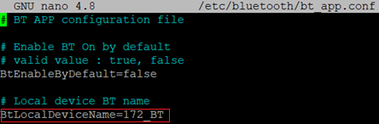

- Enable BT and pair with BT devices
$ sudo su
$ /home/advantech/Desktop/AIW_172_BT/x86_64_out_rootfs/debug/btproperty &
$ /home/advantech/Desktop/AIW_172_BT/x86_64_out_rootfs/debug/btapp
$ gap_menu (go to gap menu)
$ enable (Enable BT)
$ inquiry (Scan device)
$ pair <bt_address> (pair bt device)
$ main_menu
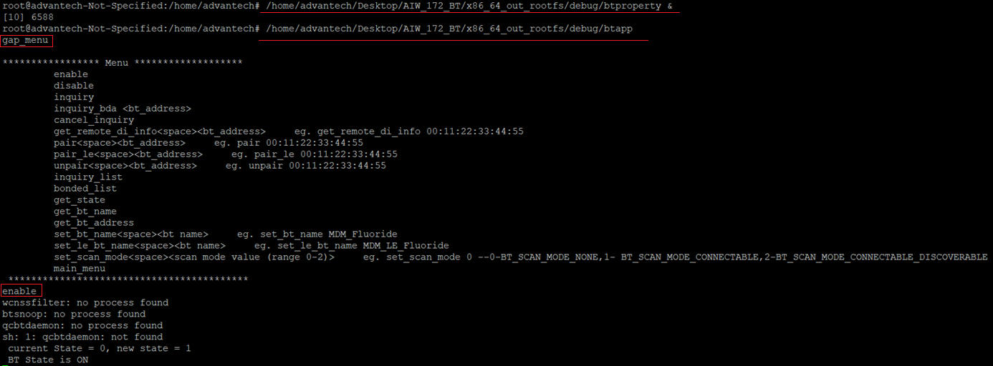
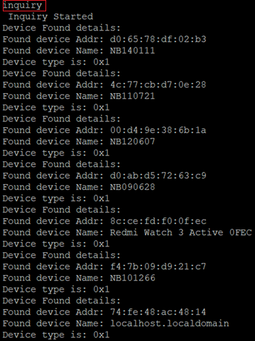
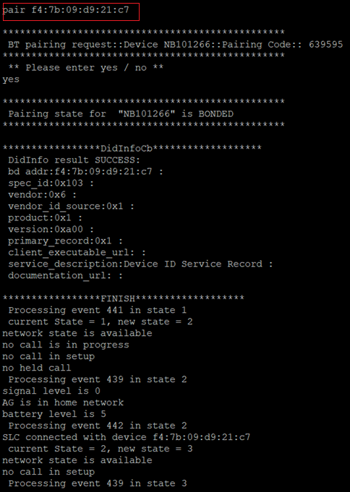
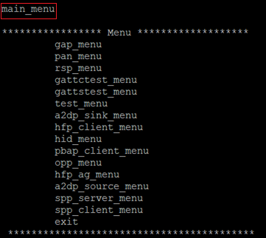
- Test SPP(Serial Port Profile) server
* Prepare an Android phone and install “Serial Bluetooth Terminal” app
- Check bt_app.conf
BtSppServerEnable=true
BtSppClientEnable=true
- Start btproperty and btapp with root privilege
$ sudo su
$ /home/advantech/Desktop/AIW_172_BT/x86_64_out_rootfs/debug/btproperty &
$ /home/advantech/Desktop/AIW_172_BT/x86_64_out_rootfs/debug/btapp
- Enable BT and setup SPP service
$ gap_menu (go to gap menu)
$ enable (Enable BT)
$ inquiry (Scan device)
$ pair <bt_address> (pair bt device)
Go to main menu
$ main_menu
$ spp_server_menu
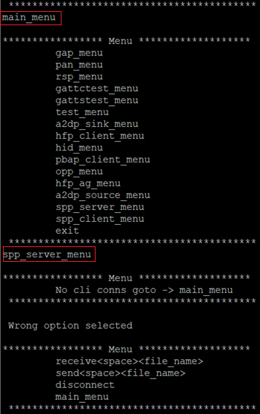
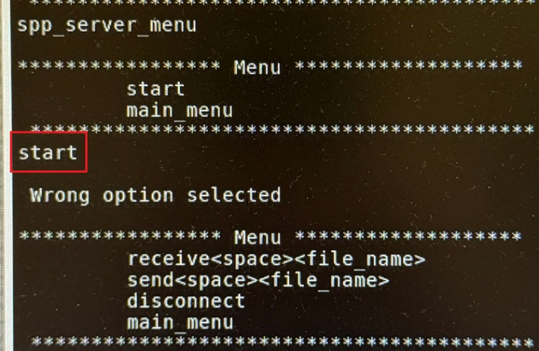
- Use Android phone and open “Serial Bluetooth Terminal” app for following operations.
- Select “Devices”.
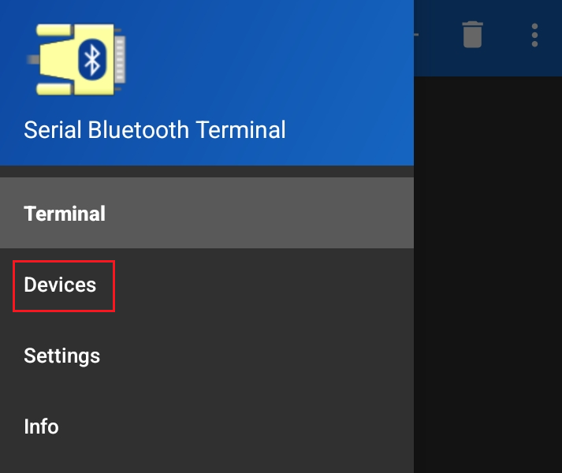
- Refresh to show available BT devices and click DUT to make connection establish.
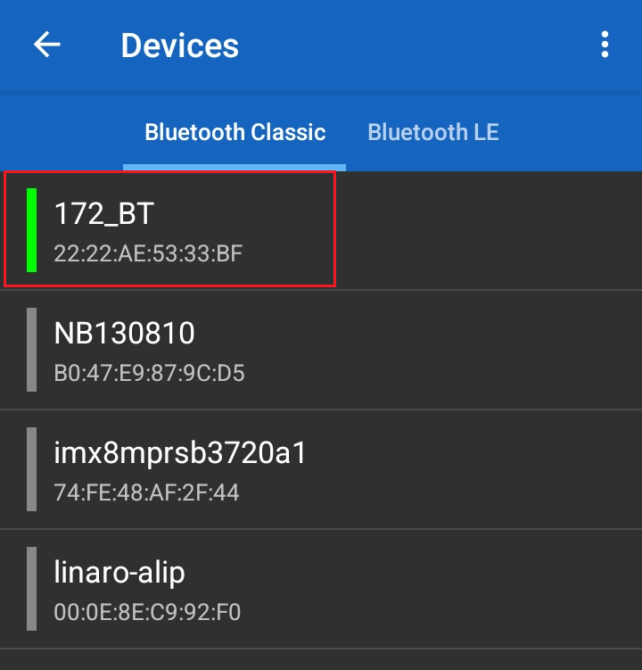
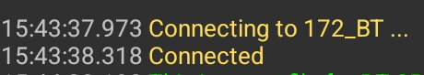
- Test receiving data.
- Setting on Android phone “Serial Bluetooth Terminal”:
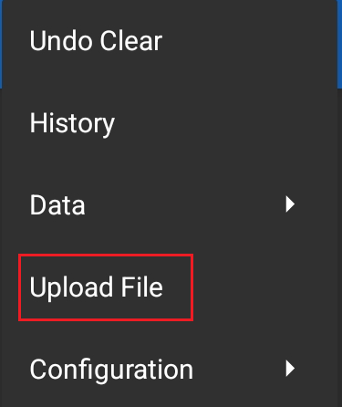
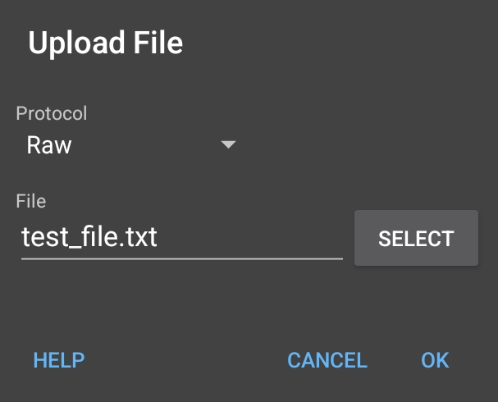

- Command for receiving data on DUT.
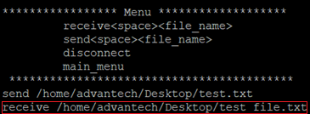

- Test sending data:
- Command for sending data on DUT.
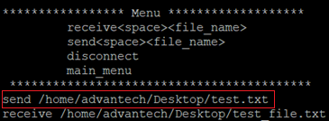
- Content of test.txt shown on Android phone “Serial Bluetooth Terminal”
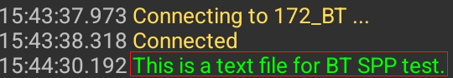
- Test A2DP(Advanced Audio Distribution Profile) source
- Check bt_app.conf
BtA2dpSourceEnable=true
BtA2dpSinkEnable=false
BtAvrcpEnable=false
- Start btproperty and btapp with root privilege
$ sudo su
$ /home/advantech/Desktop/AIW_172_BT/x86_64_out_rootfs/debug/btproperty &
$ /home/advantech/Desktop/AIW_172_BT/x86_64_out_rootfs/debug/btapp
- Enable BT and start A2DP
$ gap_menu (go to gap menu)
$ enable (Enable BT)
$ inquiry (Scan device)
$ pair <bt_address> (pair bt device)
$ main_menu
$ a2dp_source_menu
$ connect <bt_address>
$ start
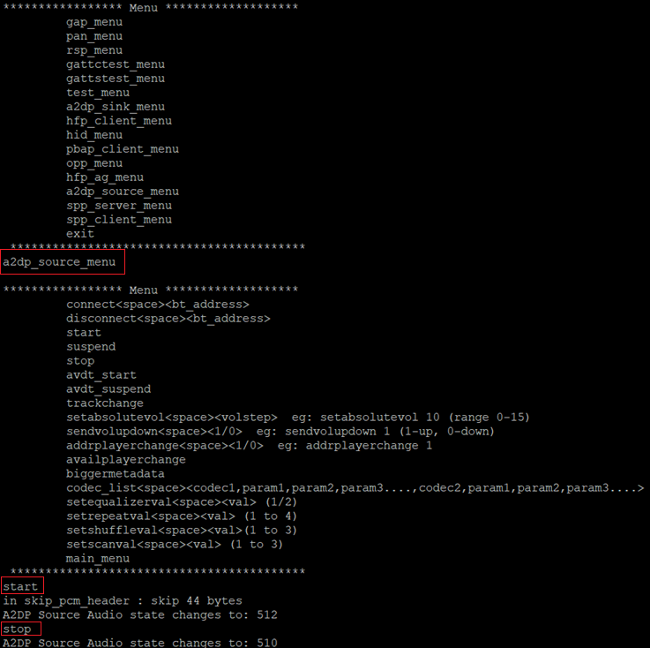
*Test with AirPods as BT client and play with following pcmtest.wav: pcmtest.wav

- Test BLE GATT(Generic Attribute Profile) server
* Prepare an Android phone and install “LightBlue” app

- Start btproperty and btapp with root privilege
$ sudo su
$ /home/advantech/Desktop/AIW_172_BT/x86_64_out_rootfs/debug/btproperty &
$ /home/advantech/Desktop/AIW_172_BT/x86_64_out_rootfs/debug/btapp

- Enable BT and start GATT
$ gap_menu (go to gap menu)
$ enable (Enable BT)
$ main_menu
$ gattstest_menu
$ gattstest_init
$ gattstest_start
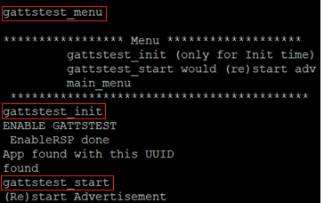
- Use Android phone and open “LightBlue” app for following options.
