AIW(EWM) FAQ
Category | AIW | Date | 2026/1/27
Keyword | AIW-170BQ, ARK-3533, Windows 11 24H2, Bluetooth

- Question:
No Bluetooth interface on ARK-3533 and there’s a yellow bang option “Unknown USB Device”.
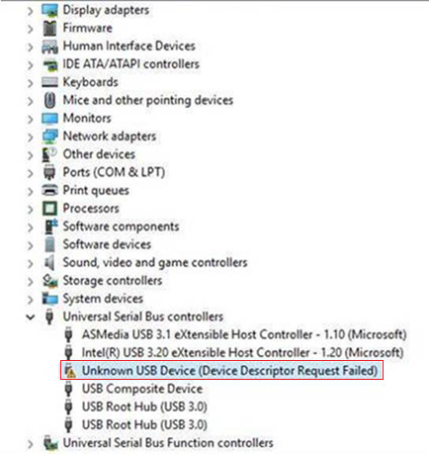

- Analysis :
- Due to AIW-170BQ pin12 I2S_SD_OUT(1.8V) is an output pin for I2S Bluetooth audio.
If there’s signal input from main board to affect this module pin12, it may cause USB Bluetooth related issue.
When module pin12 is tapped, then Bluetooth can be recognized successfully and Bluetooth interface does appear.
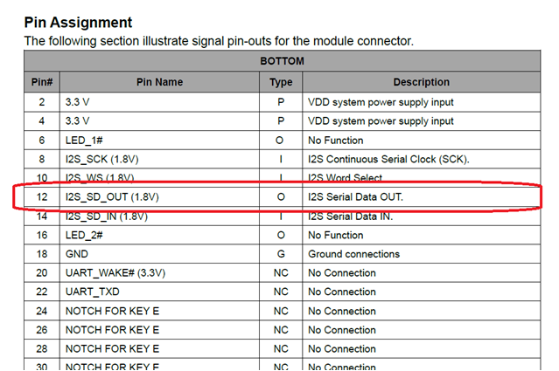

After AIW-170BQ pin12 is tapped, Bluetooth interface appears in device manager.
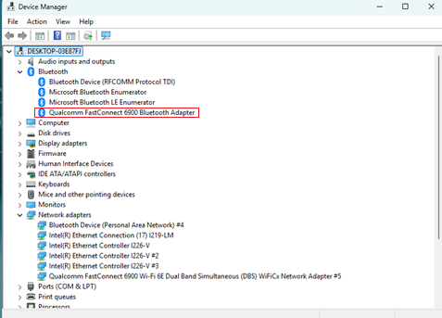

Thus, suggestion is to set pin 12 to high impedance to prevent the signal from affecting the USB Bluetooth interface.

- Check with ARK team EE, the original status is already high impedance.
However, it passes through a level shifter, it looks like the level shifter pin definition conflicts with the module pin assignment.
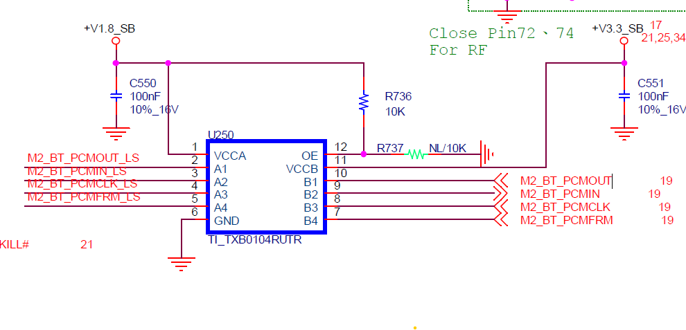
- Conclusion :
The solution to fix this AIW-170BQ Bluetooth issue on ARK-3533 is to remove level shifter but it needs to be confirmed and evaluated by ARK PM, basically, only for special project depends on project scale.
The preferred approach is to replace AIW-170BQ with the other module if the device has been confirmed to use ARK-3533.
For example, AIW-169BR-GX1 which is the same Wi-Fi 6E generation as AIW-170BQ.

AIW-169BR-GX1 pin12 is NC:
